SSES Amt’s Science College, Congress Nagar, Nagpur
Session- 2022-23
SCIENCE ASSOCIATION
Jamnalal Bajaj Science College, Wardha -2023,
VISIT REPORT
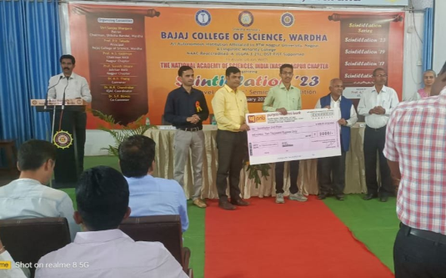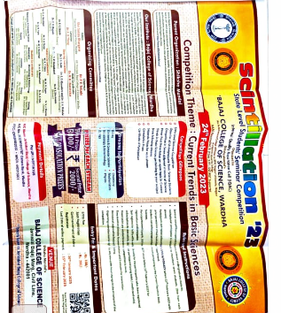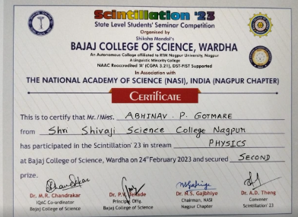

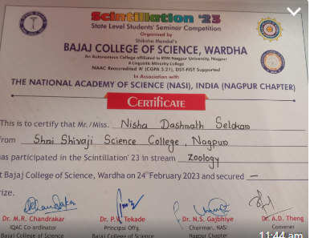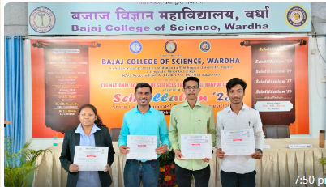

Four Students (U.G.) of Shri Shivaji Education Societie’s Science college, Congress Nagar, Nagpur had participated in State Level Students Seminar Competition Organized by Bajaj College Of Scoence, Wardha in association with the National Academy of Science, India (NASI) Nagpur- Chapter on 24th February 2023.
1)Nisha selokar, B.Sc. Final Year (CBZ)
Representing department of Zoology.
2)Abhinav Prashant Gotmare,B.Sc. Final Year (PCsM)
Representing Department of Physics
3)Jay Kailash Chirekar
B.Sc. Final Year (PCsM)
Representing Department of Mathematics
4)Akshay Shridhar Bhatkulkar
B.Sc. Final Year (CBZ)
Representing Department of Chemistry

Abhinav Prashant Gotmare
B.Sc. Final Year (PCsM)
Representing Department of Physics
Grab 2nd prize, congratulations

Date-24th February 2023
Place -Nagpur
Convener
SCIENCE ASSOCIATION
Dr. Rupali Patil Bhagat

