SSES Amt’s Science College, Congress Nagar, Nagpur
Session- 2022-23
SCIENCE ASSOCIATION
Jamnalal Bajaj Science College, Wardha -2023,
VISIT REPORT

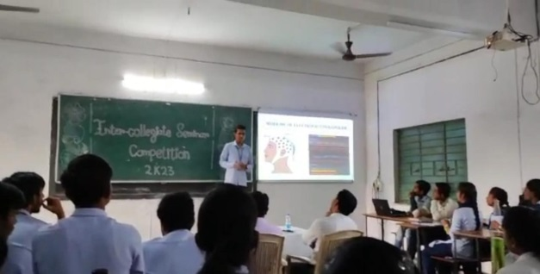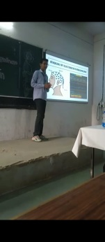
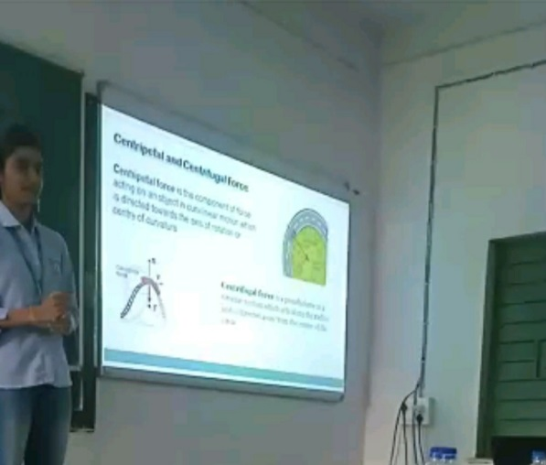
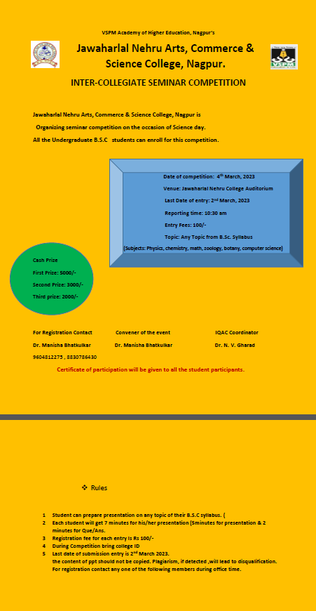

Students (U.G.) of Shri Shivaji Education Societie’s Science college, Congress Nagar, Nagpur had participated in Inter- Collegiate Seminar Competition-2023 Organized by Jawaharlal Nehru Arts, Commerce and Science College Wadi, Nagpur.
1)Nisha selokar, B.Sc. Final Year (CBZ)
Representing department of Zoology.
2)Abhinav Prashant Gotmare,B.Sc. Final Year (PCsM)
Representing Department of Physics
3)Jay Kailash Chirekar
B.Sc. Final Year (PCsM)
Representing Department of Mathematics
4)Akshay Shridhar Bhatkulkar
B.Sc. Final Year (CBZ)
Representing Department of Chemistry

Date-4th March 2023
Place -Nagpur
Convener
SCIENCE ASSOCIATION
Dr. Rupali Patil Bhagat

