24 September N.S.S Day Celebration

N.S.S unit of Shri Shivaji Educaton Society Amravati’s Science College Congress Nagar, Nagpur, Maharashtra organized and celebrated N.S.S day on 24 September 2019 with great fervor and enthusiasm. The speaker and guest for the program was Dr.G.R. Avchar , vice principal of science college.
The program started with welcome speech of N.S.S program officer Dr.P.S Utale. In his welcome speech he discussed about last programs of N.S.S and the hard work of all N.S.S volunteers. They explain how to become effective N.S.S volunteer who can enable to help 24 hr and give service to making welfare of society. After their welcome speech some volunteers give their feedback and discuss about all program initiated by unit.
Lastly Dr. Avchar gave their guest speech. He discuss history of N.S.S unit of the college as well as history of N.S.S. they encourages all volunteer to do effective work. They discuss some strategy through his speech. The program was concluded with gracious vote of thanks.
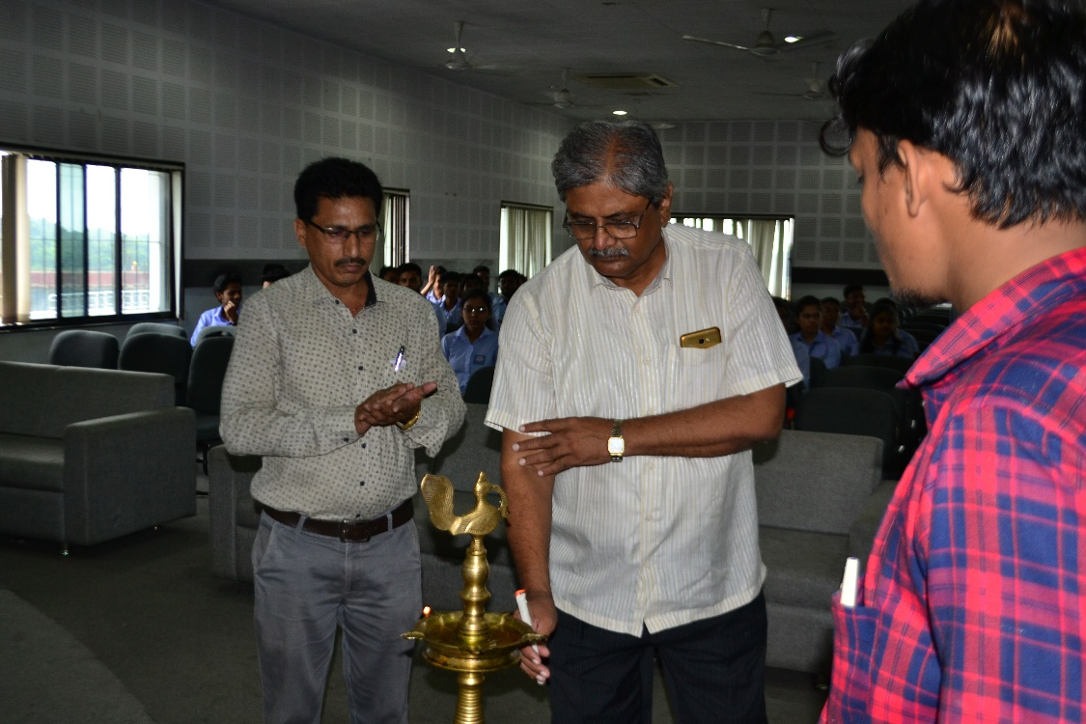
Dr G. R. Avchar, Vice Principal inaugurating the NSS Day programme
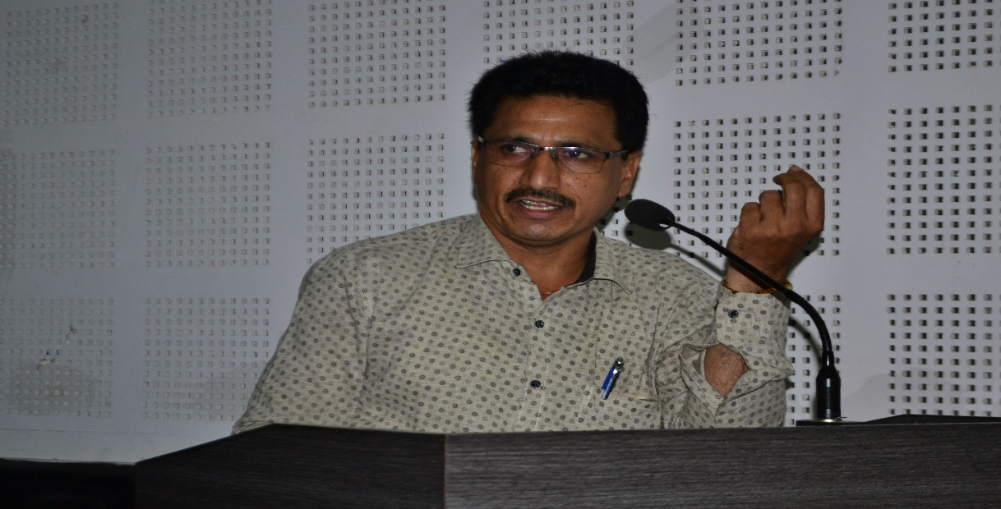
Dr. Utale, Program officer briefing the NSS volunteers
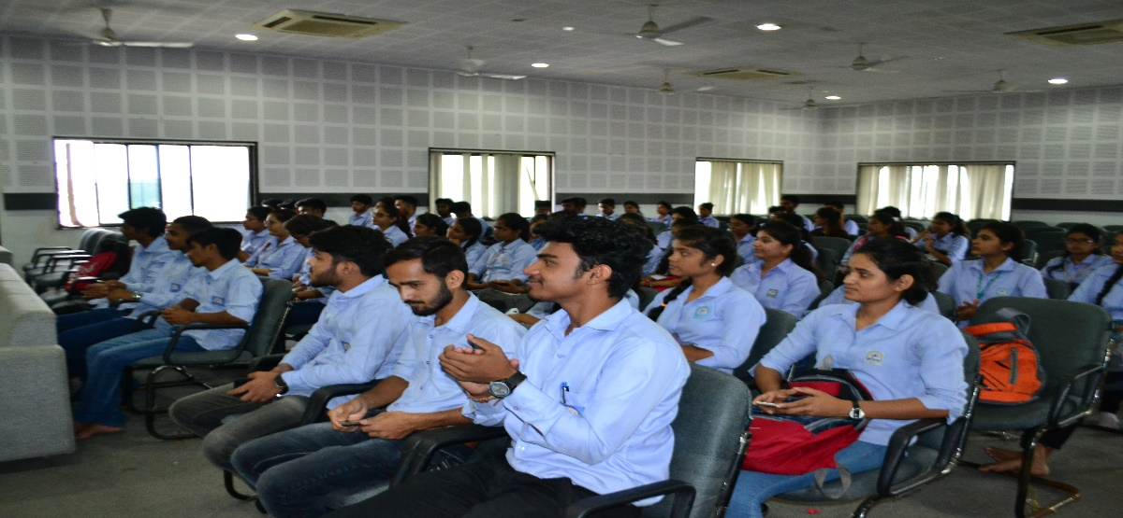
NSS volunteers In the NSS Day programme
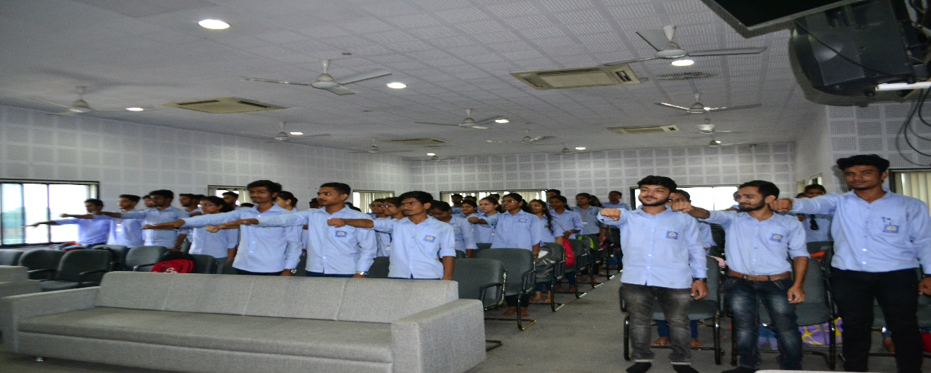
Volunteers taking NSS Oath

