Session 2019-2020
N.S.S. organized a Youth connect program on women empowerment.
24 July 2019
A Youth connect program on women empowerment organized by N.S.S of Shri Shivaji Education Society Science College College in Nagpur, Maharashtra. The program began with the welcome speech for the program guest, Sakshma Salgar Z.P member. Apart from them Manisha kate, G. Avchaar Sir and Utale Sir were also present in the program.
The guest delivered there prudence speech in that program followed by college teacher. The speech mostly including women Empowerment in India which is heavily dependent on many different variables that include geographical location (urban/rural), educational status, social status (caste and class) and age.
Policies on women‘s empowerment exist at the national, state, and local (Panchayat) levels in many sectors, including health, education, economic opportunities, gender-based violence, and political participation. Salgar ma’am explained the significant gaps between policy advancements and actual practice at the community level. One key factor for the gap in implementation of laws and policies to address discrimination, economic disadvantages, and violence against women at the community level is the largelypatriarchal structure that governs the community and households in much of India. As such, womenand girls have restricted mobility, access to education, access to health facilities, and lower decision-making power, and experience higher rates of violence. Political participation is also hindered at the Panchayat (local governing bodies) level and at the state and national levels, despite existingreservations for women. Ma’am also included the women condition in college level. At the program more than 150 student and N.S.S volunteers were present. The program ended with the guest speech.

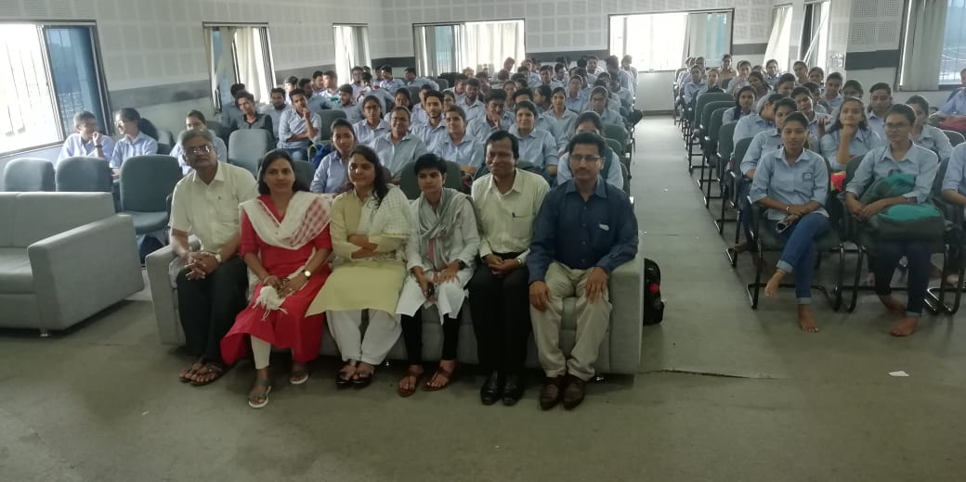
Faculty of Science College with the program guest, Sakshma Salgar Z.P member and Manisha kate

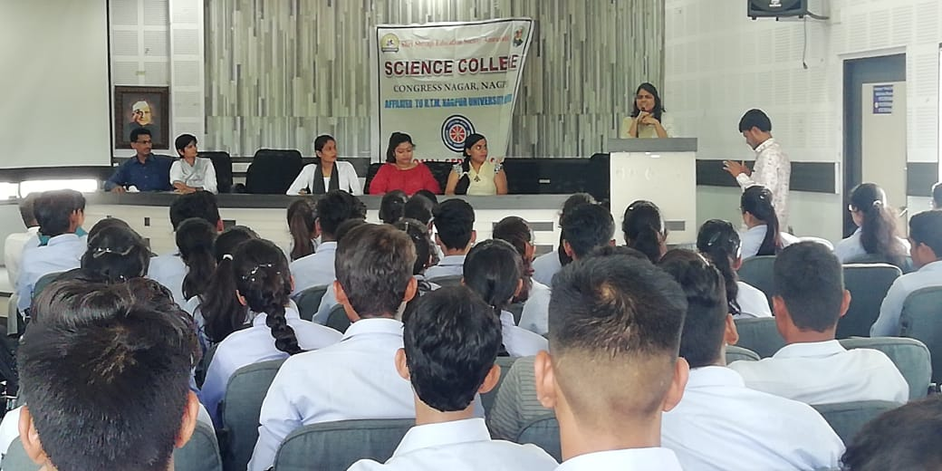
Sakshma Salgar Z.P member guiding Students on Women Empowerment
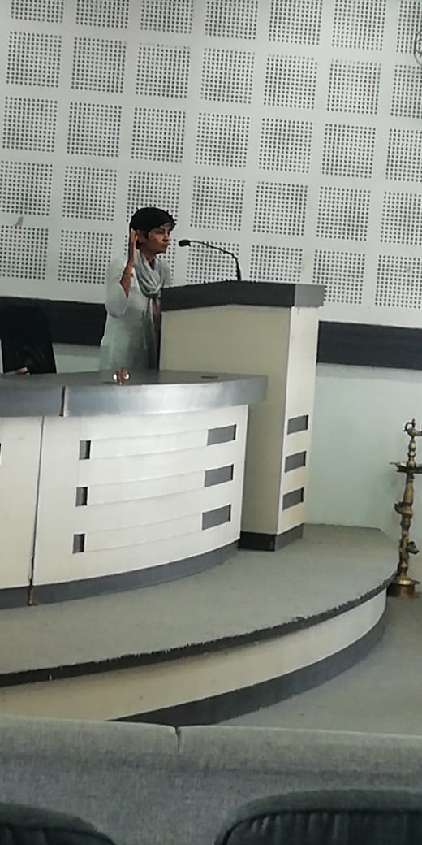
Manisha kate guiding students on Women Empowerment

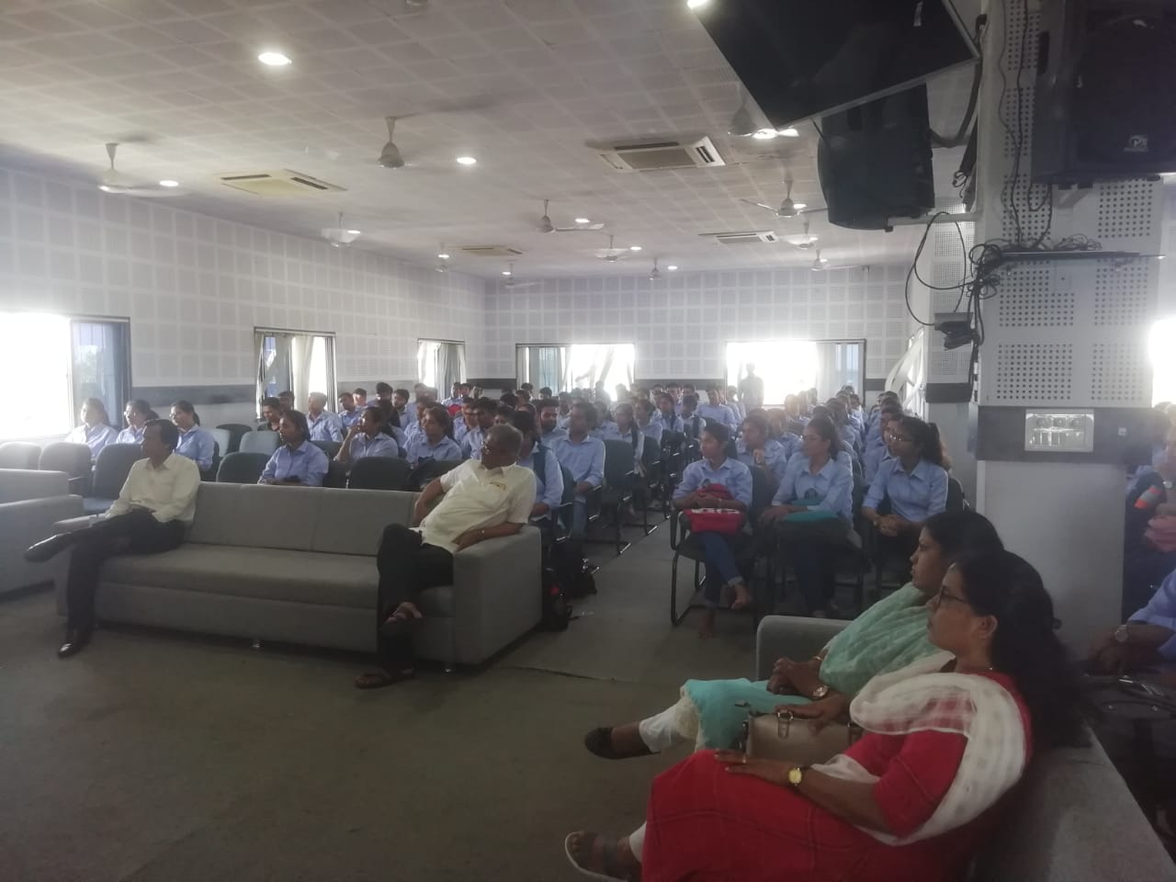
Faculty and Students listening the Guest Speaker

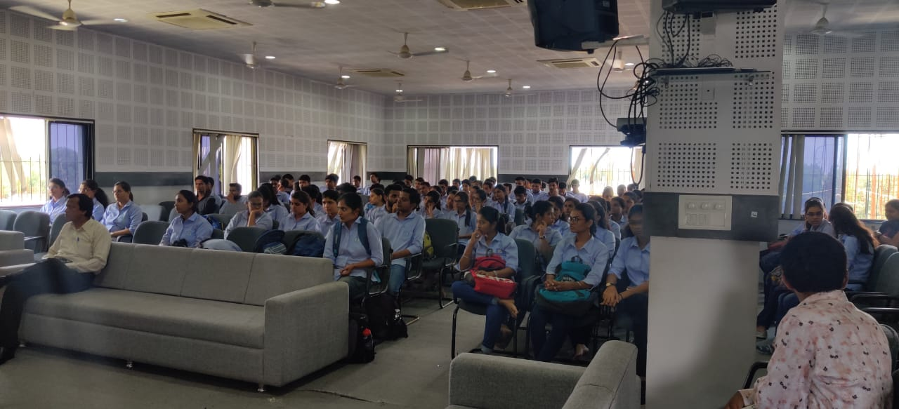
Students listening the Speaker
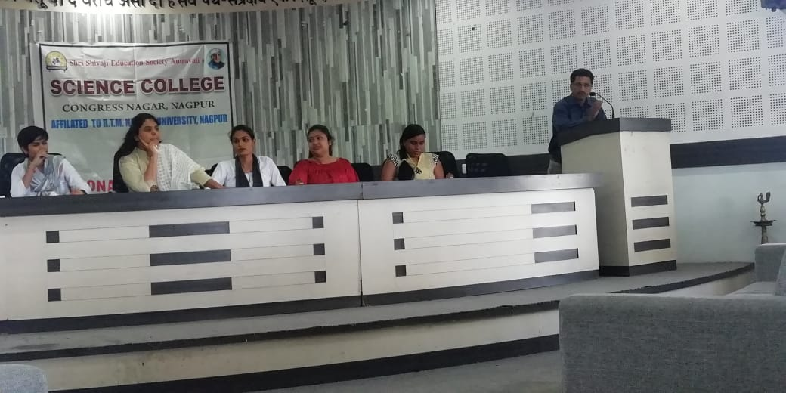
NSS Programme Officer giving concluding Remark

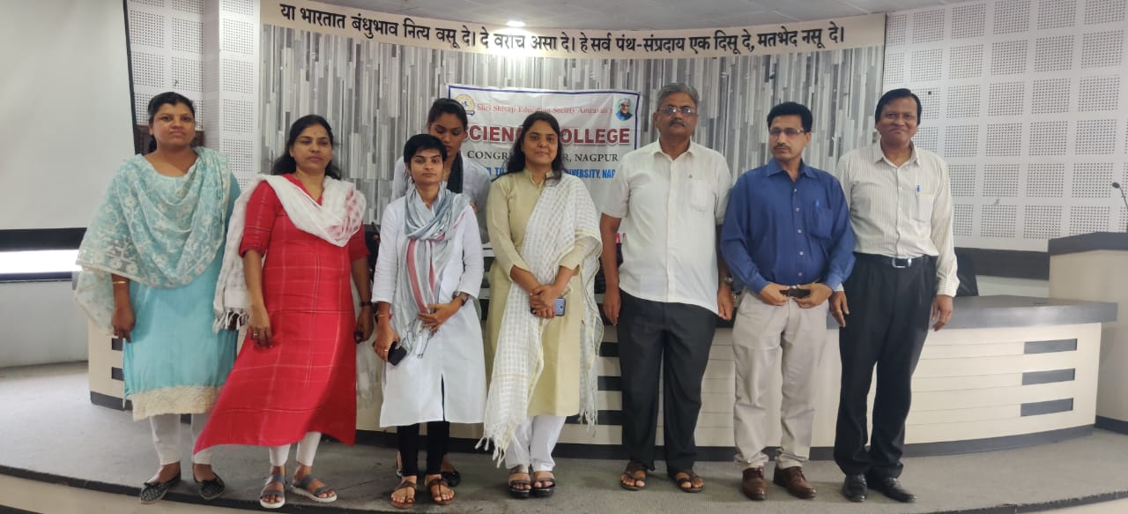
Program guest, Sakshma Salgar Z.P member, Manisha kate, G. Avchaar Sir , Ghatole Sir, Utale Sir, Meshram Madam and Deshmukh Madam

