Session 2020-2021
Voters day
25th January 2021
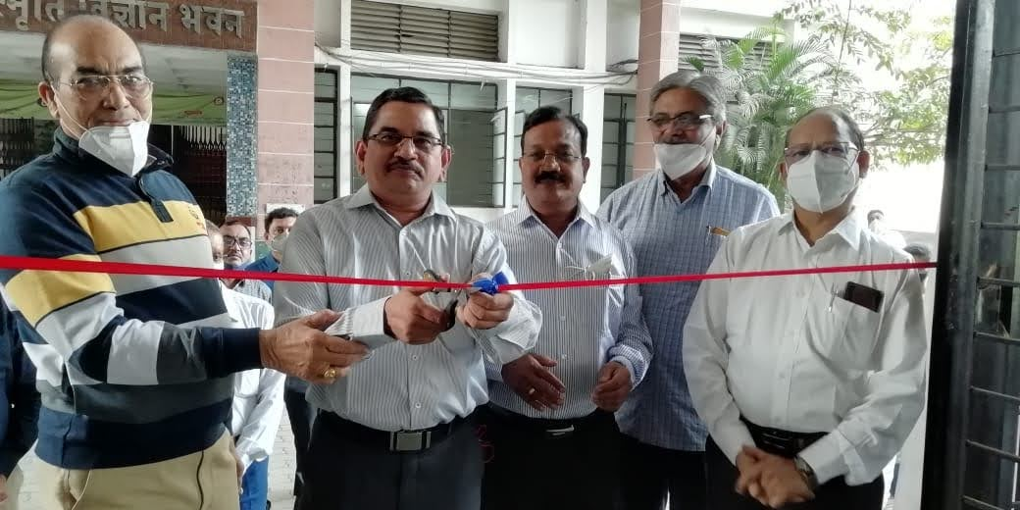
Prof. M. P. Dhore inaugurating the voters day program
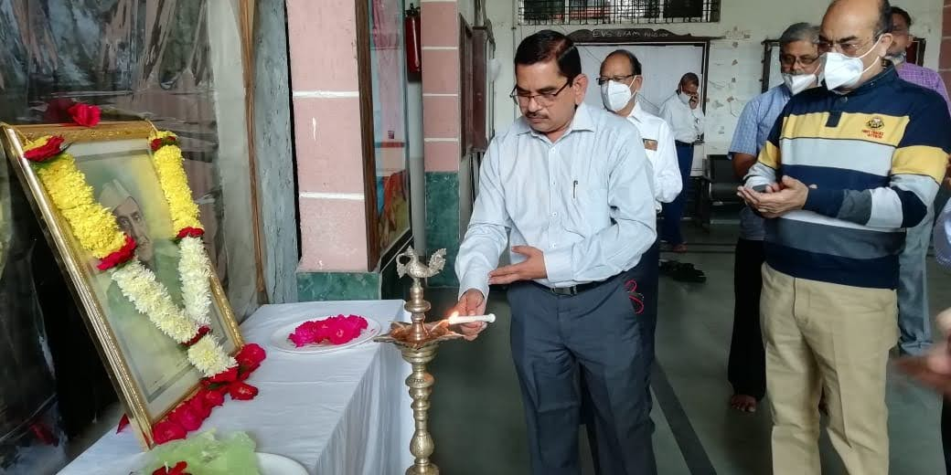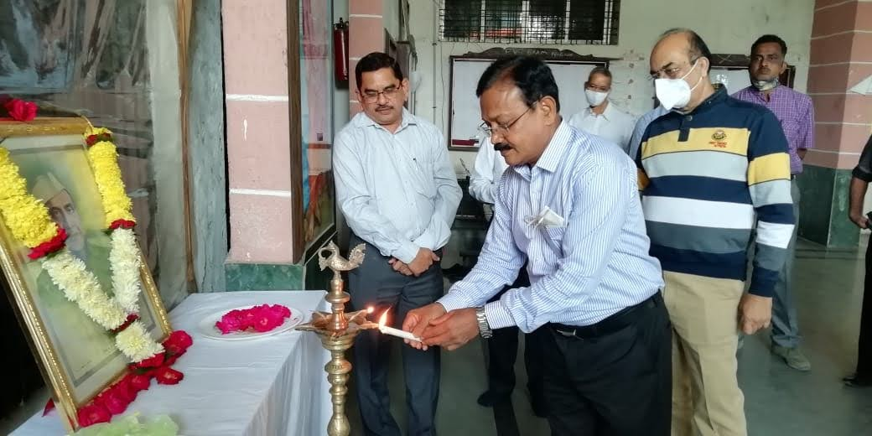
Prof. M. P. Dhore, Principal and Prof. Chandekar, Former Principal lightning the traditional lamp on voters day
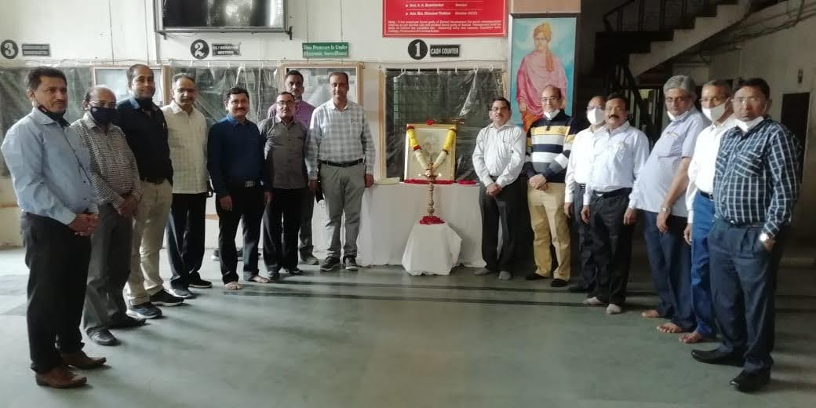
Prof. M. P. Dhore, Principal with faculty members

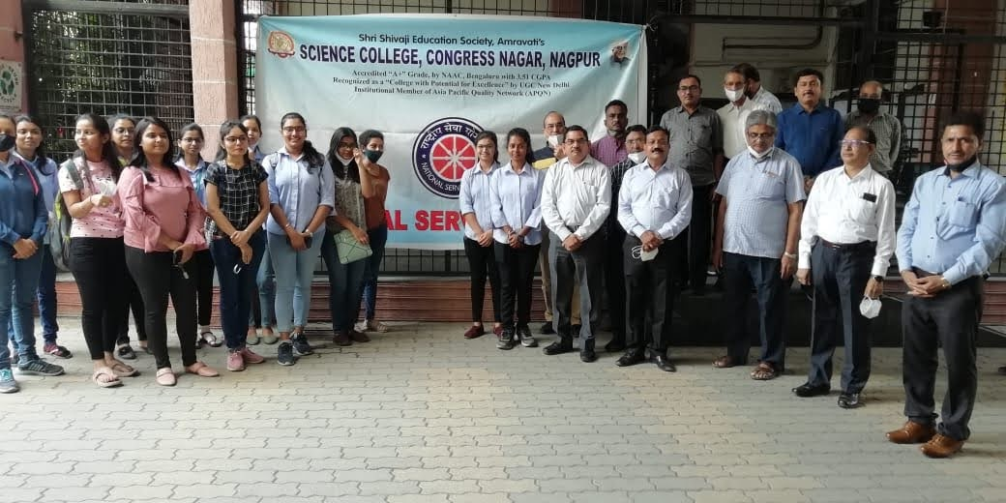
Prof. M. P. Dhore, Principal , Faculty members and Students

