Session 2020-2021
Vasundhara E-Pledge
14th January 2021

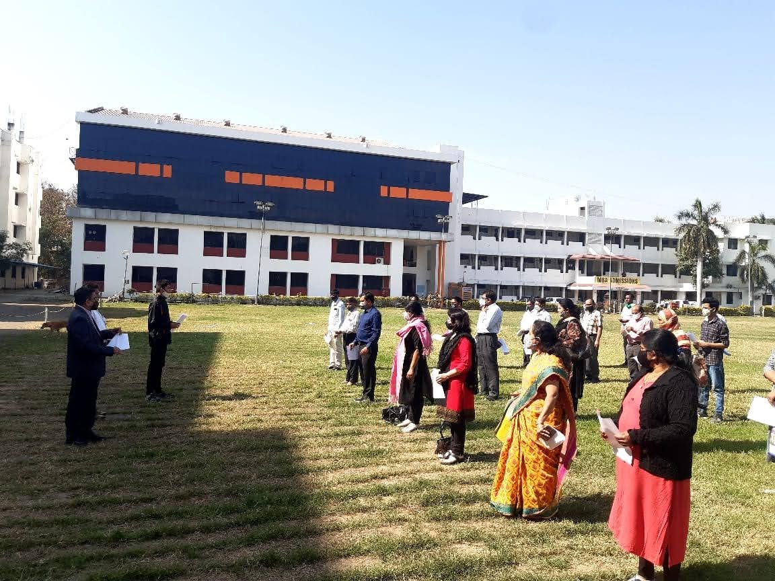
Prof M. P. Dhore, Principal, Dr. P. S. Utale, NSS Programme Officer and Faculty members taking Vasundhara E- pledge
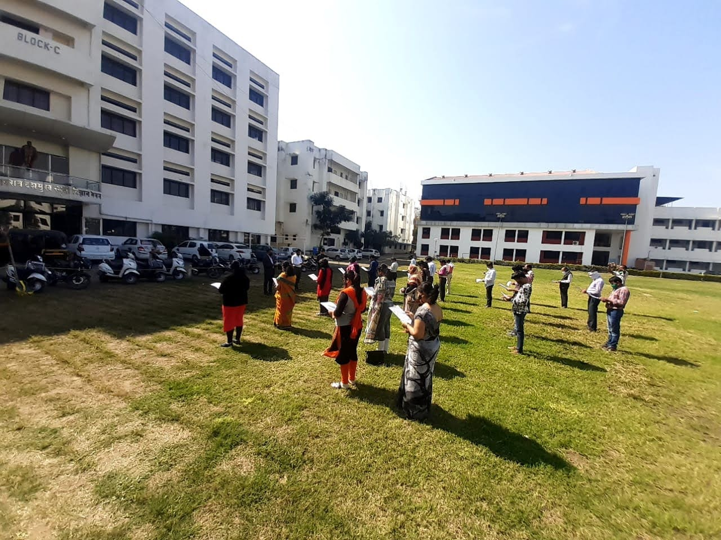
Prof M. P. Dhore, Principal, Dr. P. S. Utale, NSS Programme Officer and Faculty members taking Vasundhara E- pledge in the college premises

