Tree Plantation Activity

Activity :To plant trees in a school
Date : 26 July 2018
Department : NSS

College : Karna Badhir Vidyalaya, Sonegaon

Location :NAGPUR

Monitored by: Name(s) and position:

- Dr. C.J. Chandekar (officiating principal)
- Dr. D.K.Burghate (ex-principal)
- Dr.P.S. Utale (convenor)

Objectives of the tree platation:

- To understand the Importance of trees.
- To increase the interest in social activities.

Points of Note:

The NSS team of Shivaji Science College had organized the program “tree plantation” on 26th of July 2018. They also teached us the importance of the trees in the today's world . Later all the candidates of the NSS team start planting The trees .The main motive was to create awareness among students about the tree plantation and to give the knowledge about the trees.

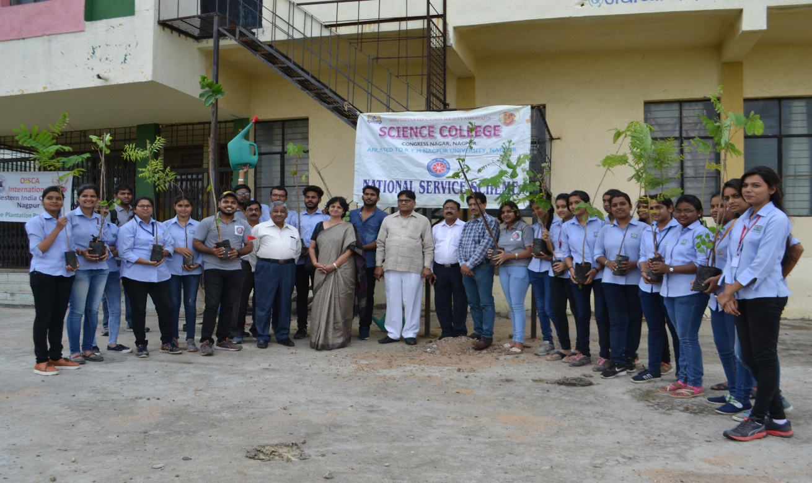
Dr. C.J. Chandekar (officiating principal), Dr. D.K.Burghate (ex-principal), Dr.P.S. Utale (convenor) with NSS volunteers in the premises of Karna Badhir Vidyalaya, Sonegaon for tree plantation

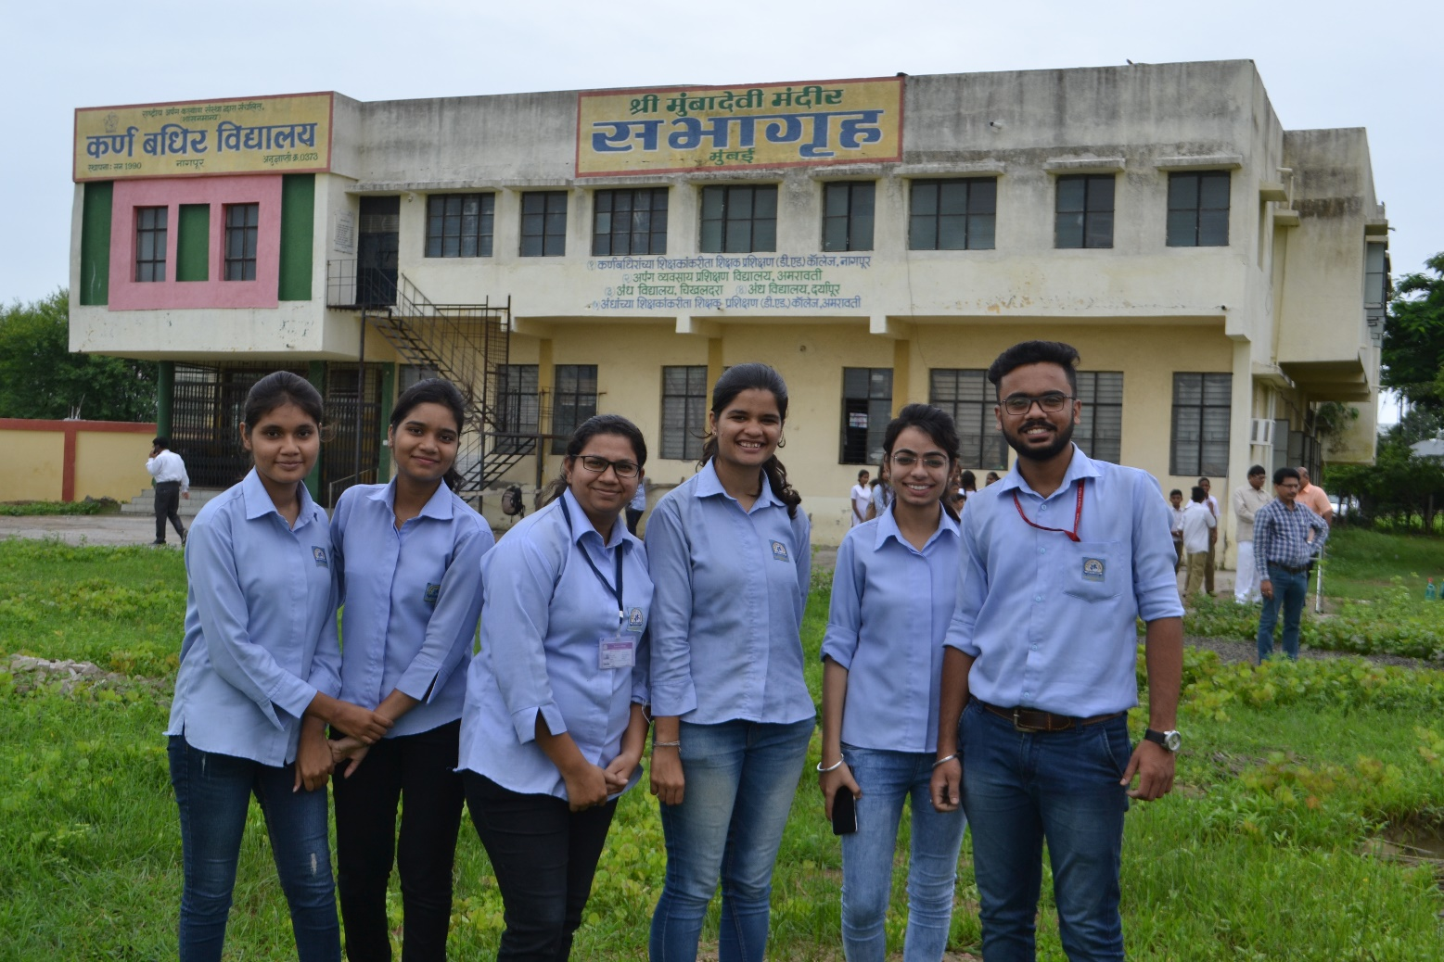
NSS volunteers in the premises of Karna Badhir Vidyalaya, Sonegaon for tree plantation

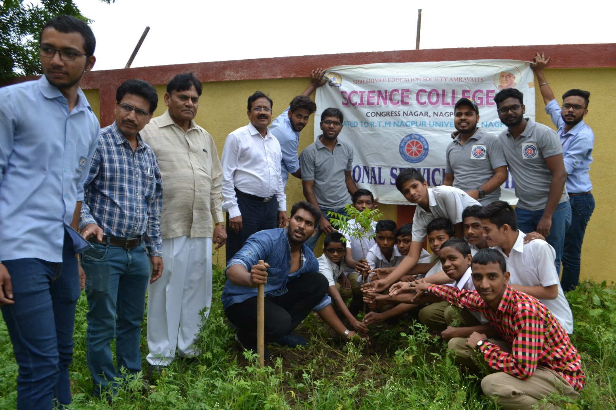
NSS volunteers and students of Karna Badhir Vidyalaya, Sonegaon planting tree

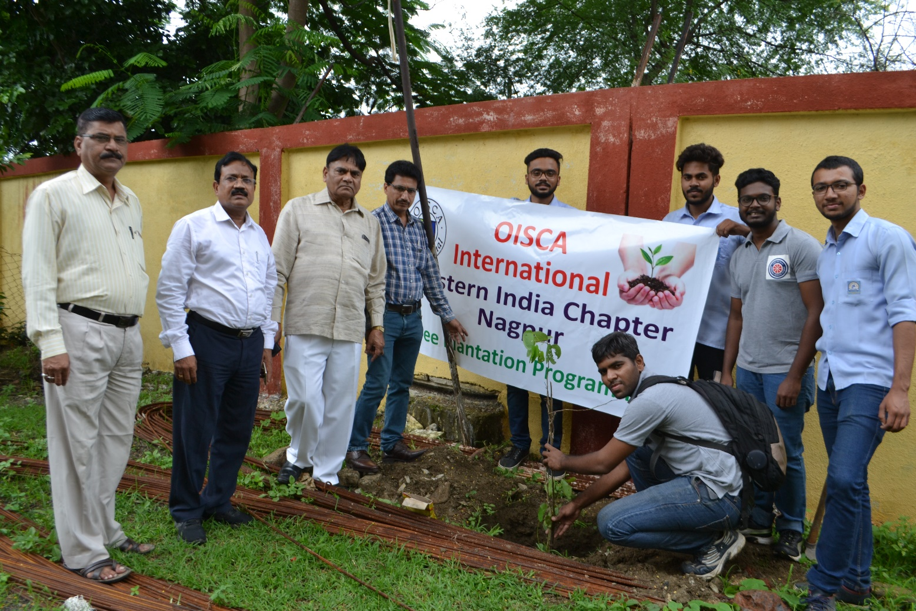
NSS volunteers planting tree in the premises of Karna Badhir Vidyalaya, Sonegaon

