Nivadnuk Shaksharta Club.

Activity : Distribution of application forms of voting cards and awareness among
the students about importance of voting in elections.
Date : 14 Oct 2018
Department : NSS

College : Shri Shivaji Science College, Nagpur.

Location : NAGPUR

Monitored by: Name(s) and position:

- Dr. C.J. Chandekar (Officiating Principal)
- Dr.P.S. Utale (Convenor)

Objectives of the seminar:

- To understand the Importance of Voting.
- Distribution of application forms of voting cards.

Points of Note:

The NSS team of Shivaji Science College and a team from the Zilla Parishad of Nagpur had organized the program “Nivadnuk Shaksharta Club ” on 14th of Oct 2018. They also told us the importance and power of the votes and voting processes in India. Later all the candidates of the NSS team distribute the application forms of voting card .The main motive was to create awareness among students about the importance of vote and to give the knowledge about the voting processes in India.

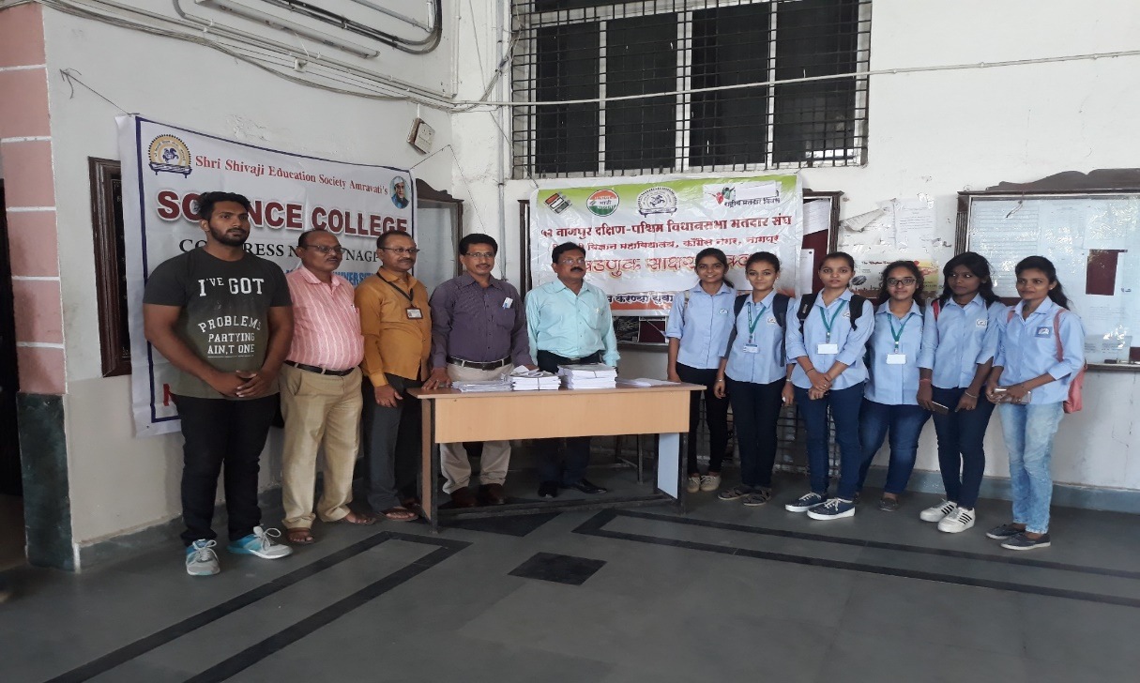
Dr. C. J. Chandekar (Officiating Principal), Dr. P. S. Utale (Convenor) and Election Commission Department officials with students

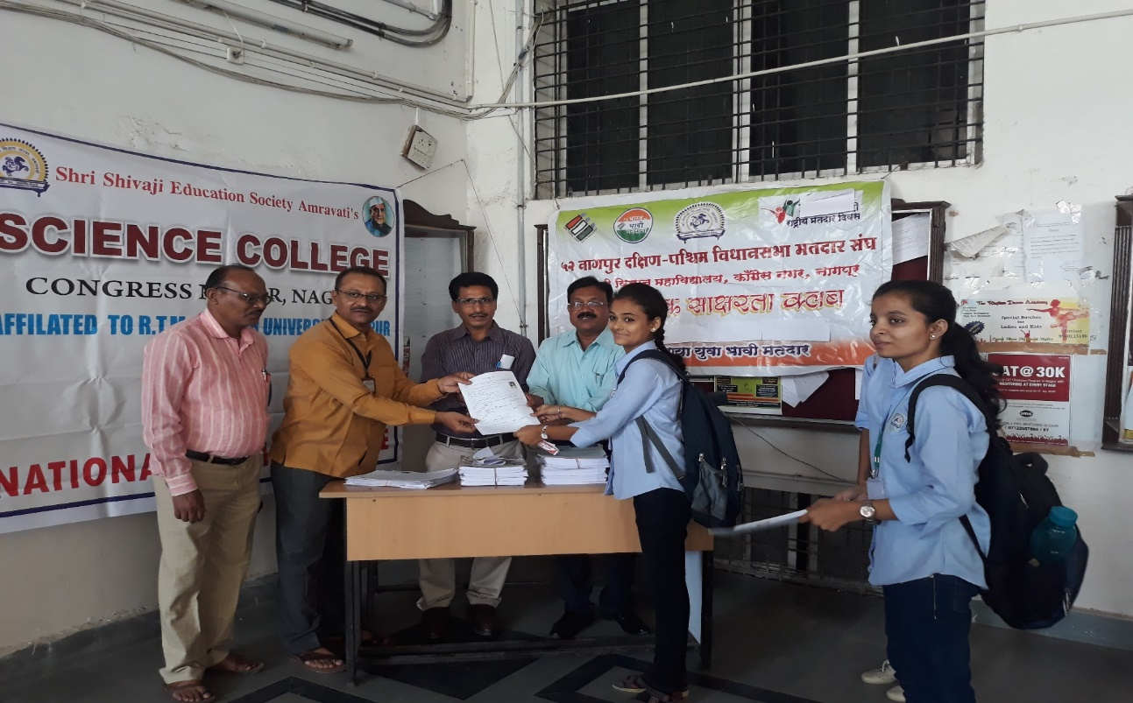

Election Commission Department officials distributing election enrollment form to student

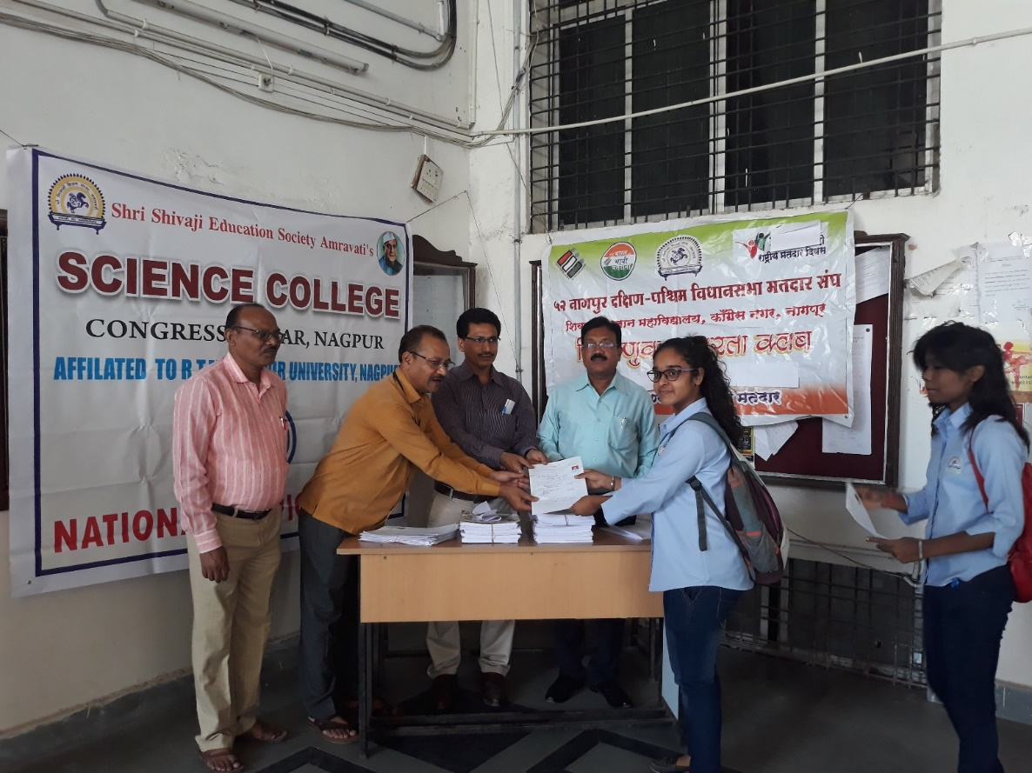

Election Commission Department officials distributing election enrollment form to student

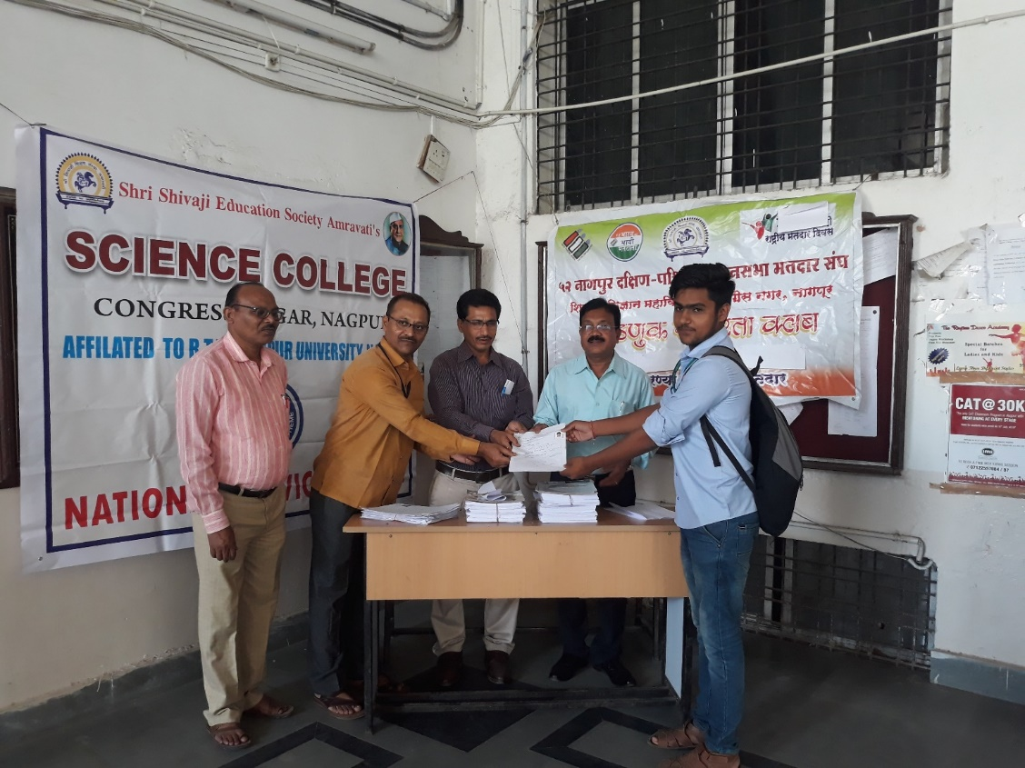

Election Commission Department officials distributing election enrollment form to student

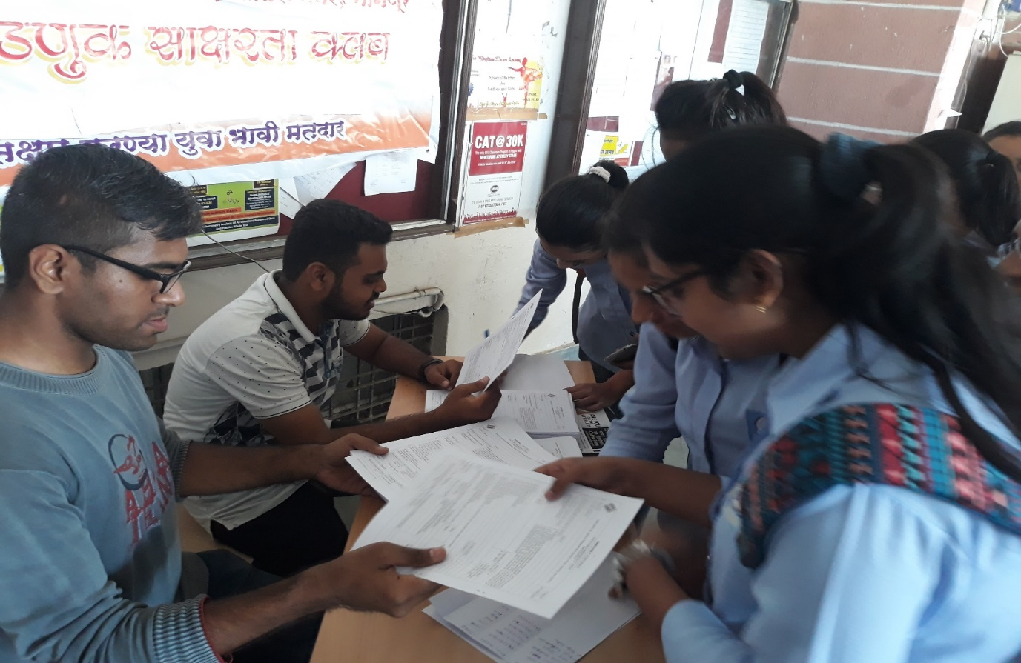

Students collecting forms

