Session 2018-2019
NSS CAMP 2019

Activity : Swachha Bharat Abhiyan
Date : 8 Jan 2019 to 13 Jan 2019
Department : NSS

Place : Fetri

Location : NAGPUR

Monitored by: Name(s) and position:

- Dr. C.J. Chandekar (Officiating Principal)
- Mr. G.R. Avachar (Vice Principal)
- Mrs. Vinita S. Gaikwad (Sachiv, Fetri Gram panchayat)
- Dr. P.S. Utale (Convener)
- Mrs. Dhanashri M. Dhomne (Sarpanch, Fetri Gram panchayat)

Objectives of NSS camp:

- To conduct the Swachha Bharat Abhiyan.
- To understand the importance of cleanliness.

Points of Note:

The NSS team of Shivaji Science College had organized the 6 days camp “Swachha Bharat Abhiyan” from 8 Jan 2019 to 13 Jan 2019. This camp was organized to teach the students the importance of the cleanliness and to teach the students to maintain the discipline in our day to day life. Also the students were faced with real life problems and learned to be self dependent. Regularly waking up early and doing Yoga for a healthy body.

The Six Day Program is explained below date wise:

Day 1: Tuesday, 8 Jan 2019 : Inauguration of Camp

Monitored by: Name(s) and position:

- Mr. Keshavrao Gawande (Principal's NSS Society Member )
- Mr. Hemant Kalmedh (Shivaji Education Society Member)
- Dr. C. J. Chandekar (Principal)
- Mr. G. R. Avachar (Vice-Principal)
- Dr. P. S. Utale (Convener)

Points of Note:
The Camp was inaugurated by our vice principal and the guest present in program gave a speech to enlighten us about the importance of the Camp and discipline and gave wishes for having a successful camp. After the program was over all the guest and the candidates had lunch. And at 6 pm we had our NSS prayer and then dinner.

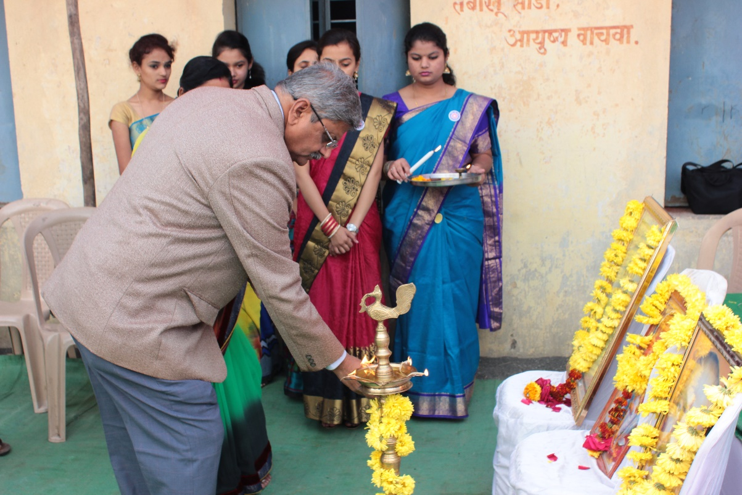
Vice Principal , Prof Mr. G. R. Avachar, Shivaji Science College lightening the lamp

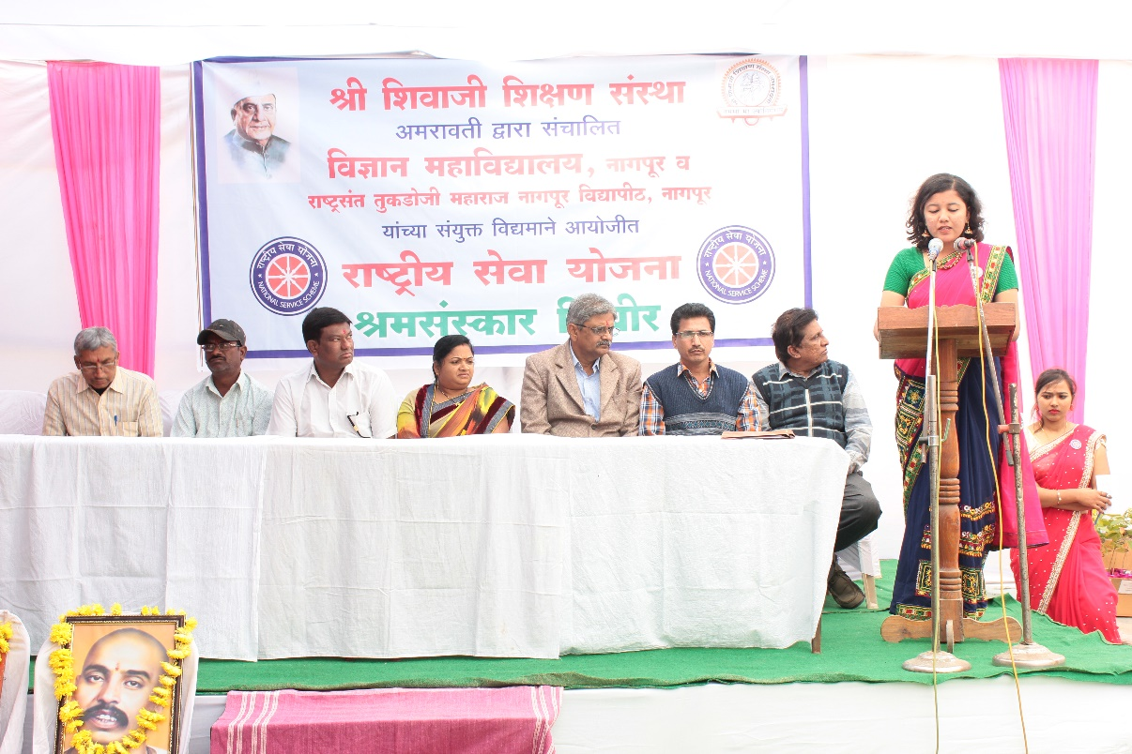
Inaugural Function of NSS Camp

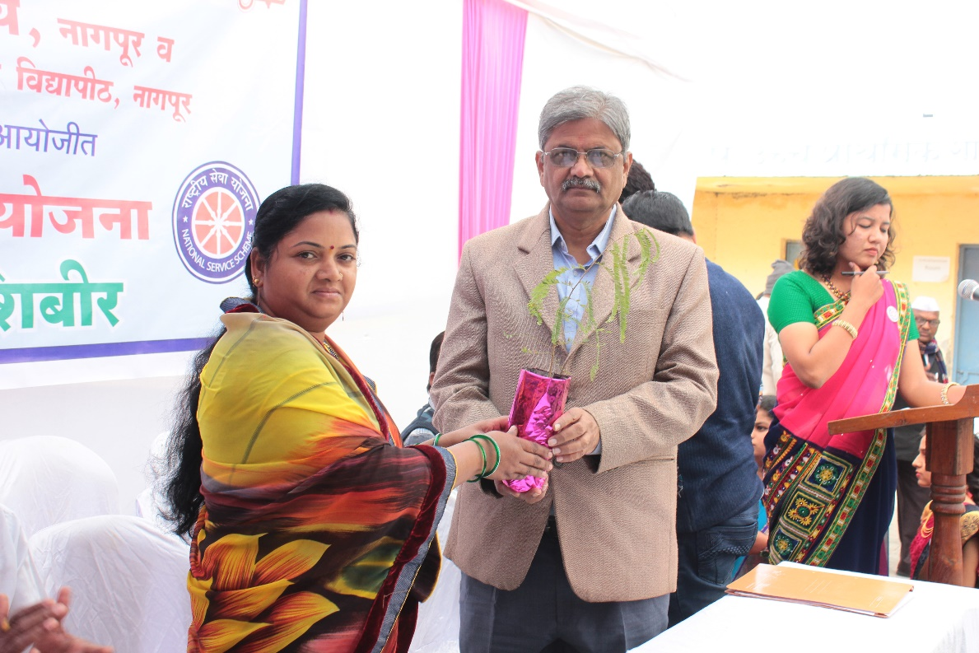

Vice Principal , Prof Mr. G. R. Avachar, Shivaji Science College welcoming Mrs. Dhanashri M. Dhomne, Sarpanch, Fetri Gram panchayat by presenting sapling

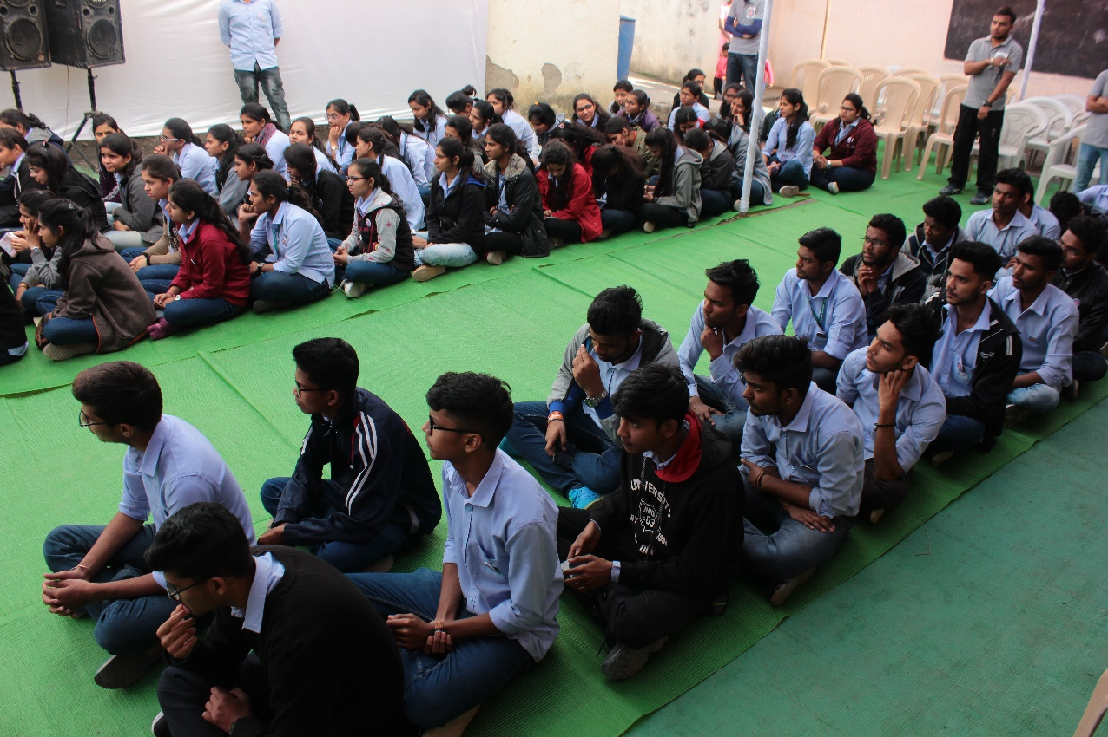
NSS students watching the inauguration function

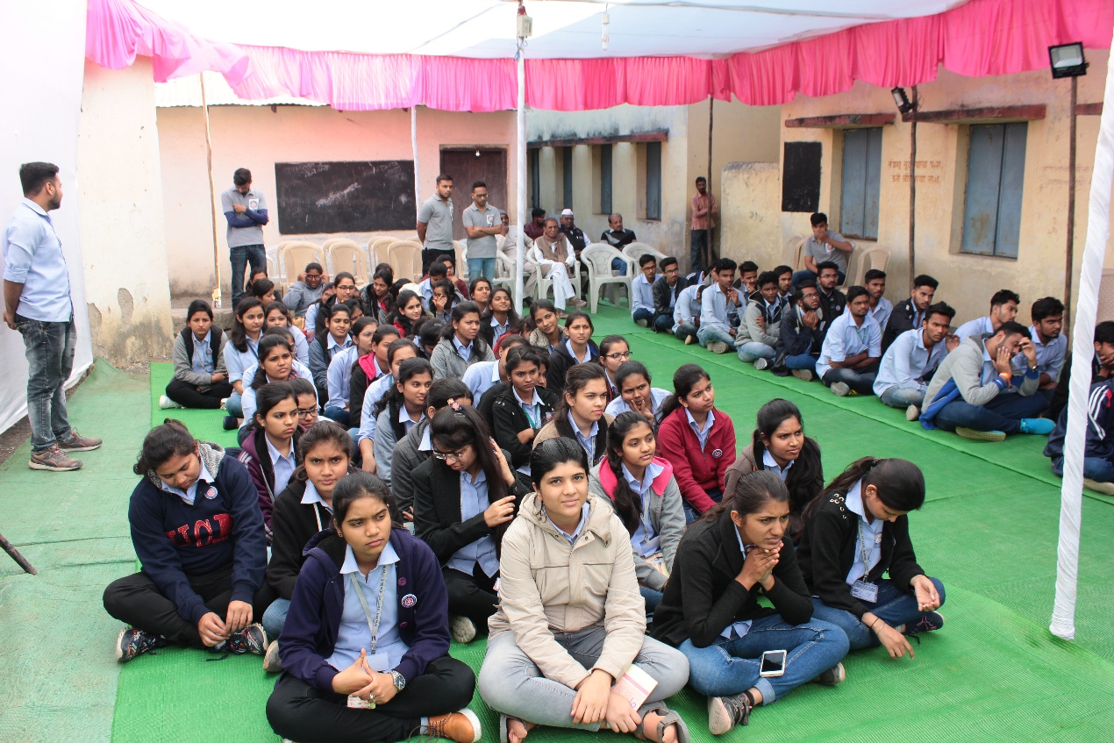
NSS students watching the inauguration function

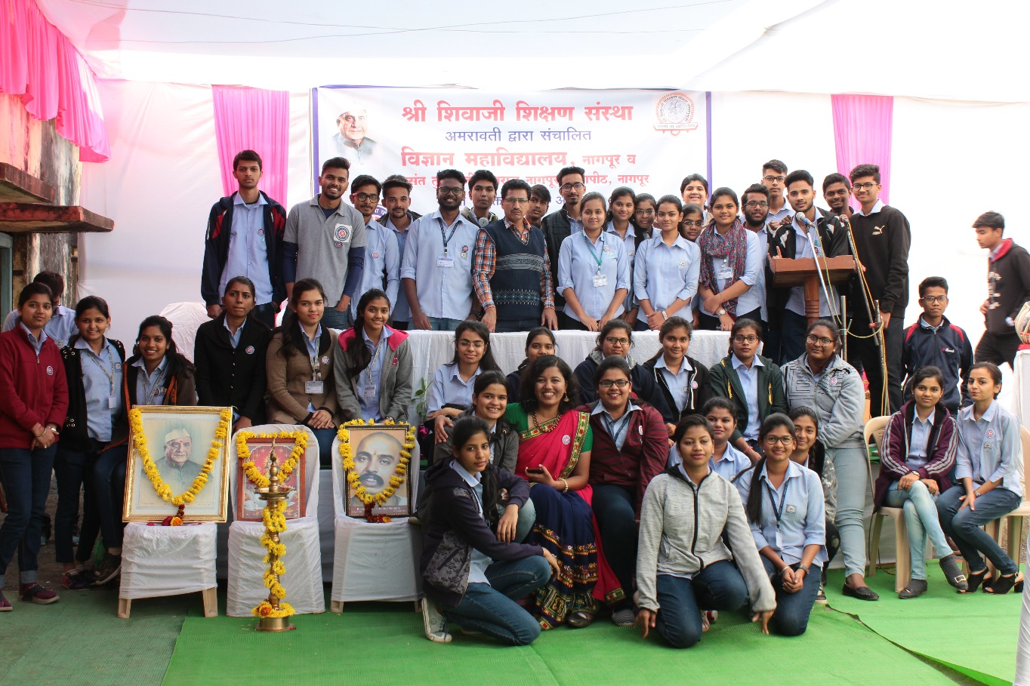

All NSS Volunteers in the Camp

Day 2 : Wednesday , 9 Jan 2019:

Monitored by: Name(s) and position:

- Dr. R.U. Khope (Head of Chemistry Dept.)
- Dr. R. N. Deshmukh (Head of Botany Dept.)

Points of Note:

The day started at 6 am when all the candidates exercise and perform yoga as instructed by our NSS convener, then all the candidates had their breakfast .After that from 8 am to 11 am we cleaned the place where we were staying. We cleaned all the toilets, the ground and we also did some gardening in the school after that all the candidates and the teachers had their lunch and then a 2 hours break. At 2 pm there was a lecture on "Biodiversity" which was successfully taken by our guest Dr. Nitin Dongarwar (Associate Professor, RTMNU) who taught us about the various diversity of plant and animals and their behavior. After that all the students have cultural program where they all perform a drama sang some songs and all the event was enjoyable .Then all the candidates and the guests with the monitors had dinner all together and the day spent all good.

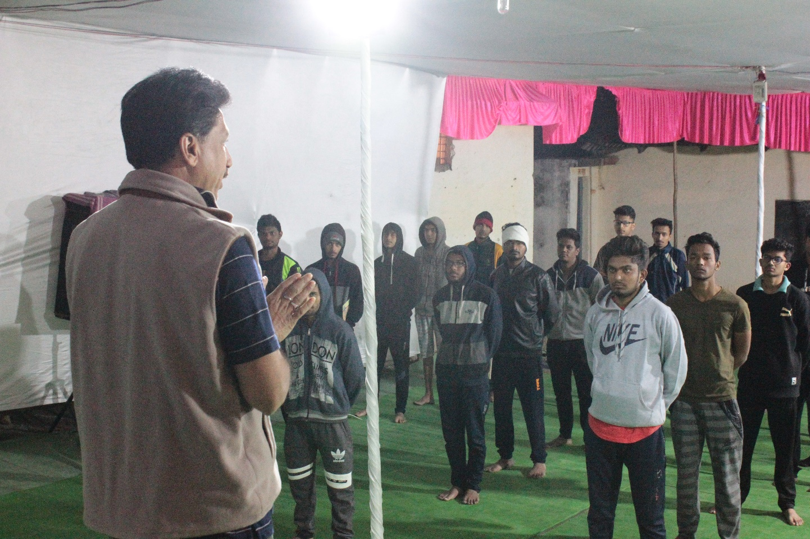
Yoga Instructor and NSS programme Officer instructing students

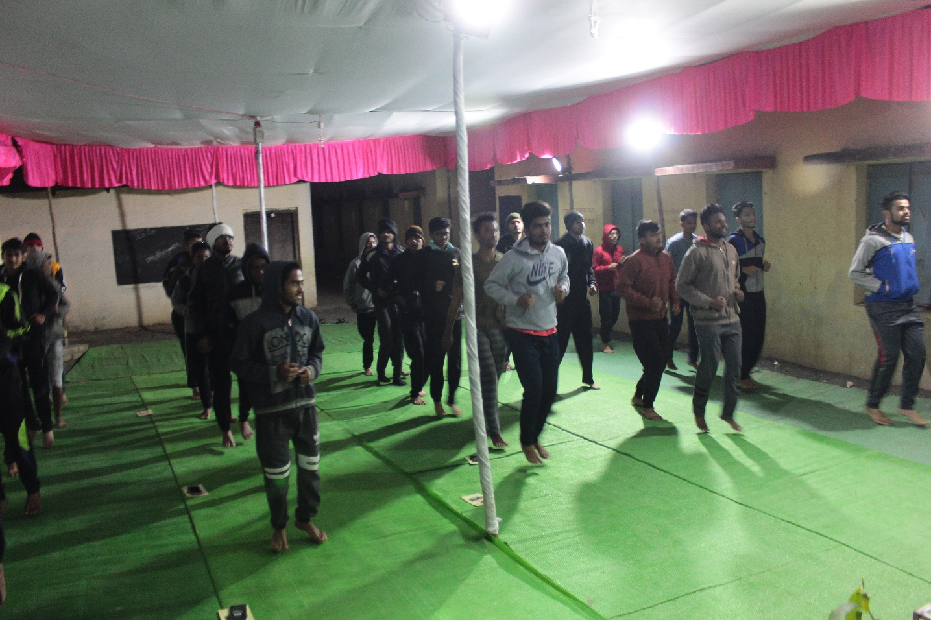

Students warming up before Yoga exercise

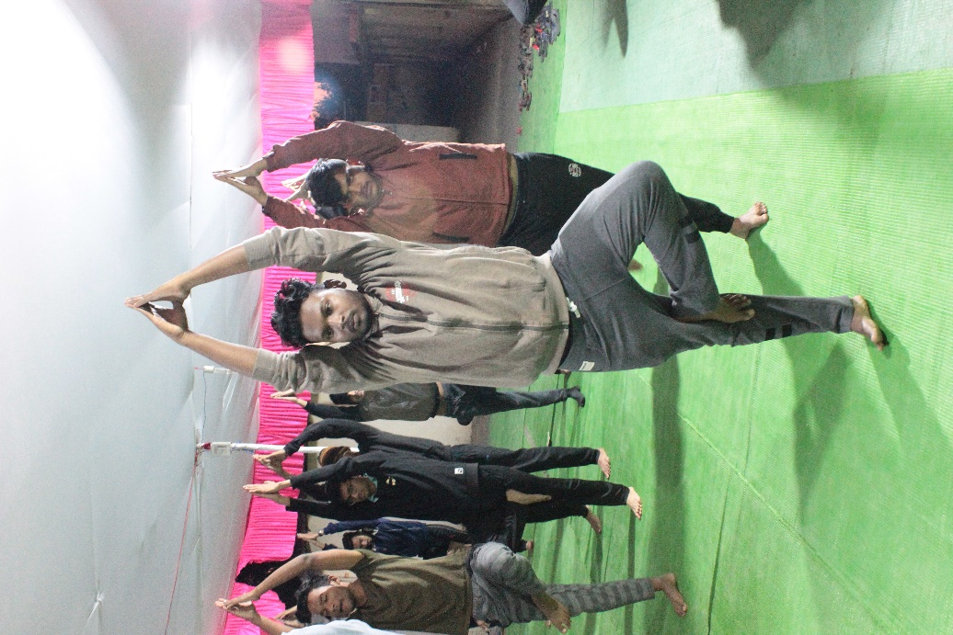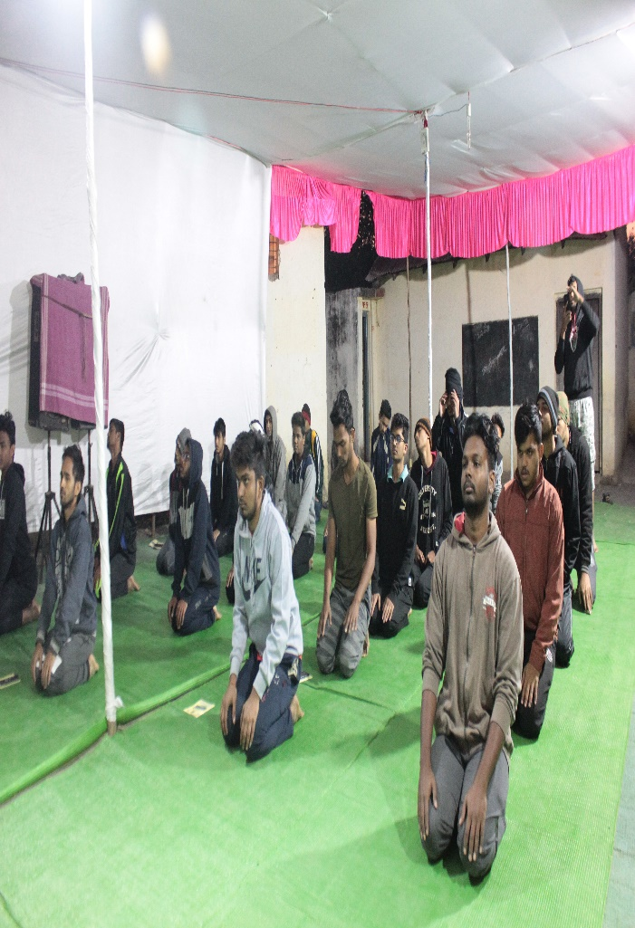
Students performing Aasanas

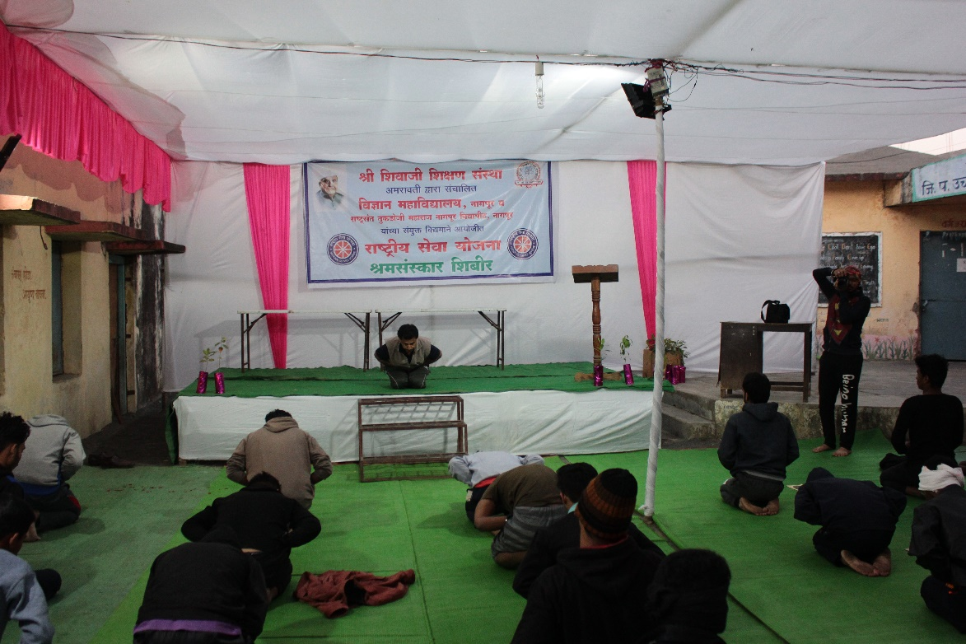
Yoga Instructor performing Asanas with Students

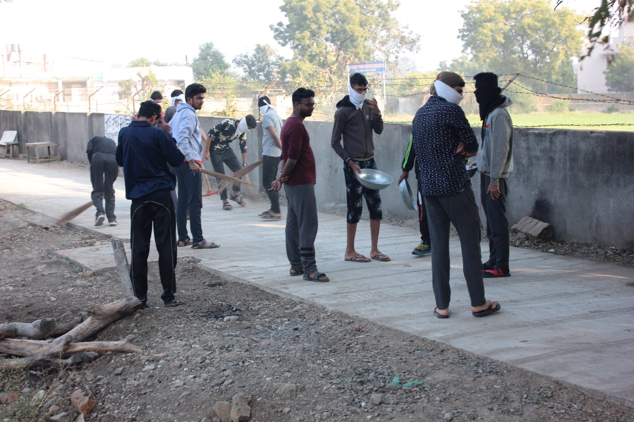
Students cleaning the campus

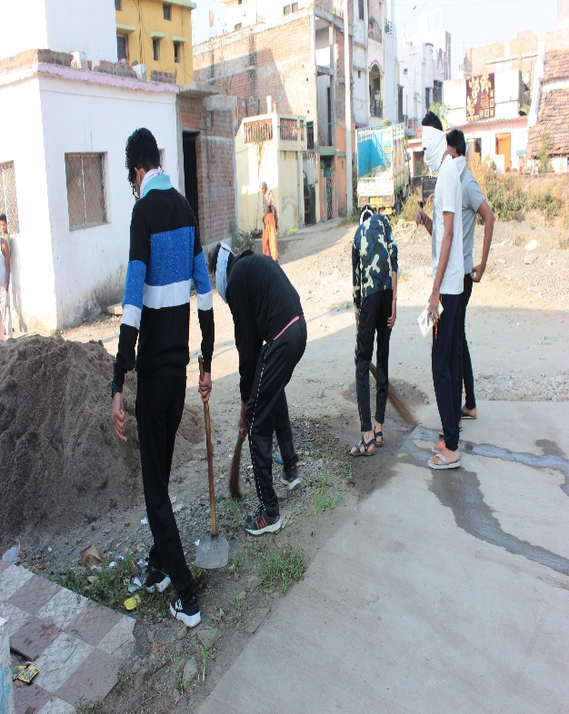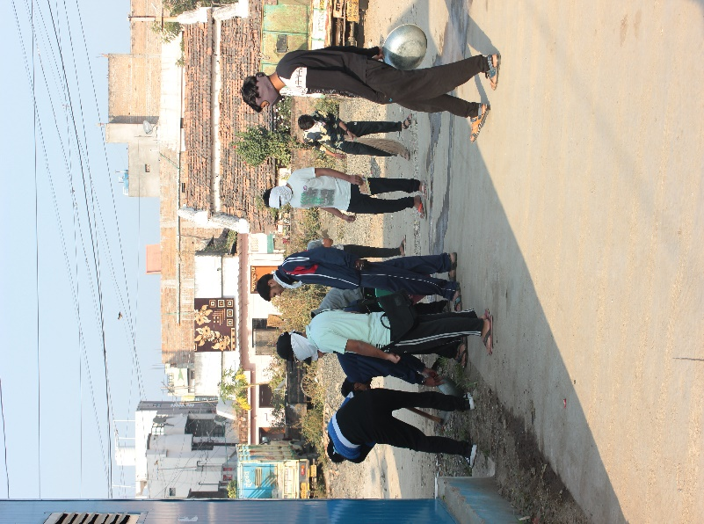
Students cleaning the campus

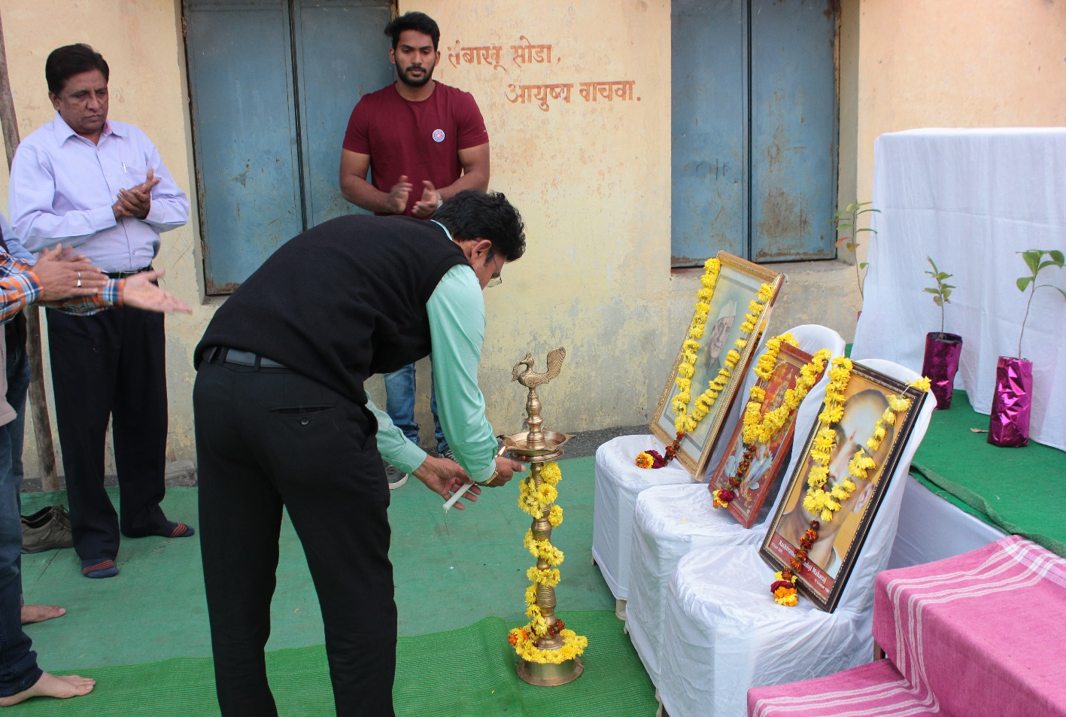
Inauguration of NSS Camp (Day 2) at the hands of Dr. Nitin Dongarwar , Associate Professor, RTMNU, Nagpur

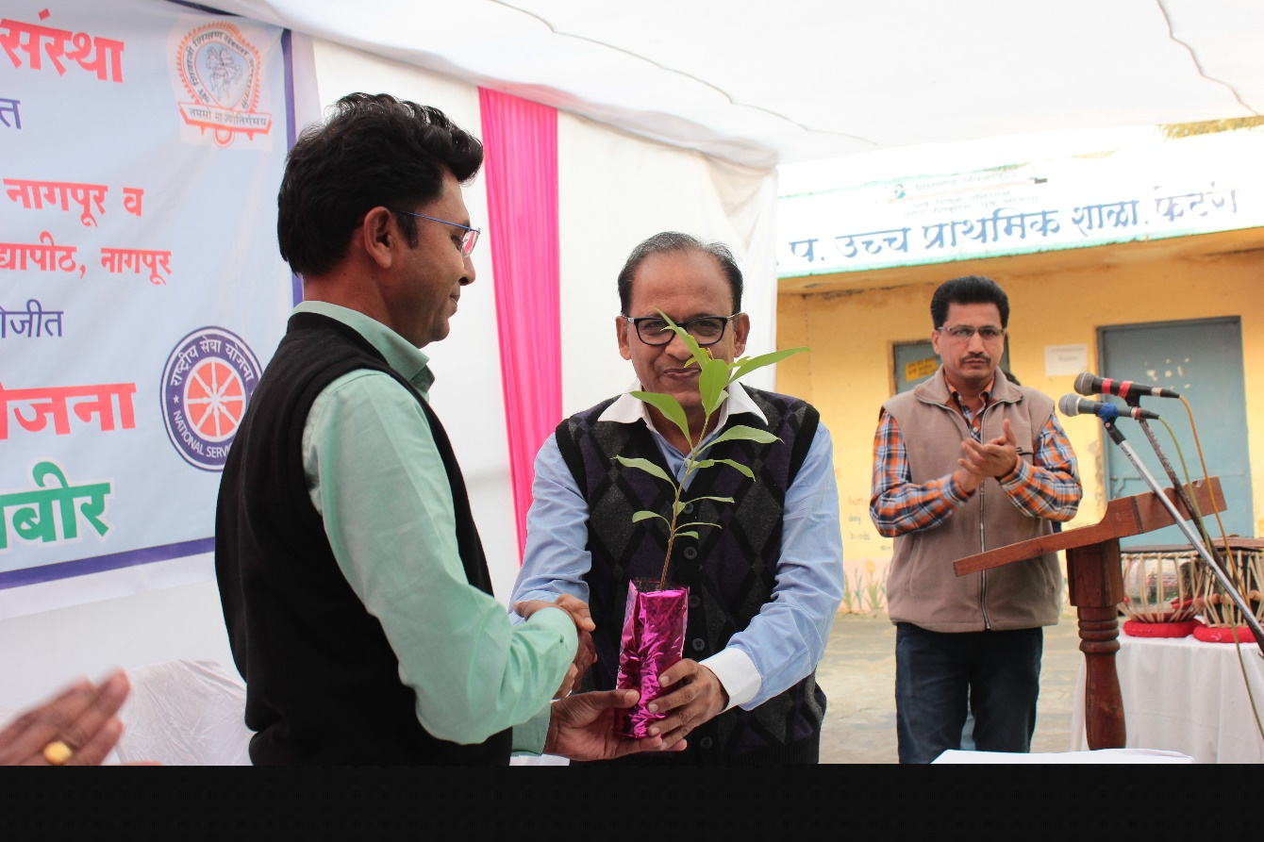
Dr. R. N. Deshmukh , Head of Botany Dept., Science College welcomes Dr. Nitin Dongarwar, Associate Professor, RTMNU, Nagpur
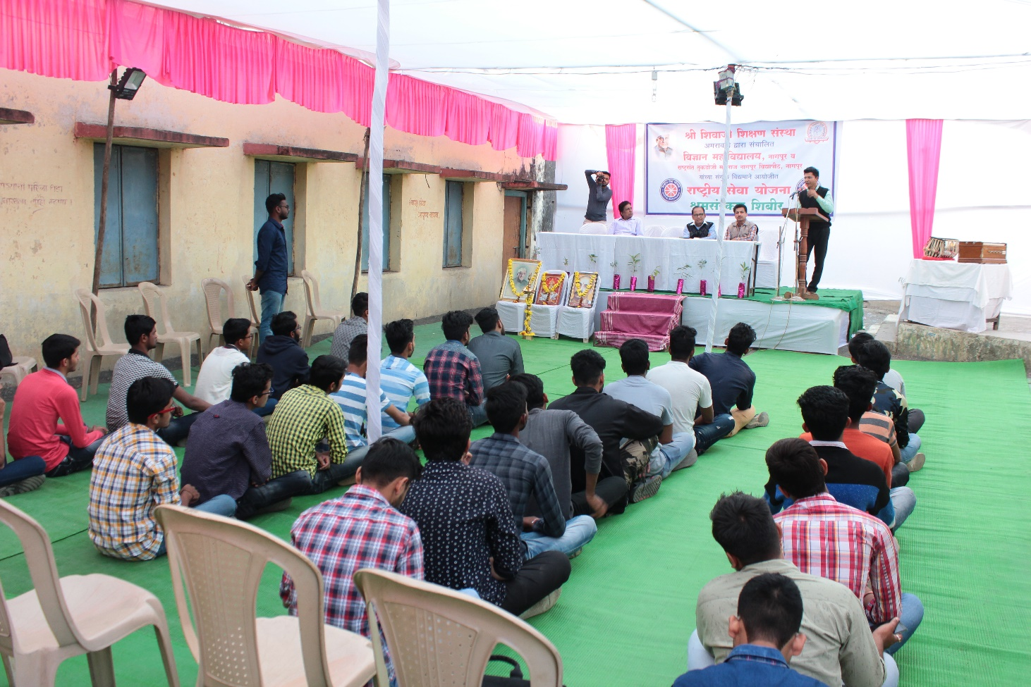

Dr. Nitin Dongarwar , Associate Professor, RTMNU, Nagpur addressing the students

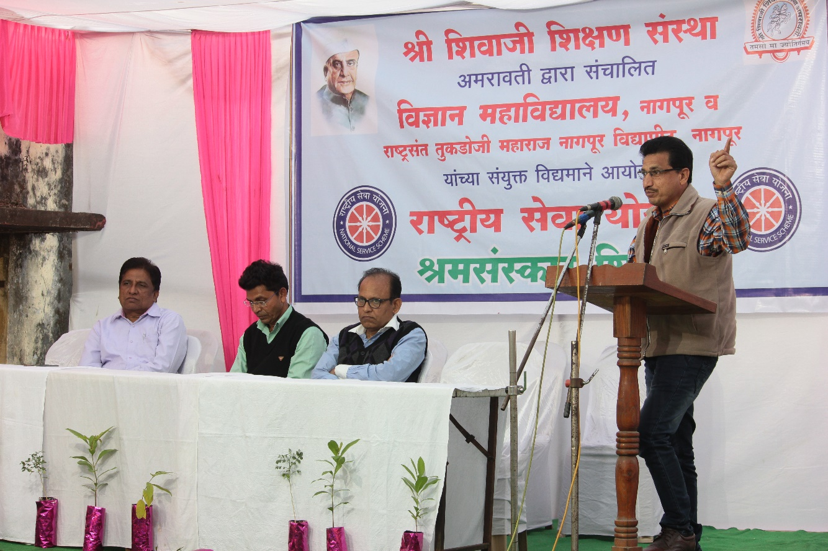
NSS Programme Officer addressing students

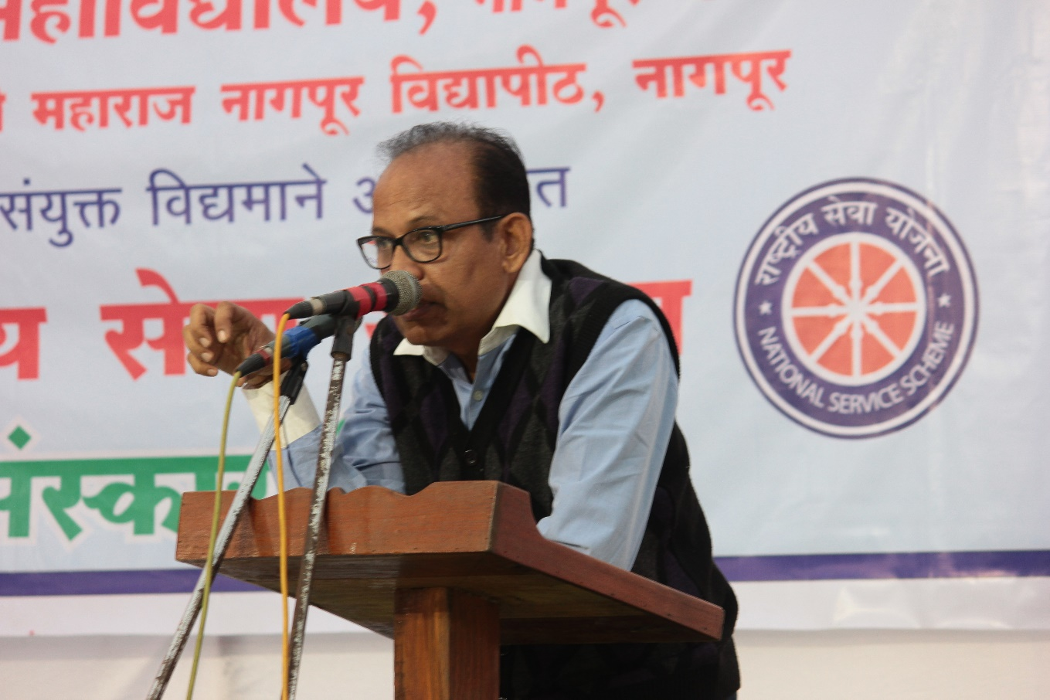
Dr. R. N. Deshmukh, Head of Botany Dept., Science College addressing NSS volunteers

Day 3: Thursday, 10 Jan 2019

Monitored by: Name(s) and position:

- Dr. S.W. Anwane (Head of Physics Dept.)
- Dr. S.S. Darokar (Associate Professor, Physics Dept.)

Points of Note:

All the students woke up at 6 am and did yoga and exercise after that we all have our healthy breakfast and then from 8 am to 11 am we have our cleanliness program where we cleaned the streets and some unclean spots inside the village. After that all the students had their lunch and some rest . At 2 pm there was a guest lecture on personality development by the Mr. Prabhu Shinde (Social worker) and shared his life experiences he told us how should person behave in society and respect for what he have . After that there was cultural program and then all the guest and students had dinner.

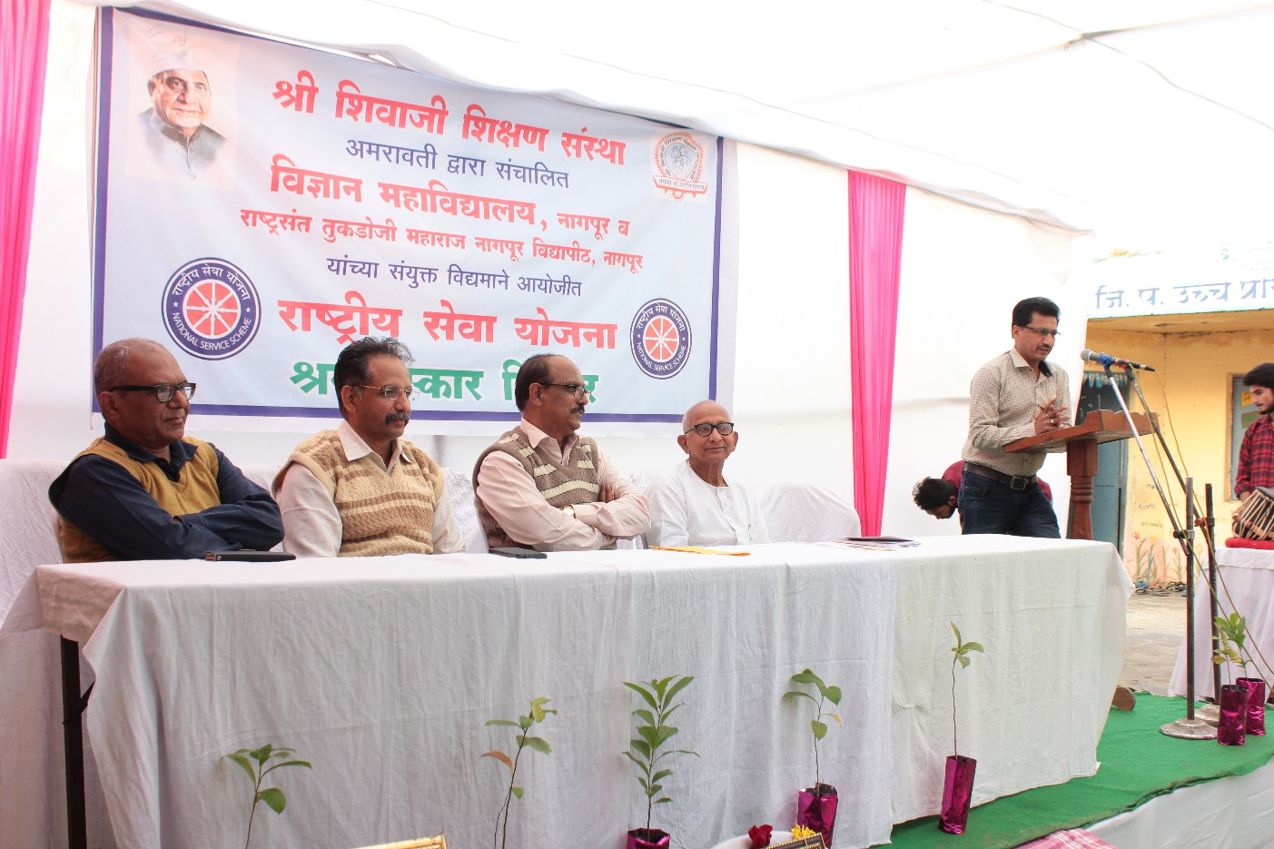

Inaugural Function (Day 3) of NSS Camp in the presence of Dr. S.W. Anwane (Head of Physics Dept.),
Dr. S.S. Darokar (Associate Professor, Physics Dept.) and Mr. Prabhu Shinde

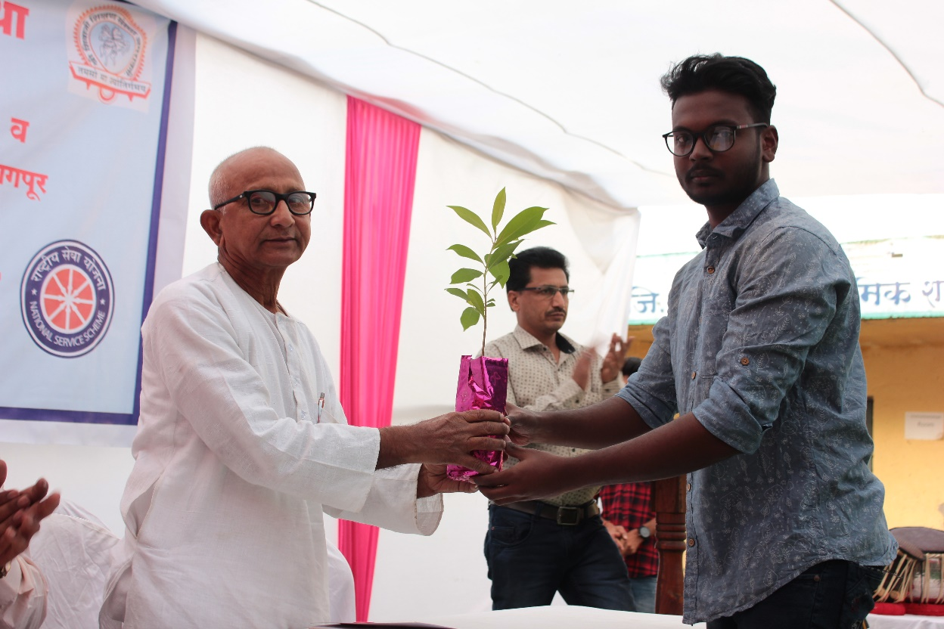

NSS Volunteer welcomes Guest Mr. Prabhu Shinde (Social worker) by presenting sapling
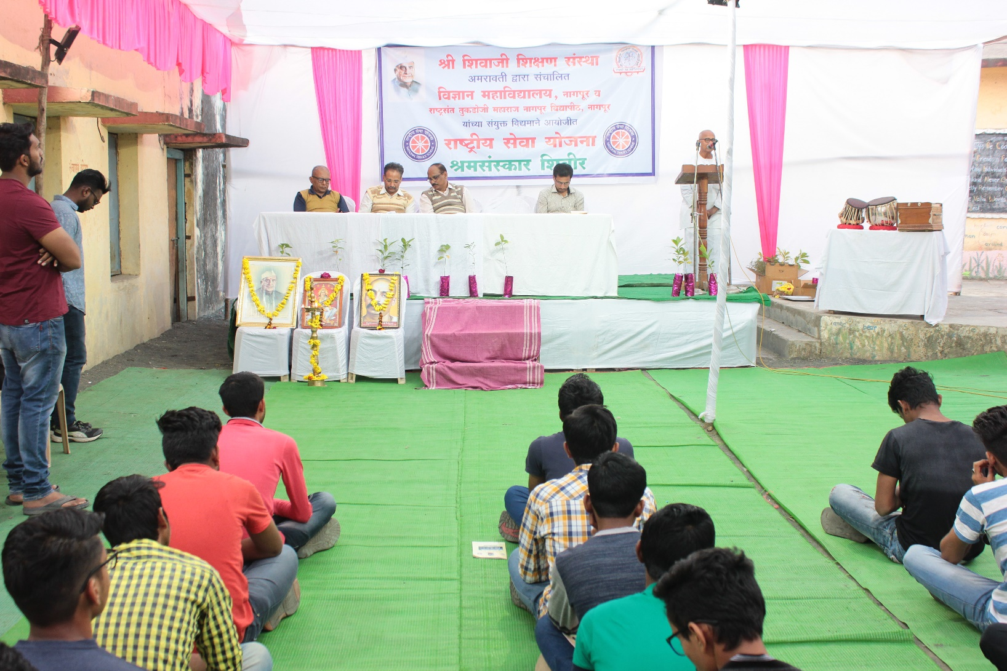
Mr. Prabhu Shinde (Social worker) addressing Students

Day 4: Friday, 11 Jan 2019

Monitored by: Name(s) and position:

1- Dr. S.R. Pande (Head of CS Dept.)
2- Dr. A. A. Haldar (Associate Professor, CS Dept.)

Points of Note:

The day started at 6 am by yoga and exercises after that all had a good and heavy breakfast. Then from 8 am to 11 am we cleaned all the campus. And then we had our lunch ad rest after that we had a guest lecture on "Ethical Hacking" by Mr. Krishna Karu who told us about how ethical hackers do their work and what scope are there in this field and thus helping Government and people. After that we enjoyed the cultural event organized by the candidates itself and then we had dinner.

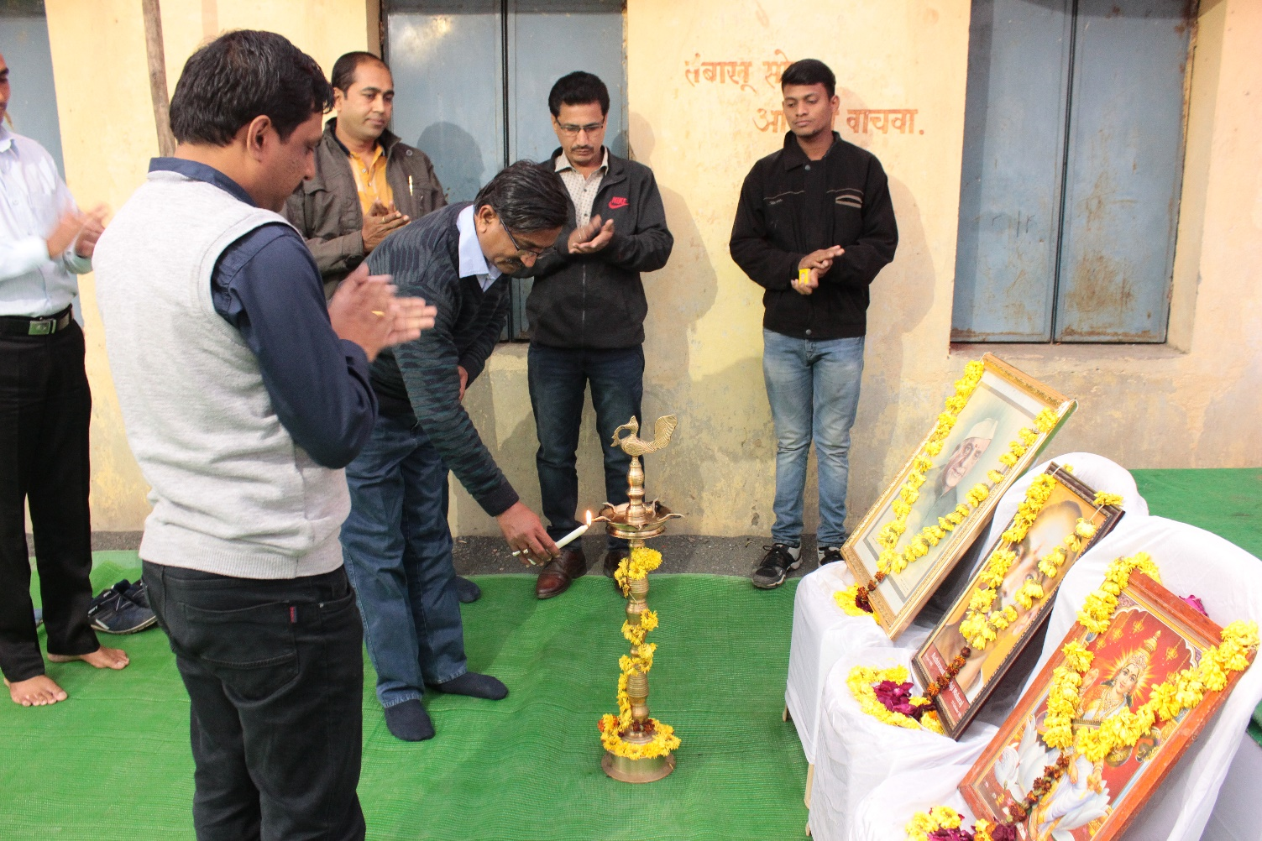

Inaugural NSS Camp (day 3) in the presence of Dr. S.R. Pande (Head of CS Dept.), Dr. A. A. Haldar (Associate Professor, CS Dept.) , Guest Speaker Mr. Krishna Karu and NSS programme officer

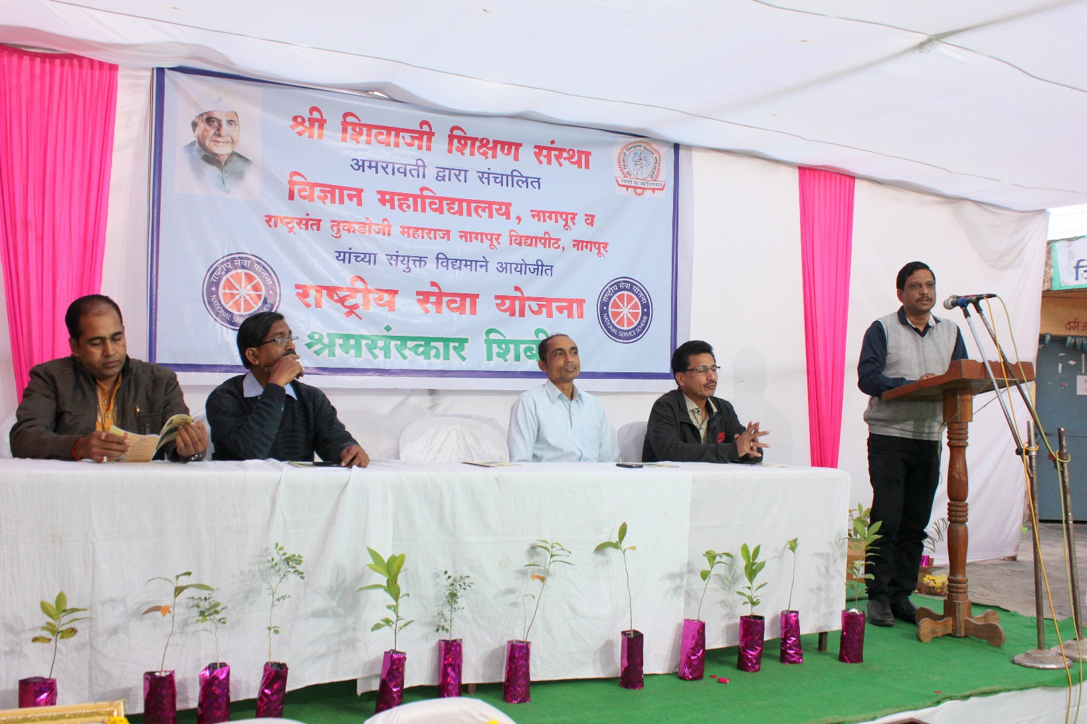

Guest lecture on "Ethical Hacking" by Mr. Krishna Karu

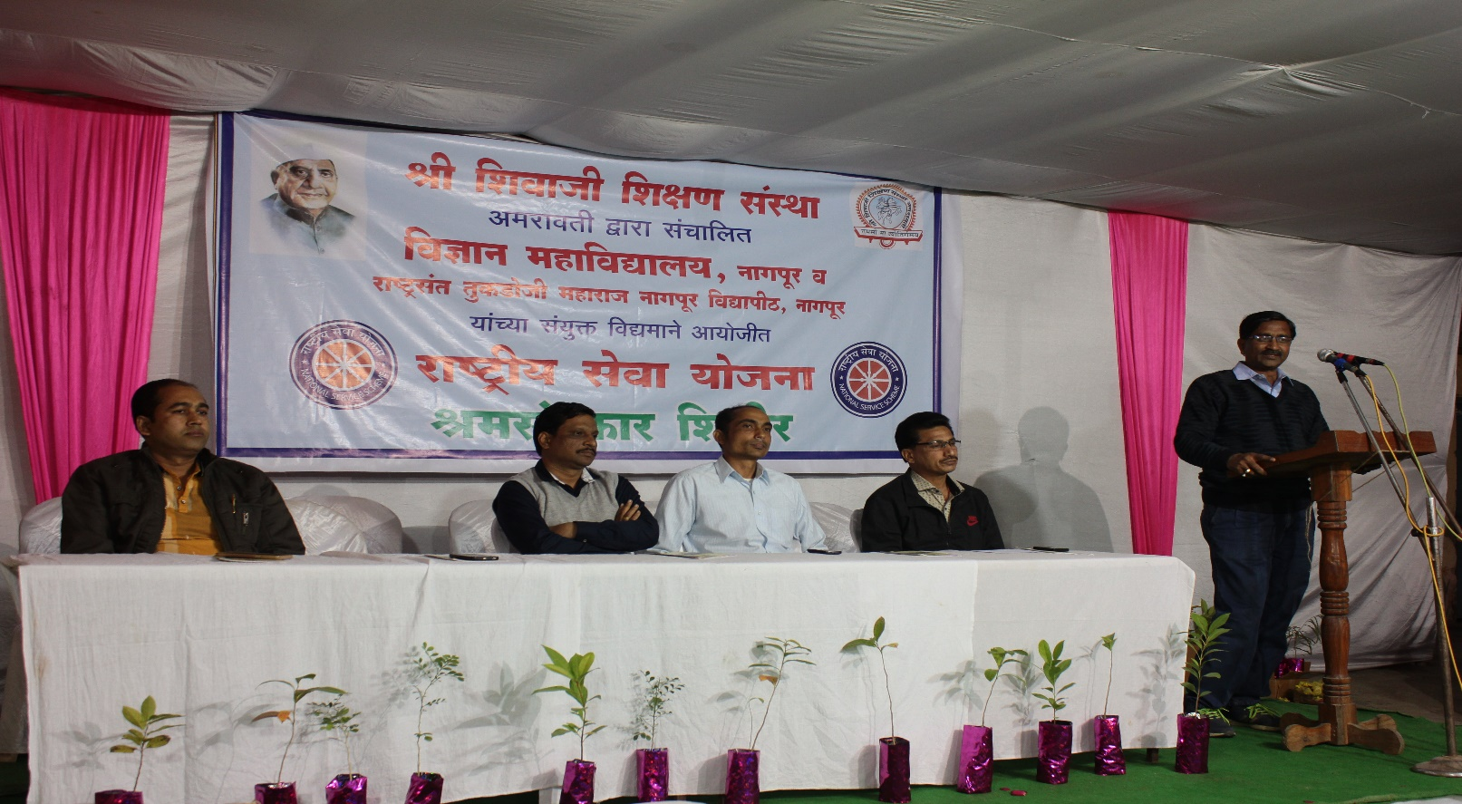

Dr. S.R. Pande (Head of CS Dept.) addressing Students
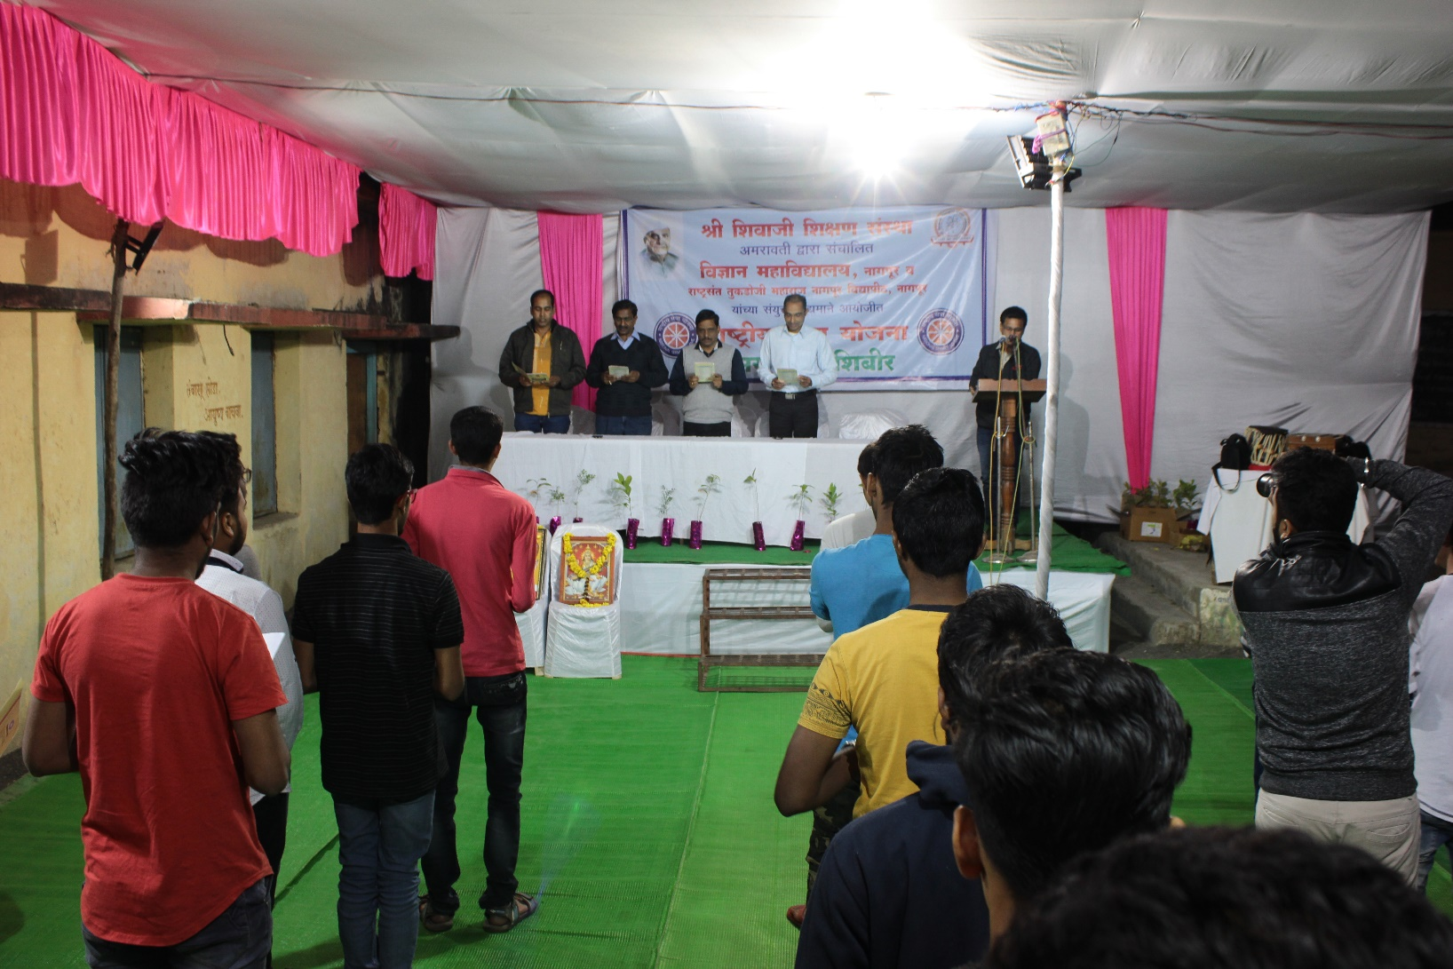

Students taking the oath

Day 5: Saturday, 12 Jan 2019

Monitored by: Name(s) and position:

- Dr. A.D. Bobde (Head of Zoology Dept.)
- Dr. V.A. Dakhole (Head of Library Dept.)

Points of Note:

Our day starts with the yoga and then breakfast after that we all visited the farm where we constructed a small Canal Wall of rocks and sand. Then there was the cultural event where all the village people were invited to enjoy the show. The event was a great success. After that we had our dinner.

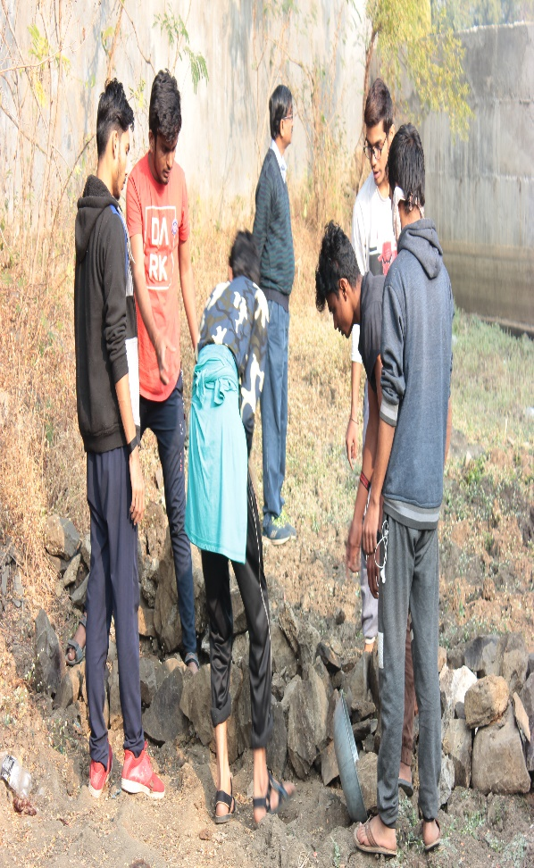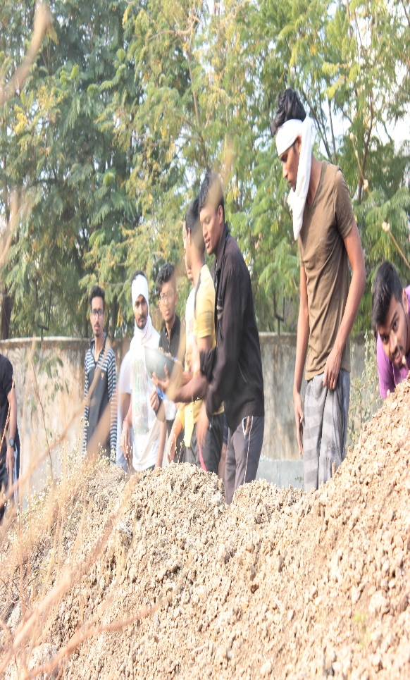

Students collecting rocks and sand

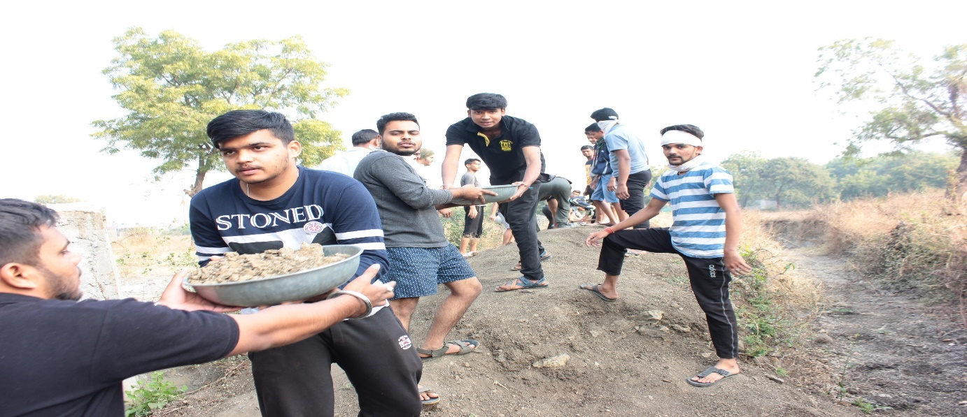
Students constructing canal

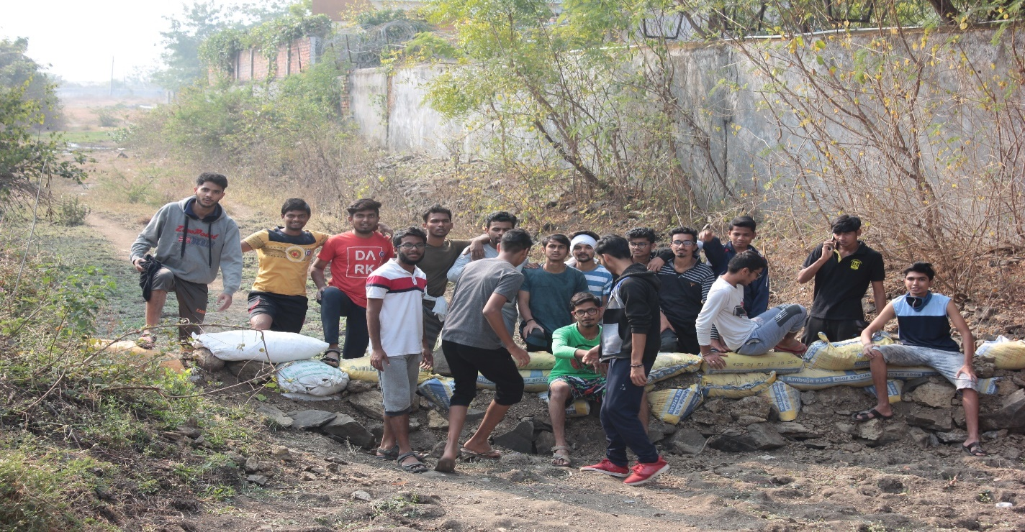
Students with constructed canal

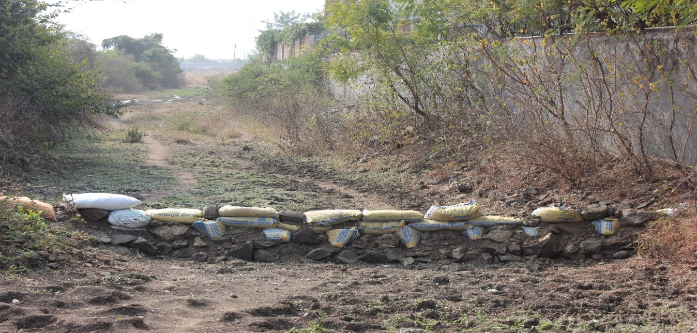
Canal constructed by NSS volunteers

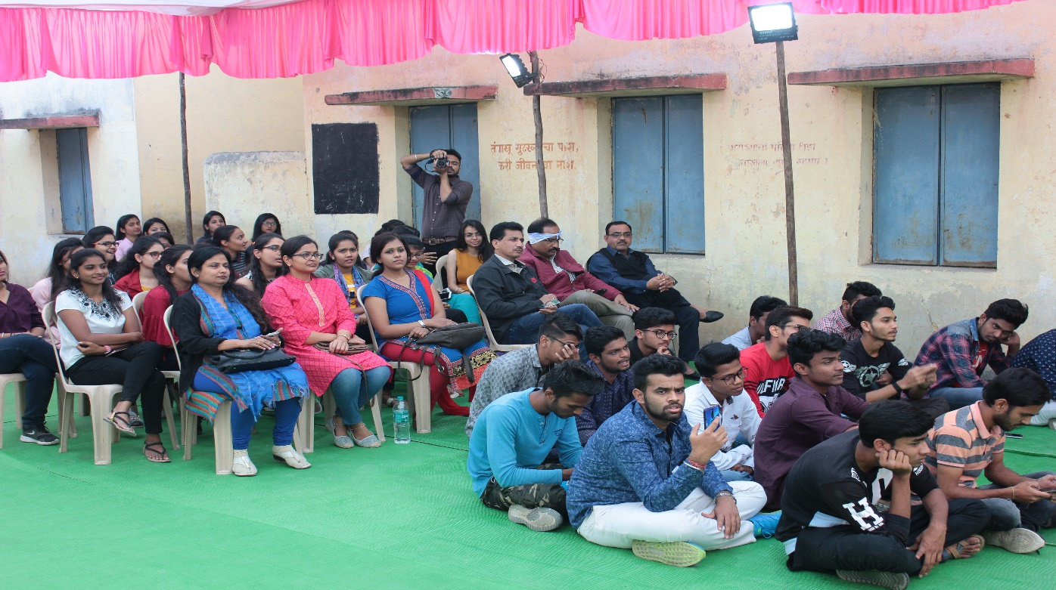
Students and Faculty watching the cultural event

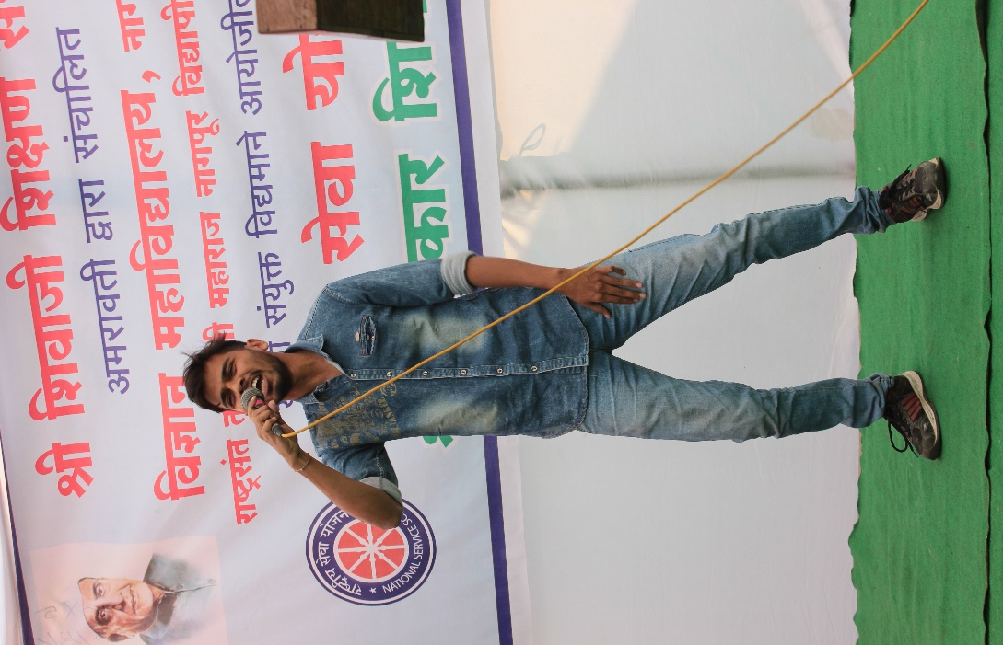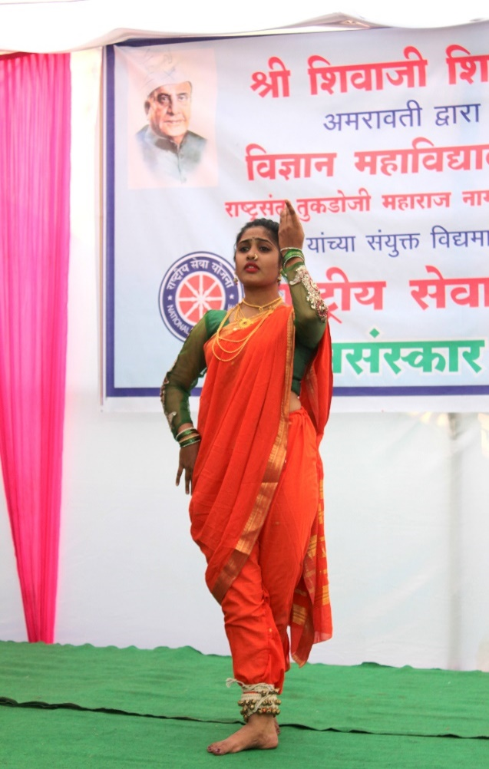

NSS volunteer performing in the cultural event

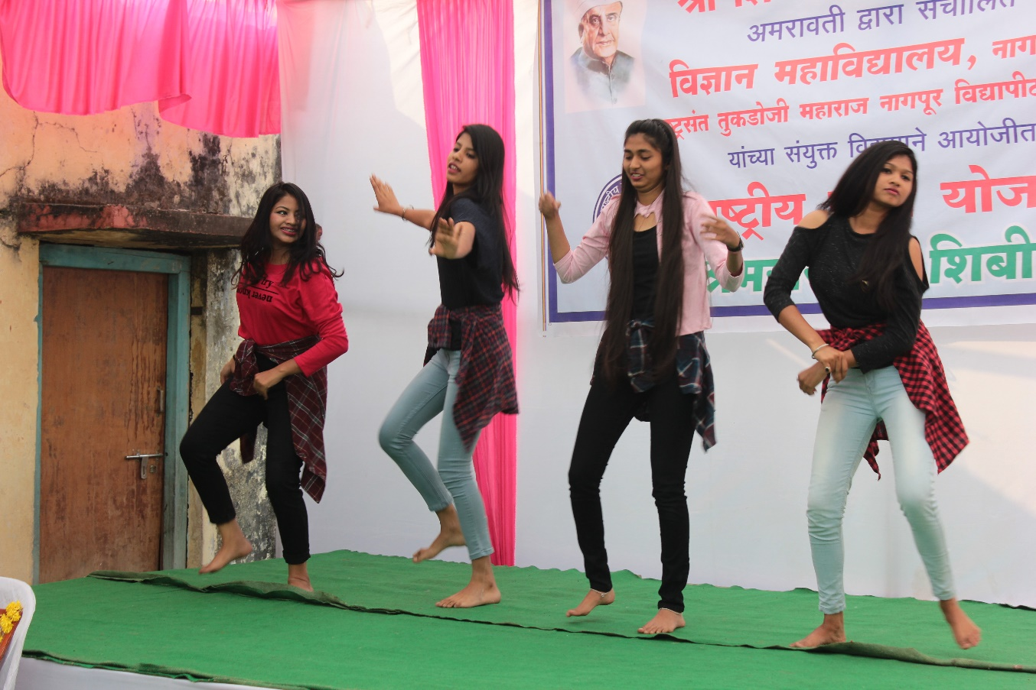
NSS volunteer performing in the cultural event

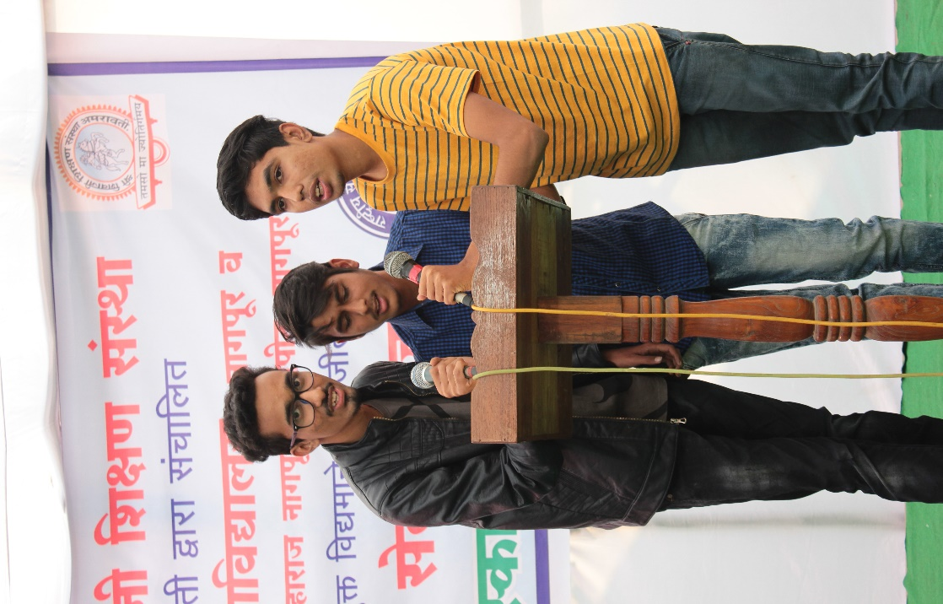
NSS volunteer performing in the cultural event

Day 6 : Sunday, 13 Jan 2019

Monitored by: Name(s) and position:

- Mr. Hemant Kalmedh (Shivaji Education Society Member)
- Dr. D. W. Deshkar (Head of Electronics Dept.)
- Dr. M.J. Hedau (Associate Professor, Electronics Dept.)

Points of Note:

It was the last day of our camp which started with doing yoga and the breakfast. Then the principal of our Shivaji Science College and all the guests concluded the NSS Camp by appreciating the hard work did by all the students and by giving the best volunteer and the all rounder awards to the candidates.

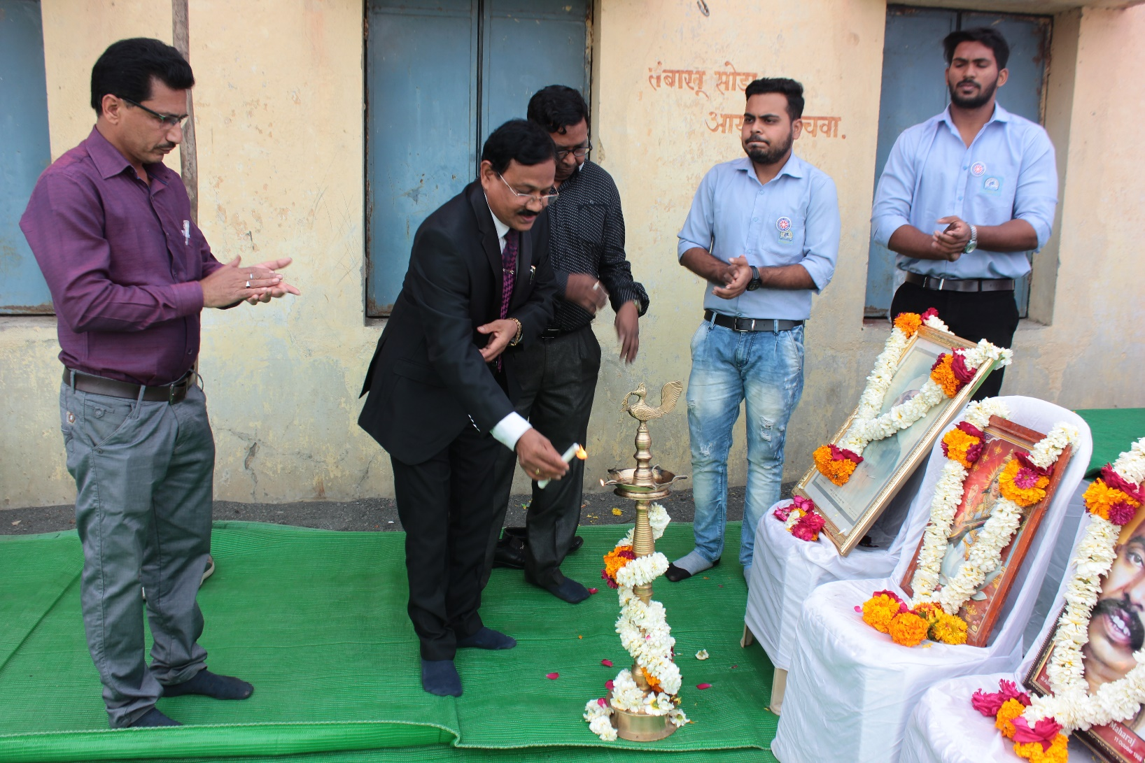
Lamp lightening at the hands of Dr. C.J. Chandekar ,Principal, Science College, Dr. M.J. Hedau (Associate Professor, Electronics Dept.) and NSS Programme officer

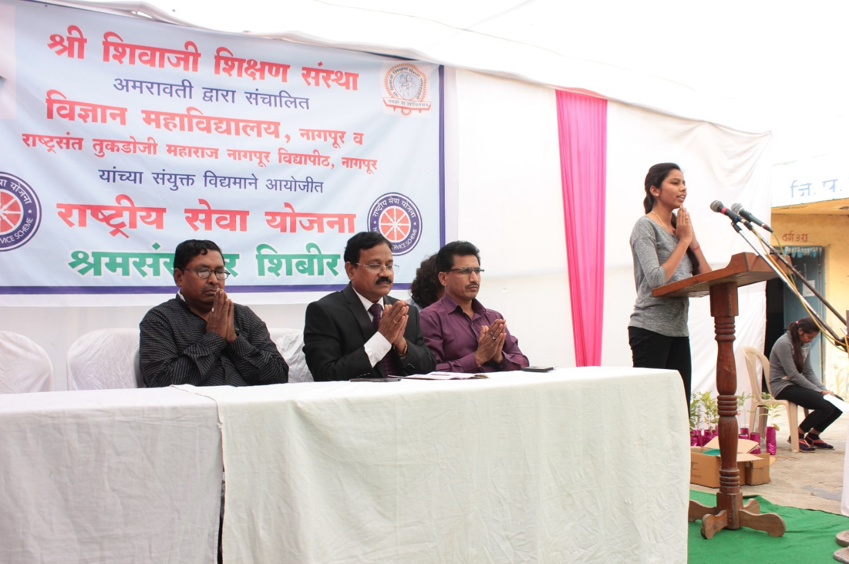

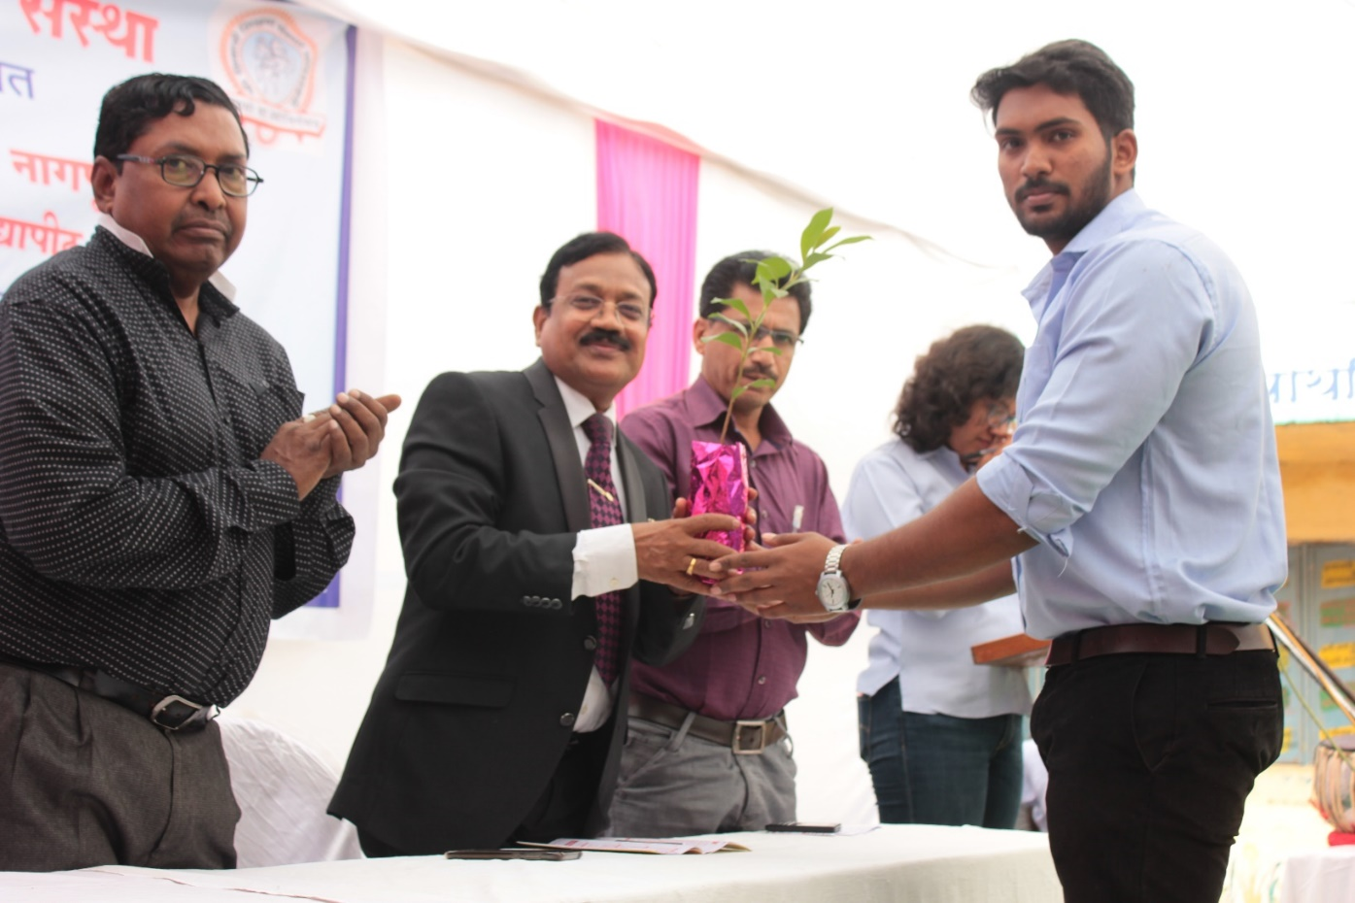
NSS volunteer welcoming Principal by offering a sapling

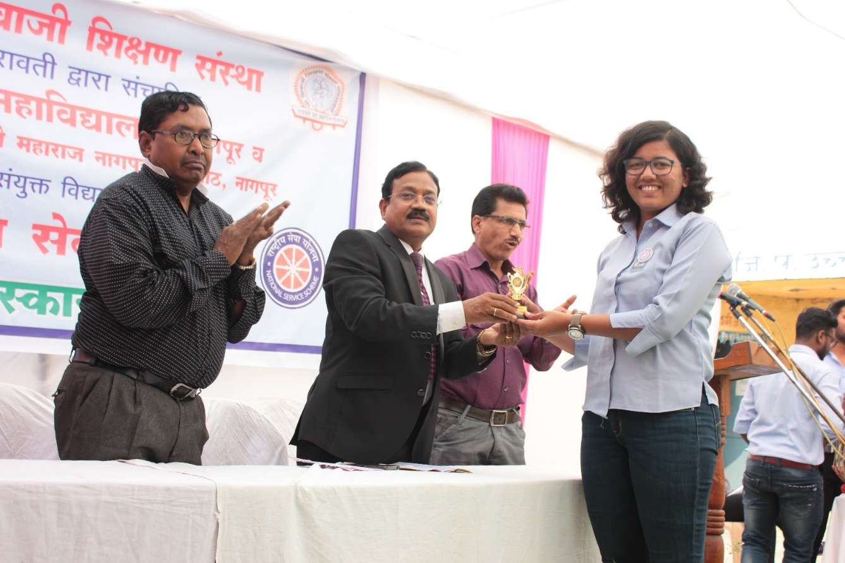
Principal distributing trophy to NSS volunteer

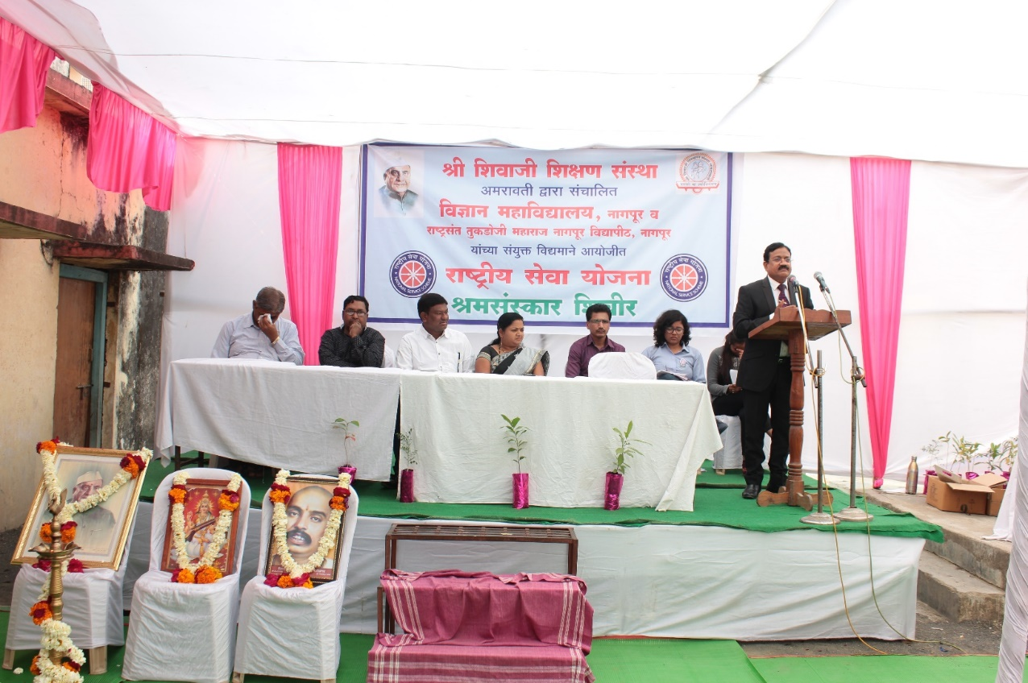
Dr. C.J. Chandekar , Principal, Science College addressing the gathering

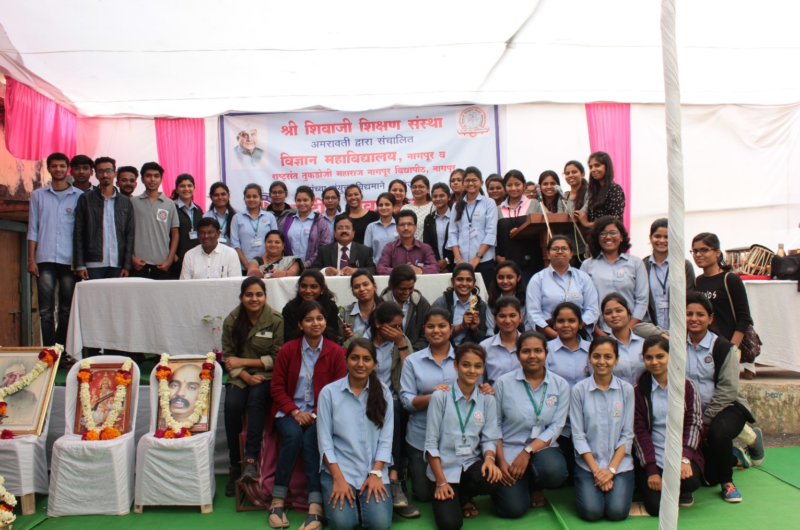

All NSS volunteers with Dr. C. J. Chandekar , Principal, Science College , Mrs. Dhanashri M. Dhomne (Sarpanch, Fetri Gram panchayat), Dr. P. S. Utale, NSS Programme Officer on 13 Jan 2019

