International Yoga Day Celebrated In Shri Shivaji Science College, Congress Nagar, Nagpur

Yoga is physical, mental and spiritual practice originated in India. International day of yoga commonly referred as YOGA DAY is celebrated annually on 21st June, since it’s inception in 2015.
Every year International Day of Yoga celebrated in Shri Shivaji Science College, Congress Nagar, Nagpur. This year also YOGA DAY was celebrated on 21st June 2019 to raise awareness among people about the benefits of yoga in daily life. Total 40 teaching and non-teaching staff members were present on the occasion.
Yoga exercises were demonstrated by Dr. S. R. Pande and Dr. P. S. Utale. All present staff members had performed the yoga.
Dr. M. P. Dhore, Principal of Shri Shivaji Science College, narrated the importance of yoga. He stated that yoga brings balance between the body, soul and mind. It helps us to understand the purpose of life and how to survive in the changing environment.
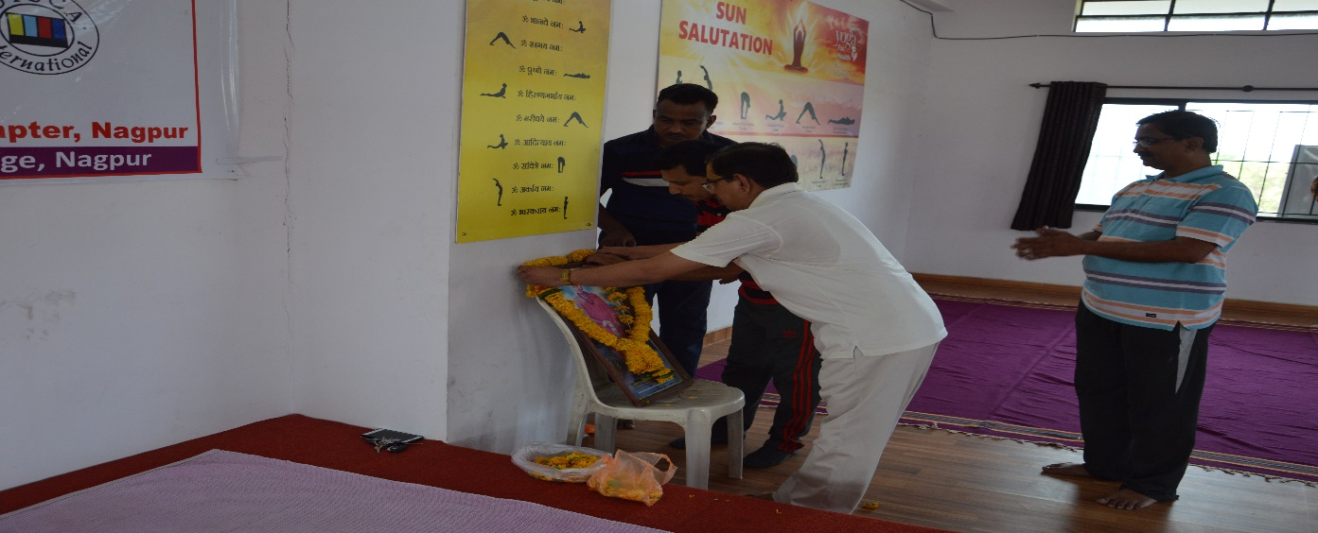
Prof M.P. Dhore , Principal paying floral tribute to the portrait of Yog Guru Janardan Swami

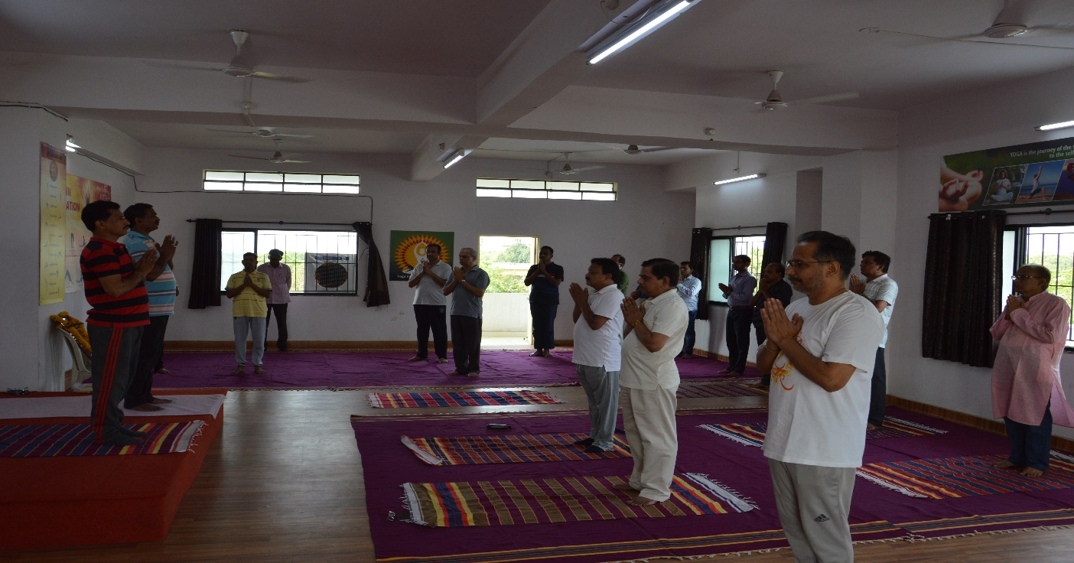
Faculties relaxing before performing yoga
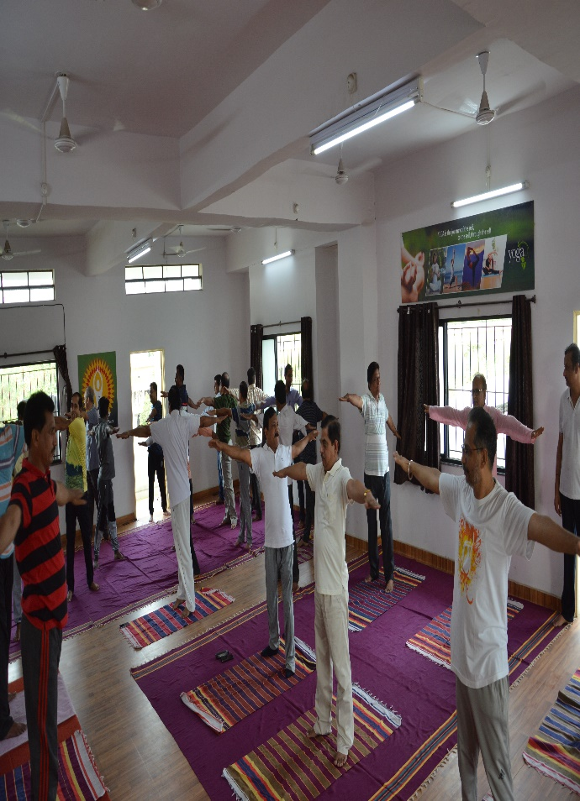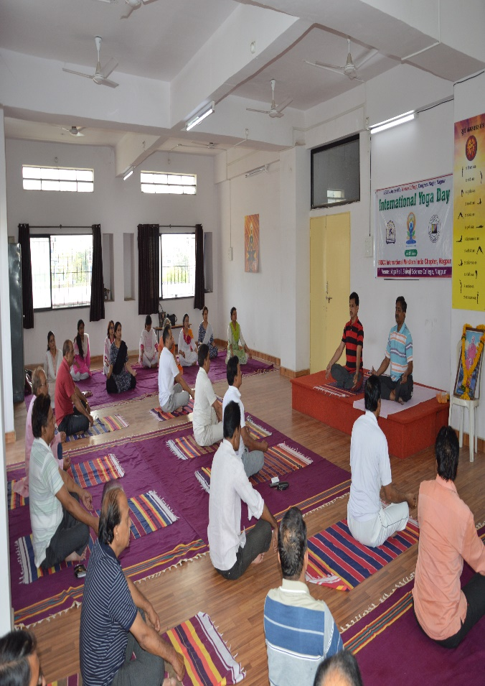
Faculties performing yoga

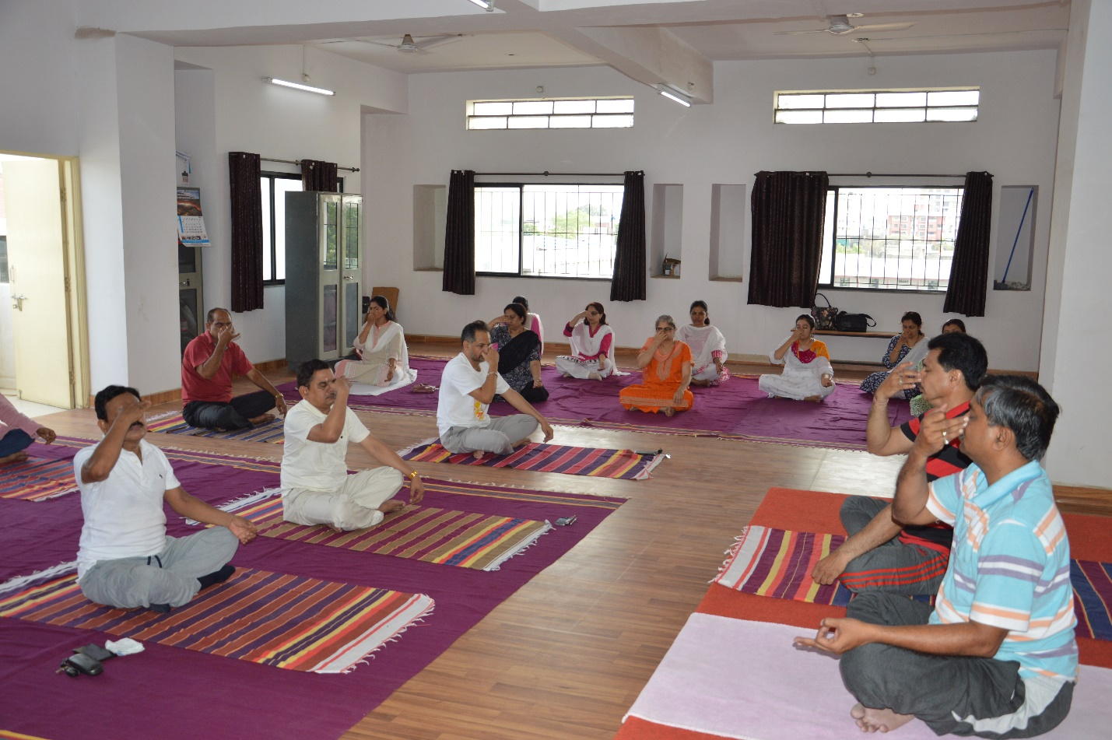
Faculties performing yoga

