Session 2020-2021
Constitution Day
26th November 2020
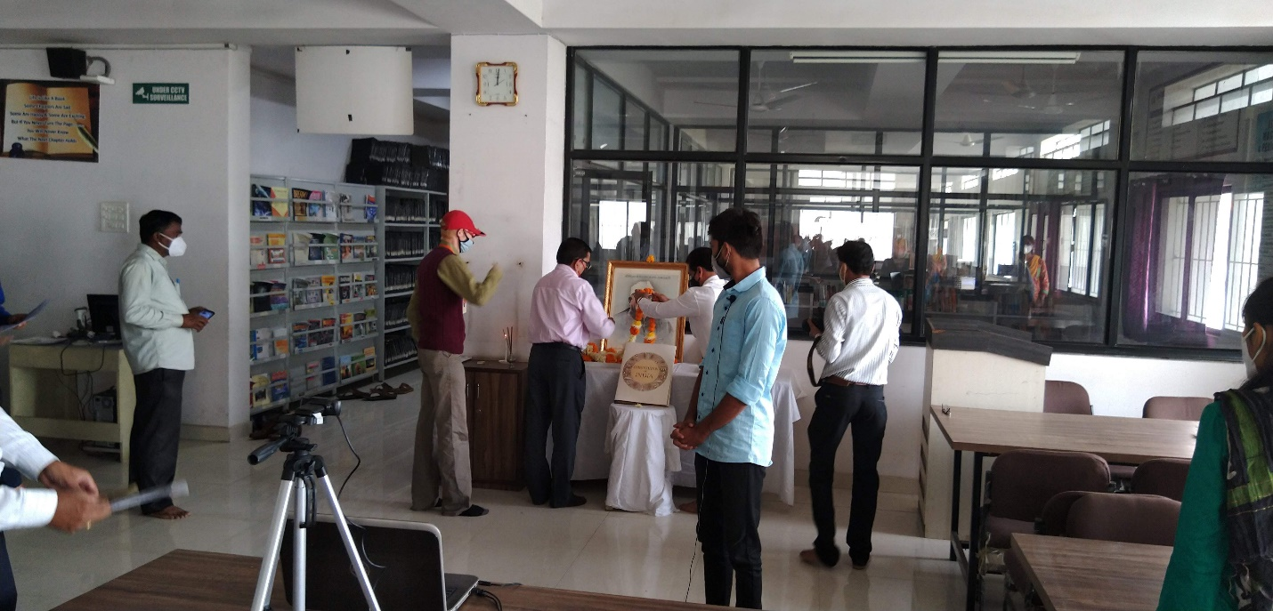
Prof M. P. Dhore, Principal and Dr. P. S. Utale , NSS Program Officer paying floral tribute to the portrait of Dr. Panjabrao Deshmukh and Dr. B. R. Ambedkar
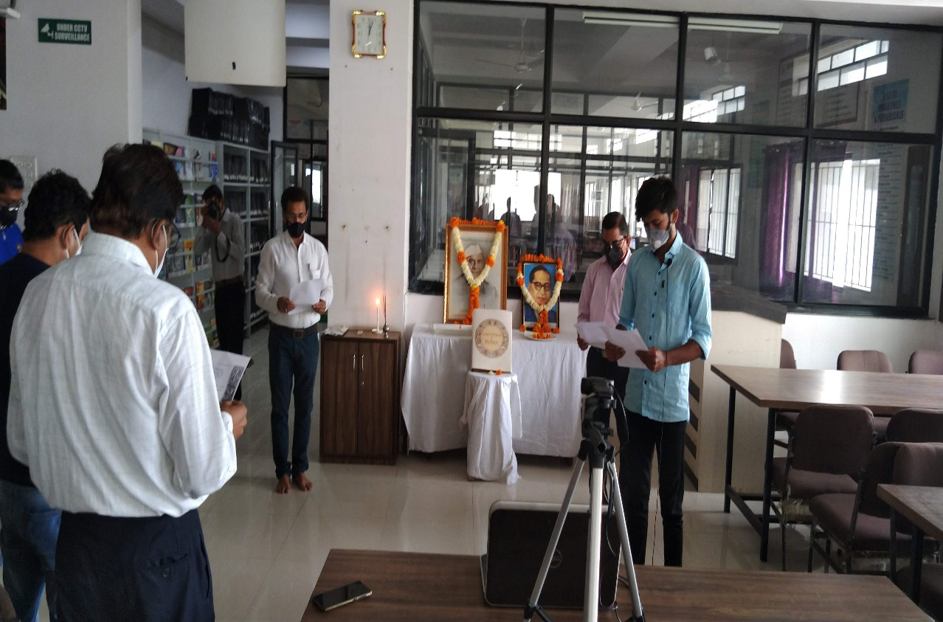
Prof M. P. Dhore, Principal , Dr. P. S. Utale , NSS Program Officer , Faculty members and NSS volunteer reading preamble of the constitution

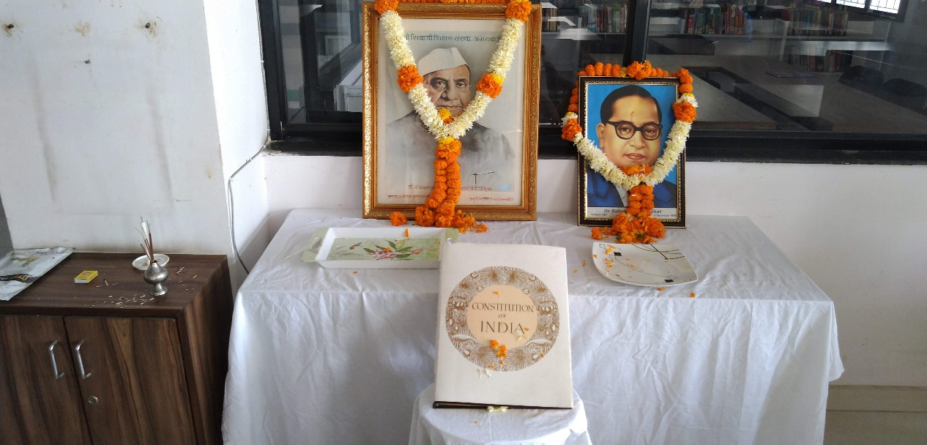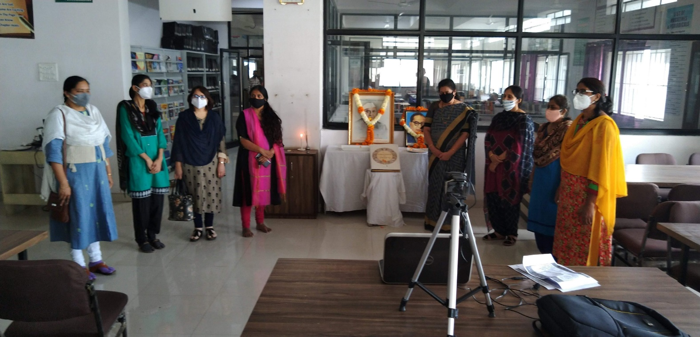
Ladies Faculty members on the Constitution Day
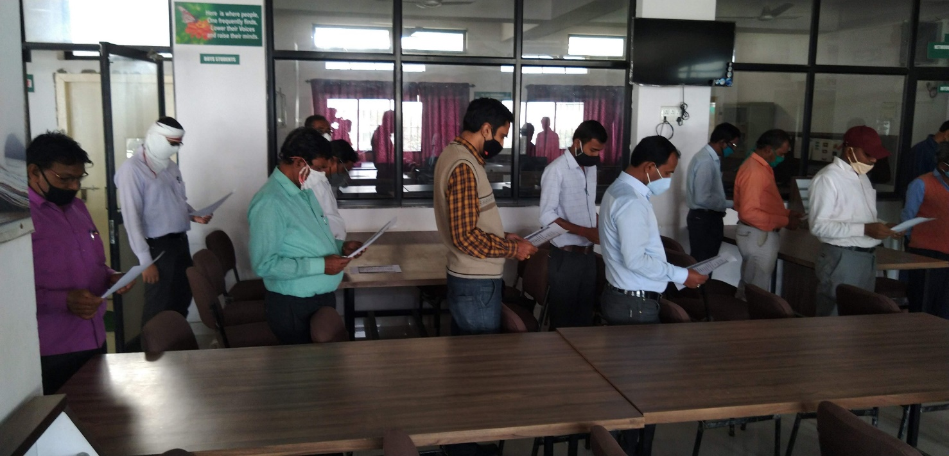
Staff members reading the preamble of the constitution

