Shri Shivaji Education Society Amravati’s
SCIENCE COLLEGE, Congress Nagar, Nagpur
Workshop Organized
On
Plant Tissue Culture Techniques
2022-23
----------------------------------------------------------------------------------------------
A training program on Plant Tissue Culture Techniques was organize for the students of B.Sc. sem V and VI students by Department of Botany, SSES Amravati’s Science College, Congress Nagar. Work shop was conducted by Prof. Punita Tiwari, professor, Dept. of Botany. 3 to 15 days workshop included general introduction, Media preparation, sterilization technique, Explant preparation, Inoculation technique, incubation and observation. Observation of different stages viz: callus formation, shooting and rooting, multiple shoot formation, regenerative callus, identification.
30 students of botany dept. participated in the workshop. After completion of the workshop visit to MAHA Beej Biotec Lab and research laboratory, Nagpur was organized for the participants.

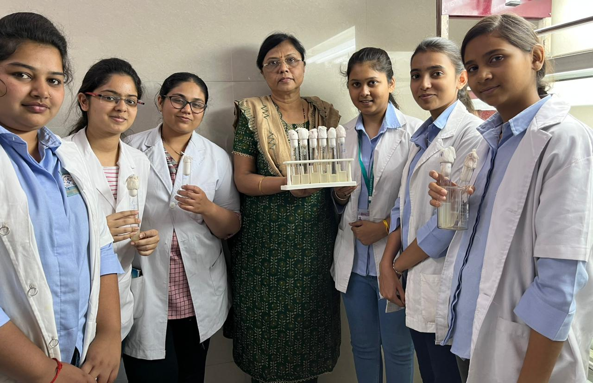
Convener & Trainer, PTC, Dr. P.S.Tiwari and Participants
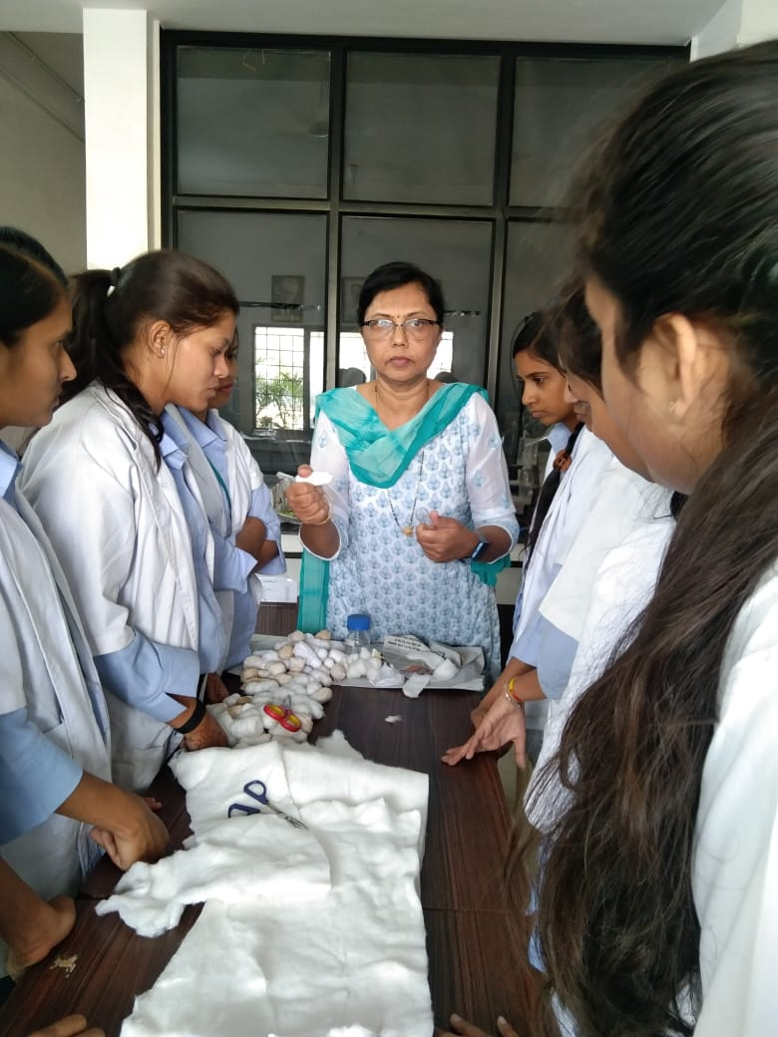
Plug preparation Explant preparation

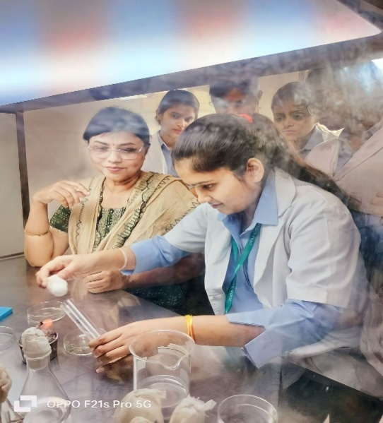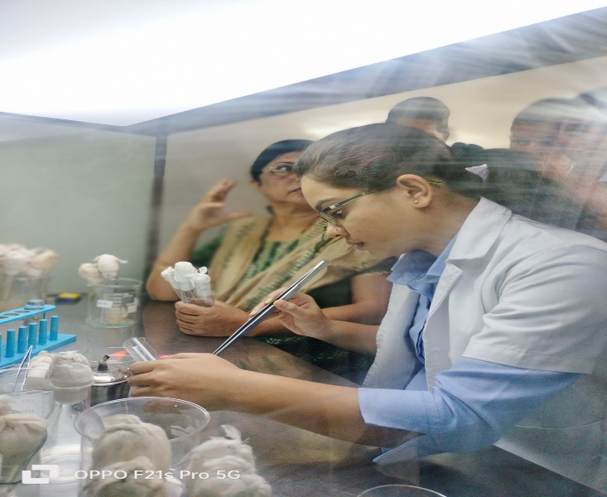
Inouculation

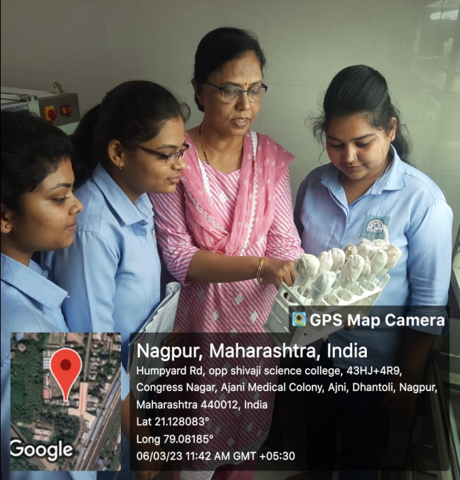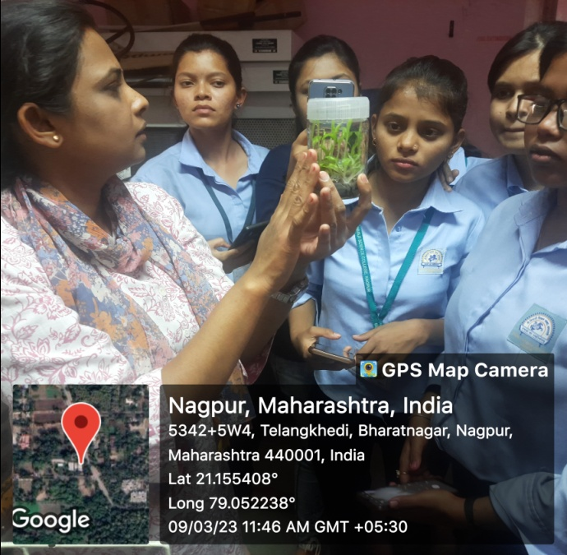
Incubation and Response Mahabeej scientist explaining the process

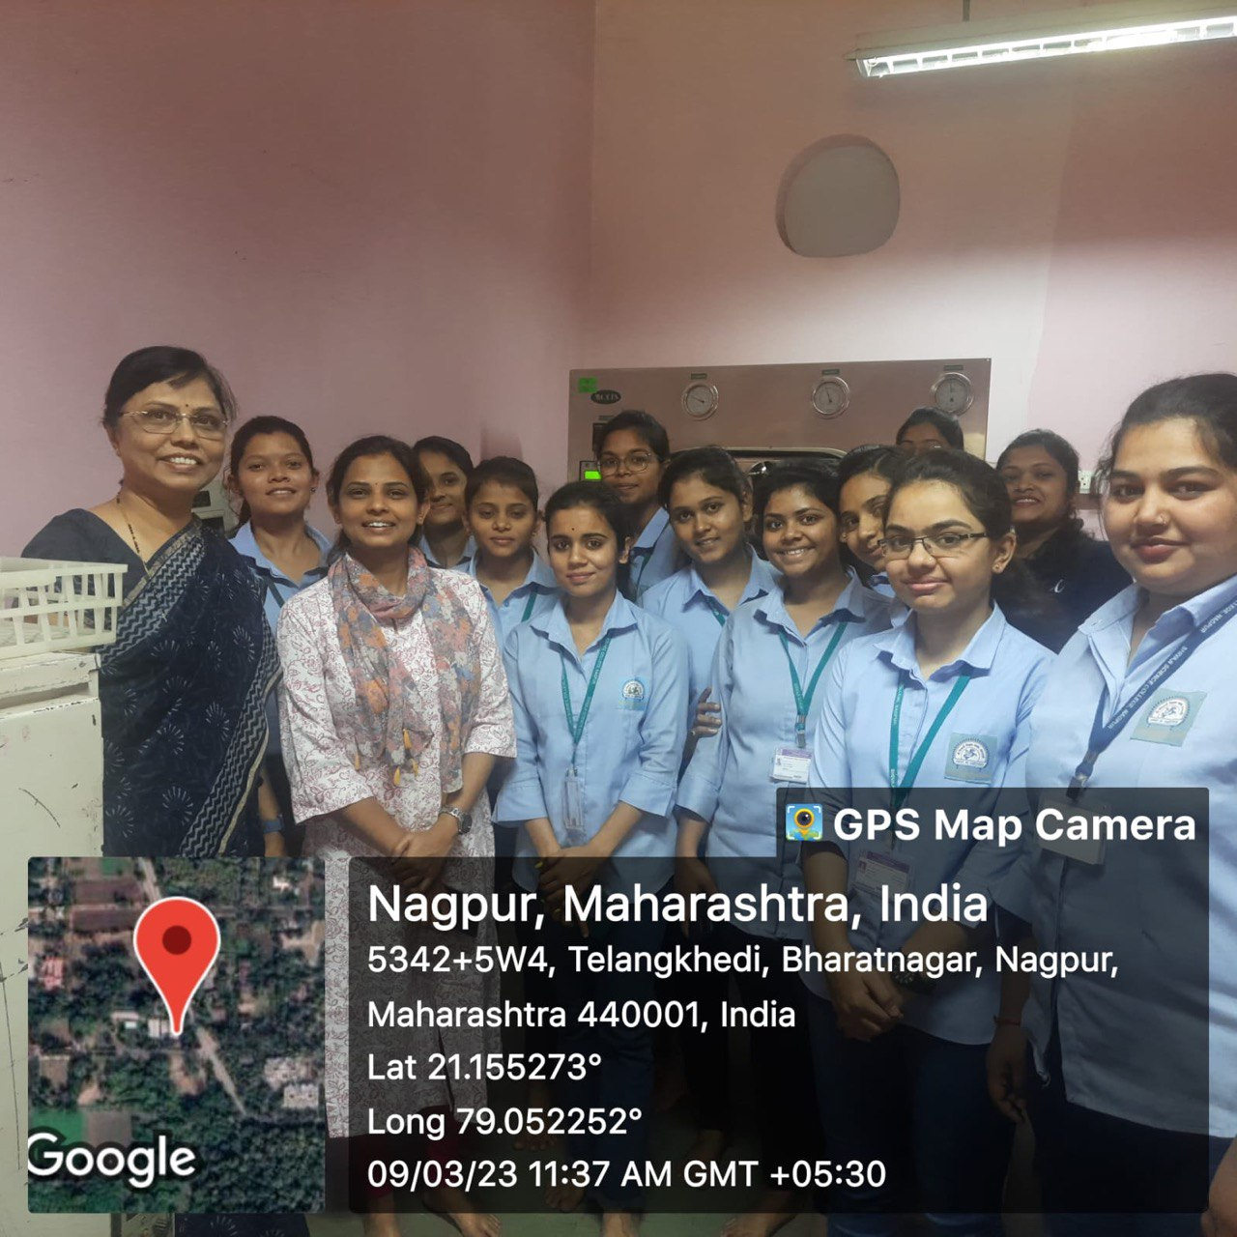
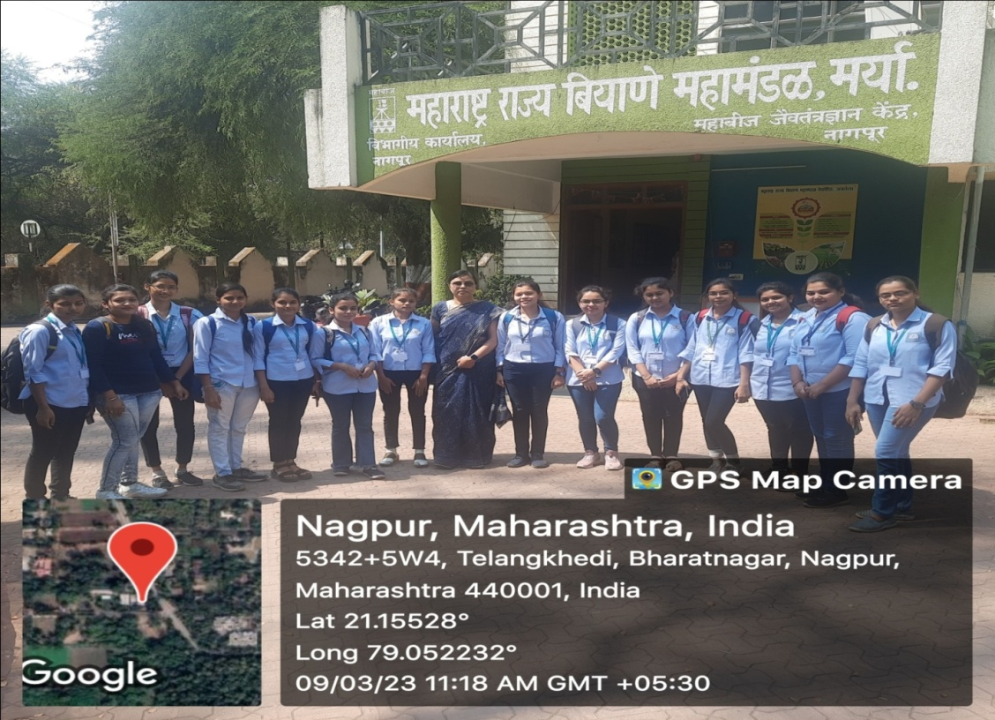
Visit to MAHABEEJ Pvt . Ltd

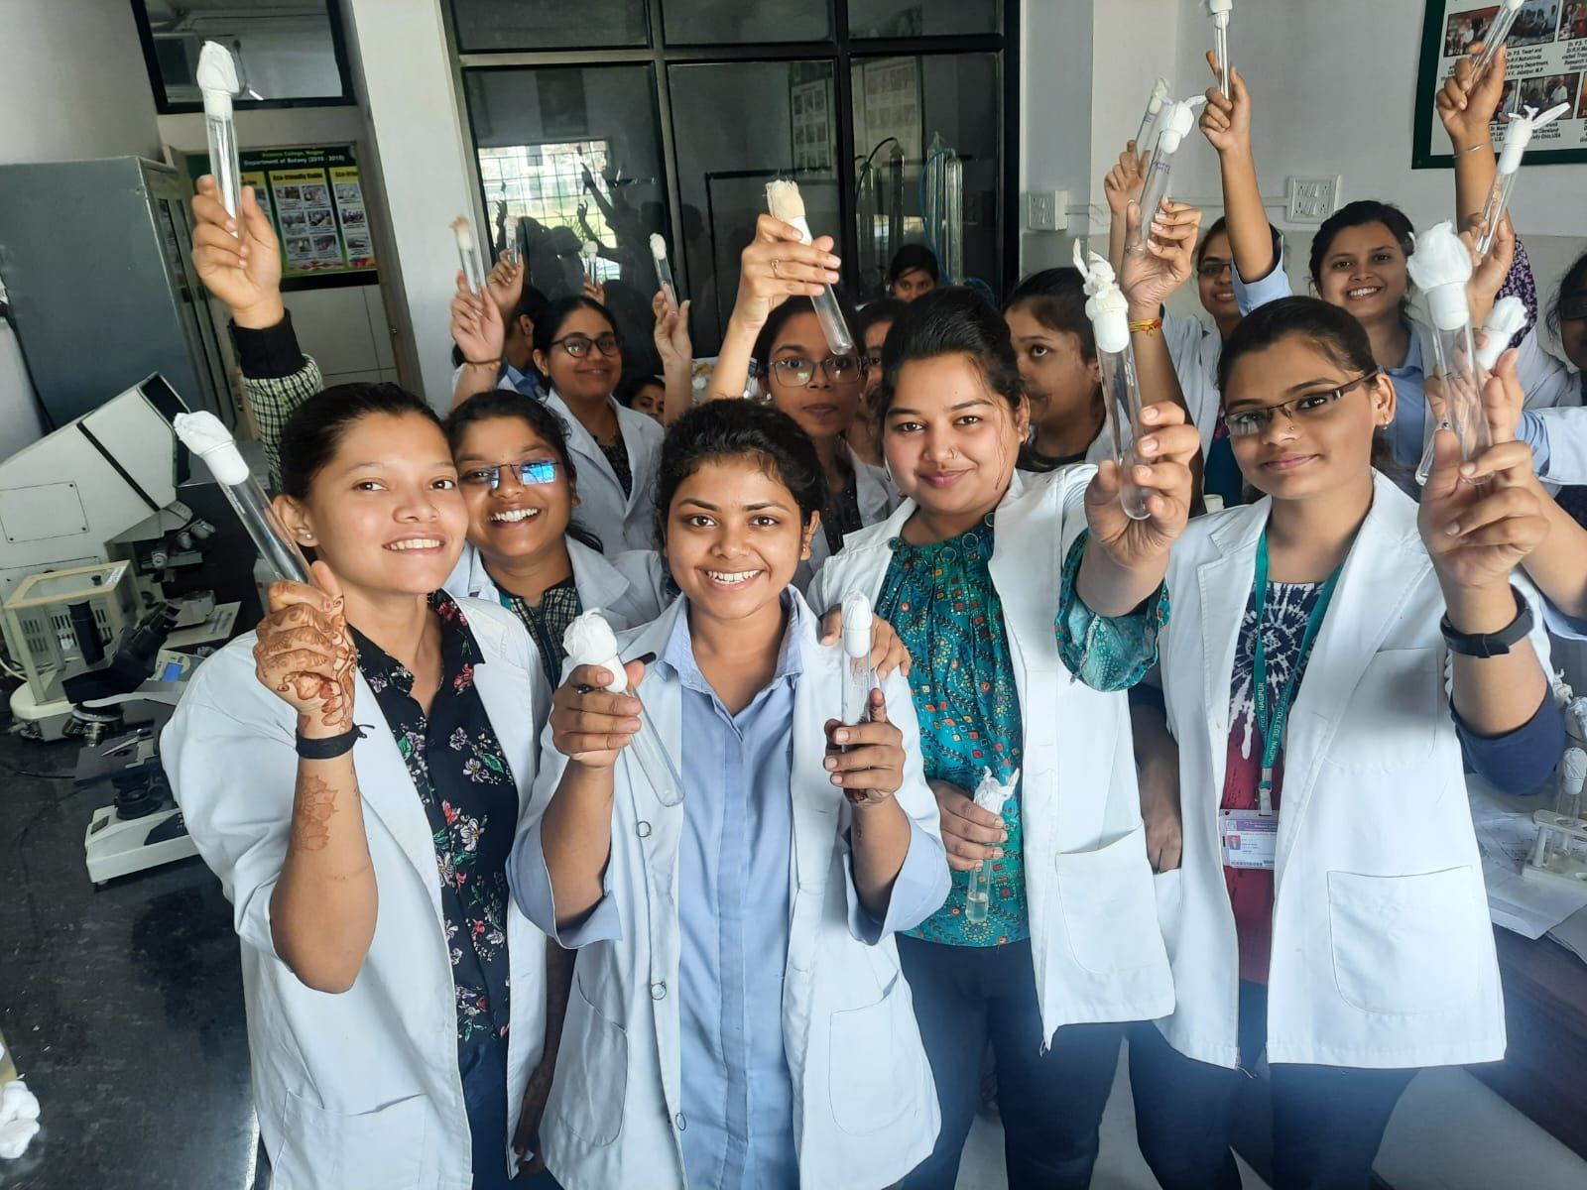
Participants

Convener
Prof.P.S.Tiwari

