Shri Shivaji Education Society Amravati’s
SCIENCE COLLEGE, Congress Nagar, Nagpur
Workshop Organized
On
Plant Tissue Culture Techniques
2017-18
----------------------------------------------------------------------------------------------
A training program on Plant Tissue Culture Techniques was organize for the students of B.Sc. III yr students by Department of Botany, SSES Amravati’s Science College, Congress Nagar. Work shop was conducted by Prof. Punita Tiwari, Associate, Dept. of Botany. 3 to 15 days workshop included general introduction, Media preparation, sterilization technique, Explant preparation, Inoculation technique, incubation and observation. Observation of different stages viz: callus formation, shooting and rooting, multiple shoot formation, regenerative callus, identification.
20 students of botany dept., Shivaji Science College, participated in the workshop. Visit to PGTD Dept. RTMNU, Nagpur was organized.

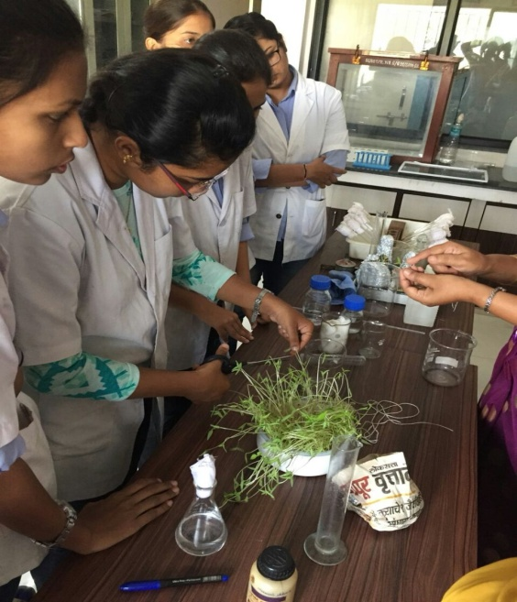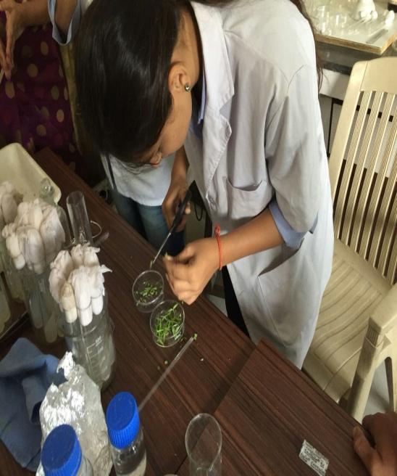
Explant preparation
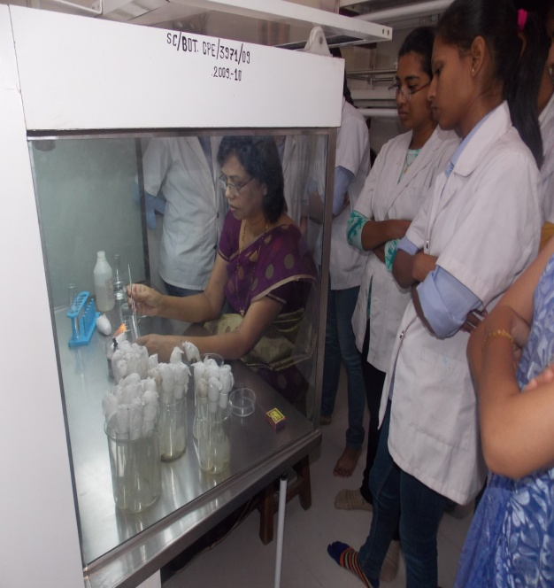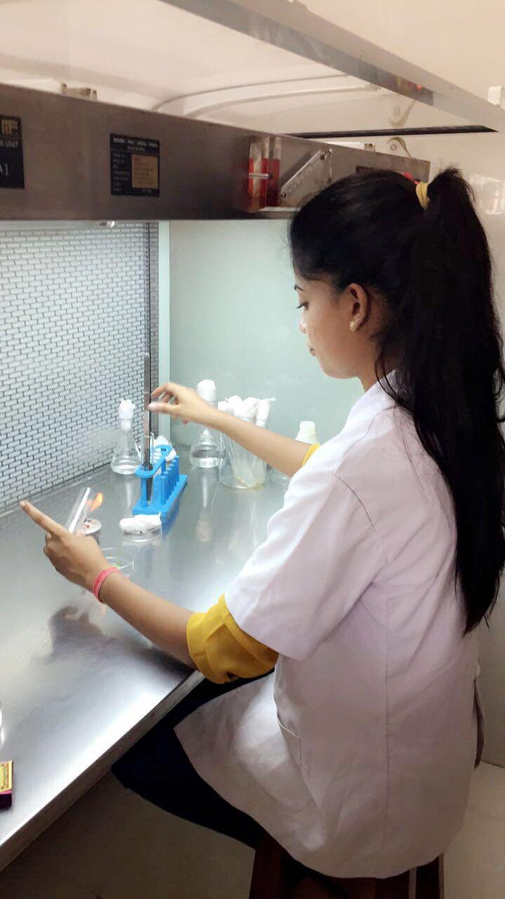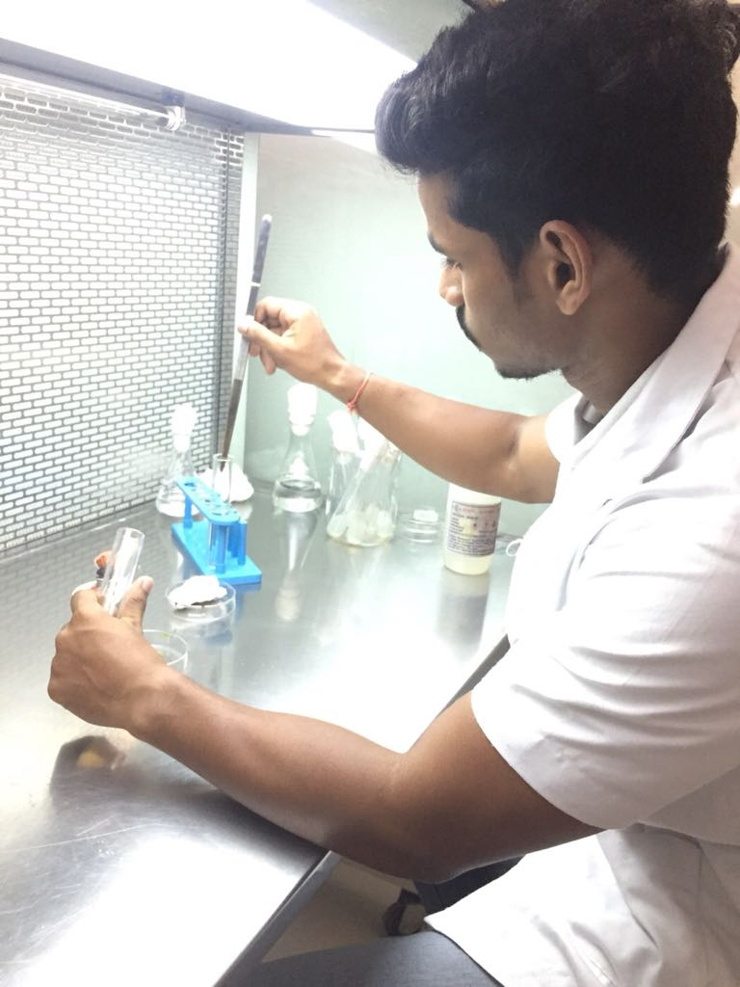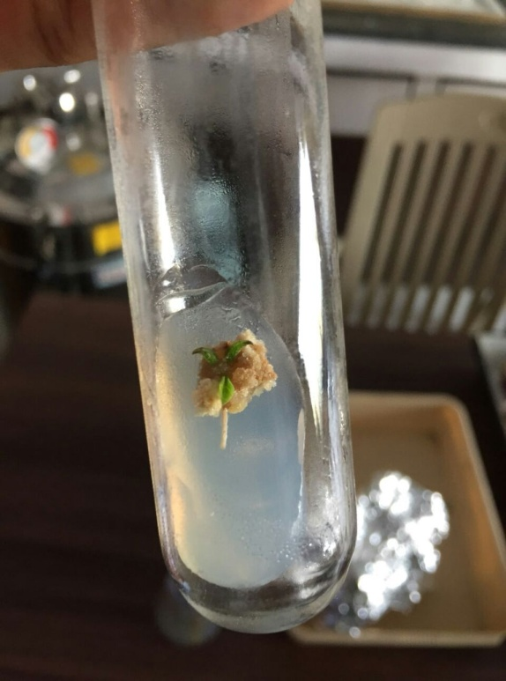
INOCULATION AND RESPONSE

Convener
Prof.P.S.Tiwari

