Shri Shivaji Education Society Amravati’s
SCIENCE COLLEGE, Congress Nagar, Nagpur
Workshop Organized
On
Plant Tissue Culture Techniques
2018-19
----------------------------------------------------------------------------------------------
A training program on Plant Tissue Culture Techniques was organized for the students of B.Sc. B.Sc.III students by Department of Botany, SSES Amravati’s Science College, Congress Nagar. Work shop was conducted by Prof. Punita Tiwari, professor, Dept. of Botany. 3 to 15 days workshop included general introduction, Media preparation, sterilization technique, Explant preparation, Inoculation technique, incubation and observation. Observation of different stages viz: callus formation, shooting and rooting, multiple shoot formation, regenerative callus, identification.
Students from Matagujari College, Jabalpur who visited college under student faculty exchange program, also attended Tissue culture training sessions. Students of INSPIRE camp (Junior college) also visited the workshop. After completion of workshop visit to ITI, Biotech lab, Betul ,M.P. was organized.

Protoplast culture: Training session on Protoplast isolation was also organized by Prof. Punita Tiwari for B.Sc.V& VI Botany students. Training program included Pre-Plasmolysis, enzymatic digestion of cell wall, washing in different solution and observation.
Plug preparation Media preparation

In the session Wrtreww
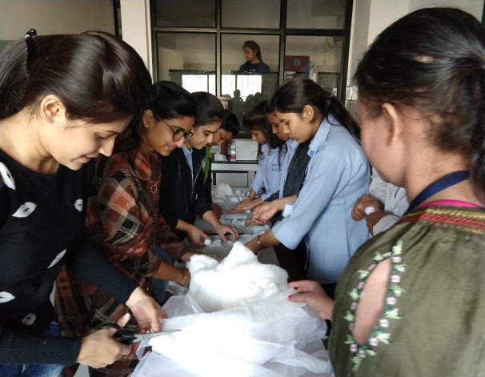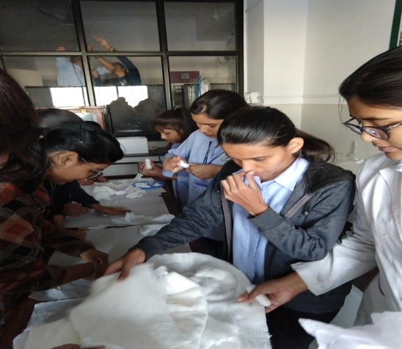

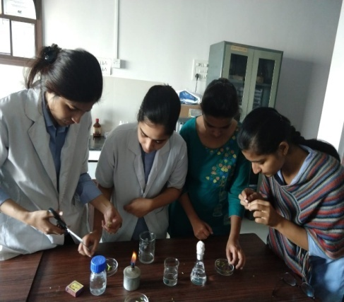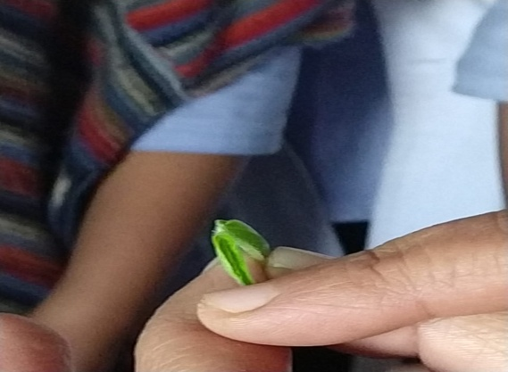
Media Preparation Explant Preparation
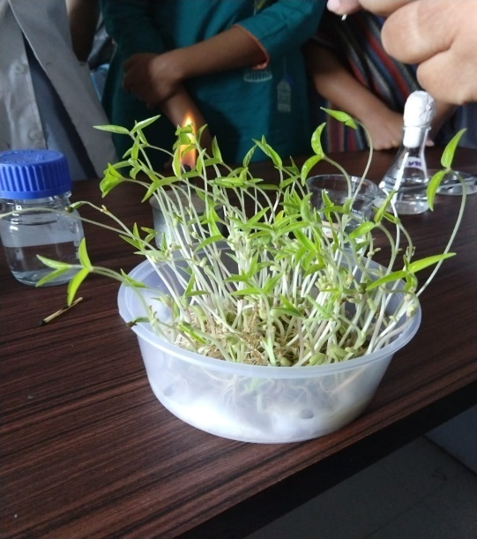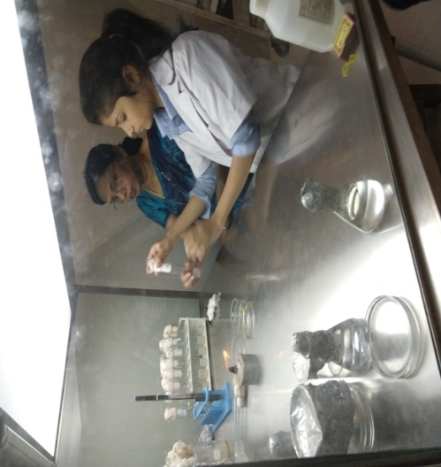
Explant source Inoculation
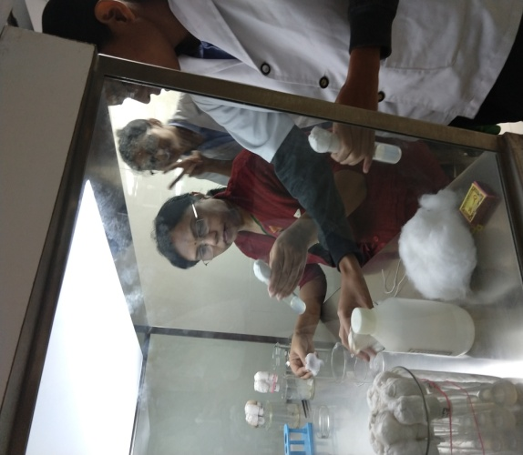
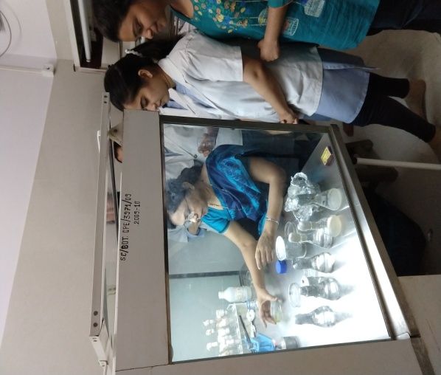

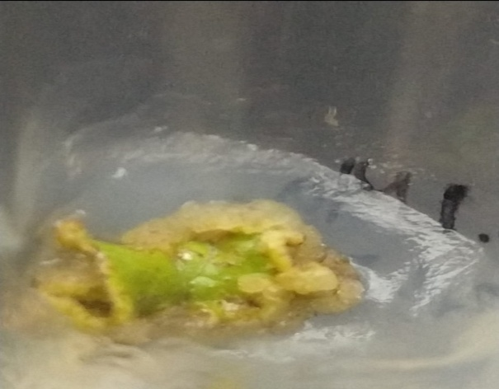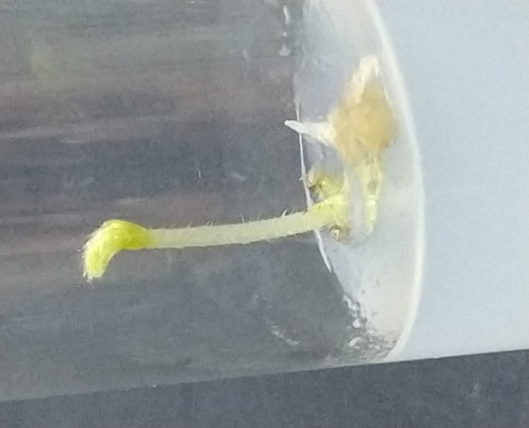
Callus Callus + Root+ Shoot
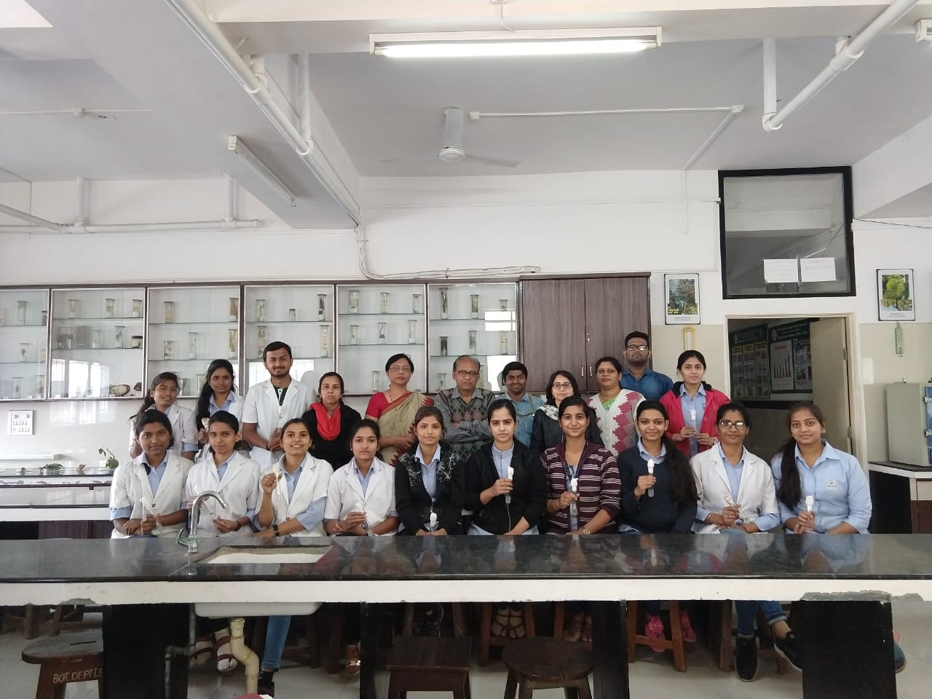
Participants and Faculty

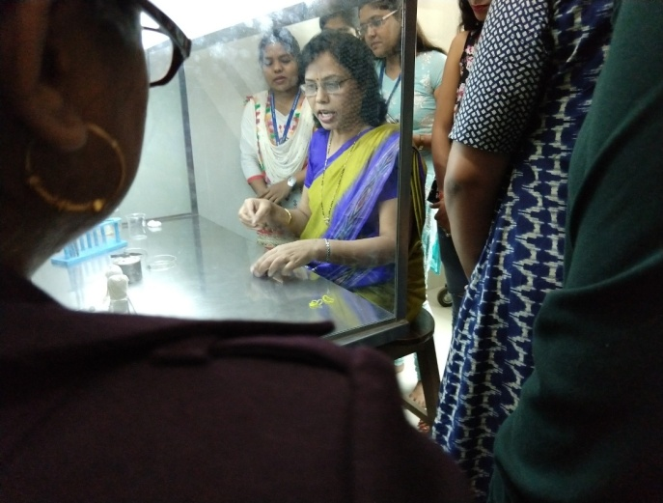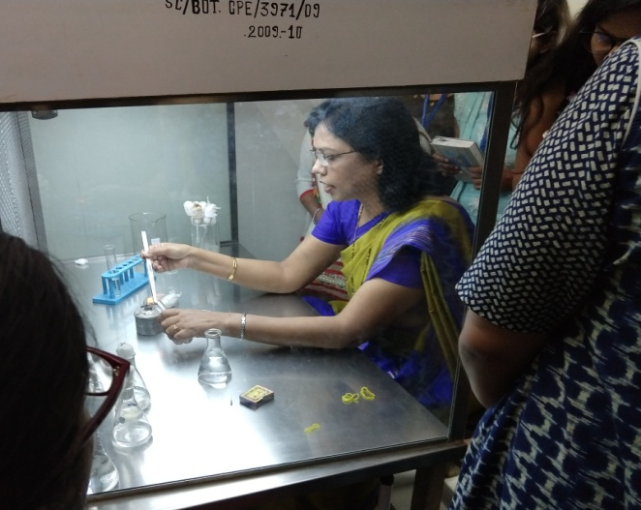
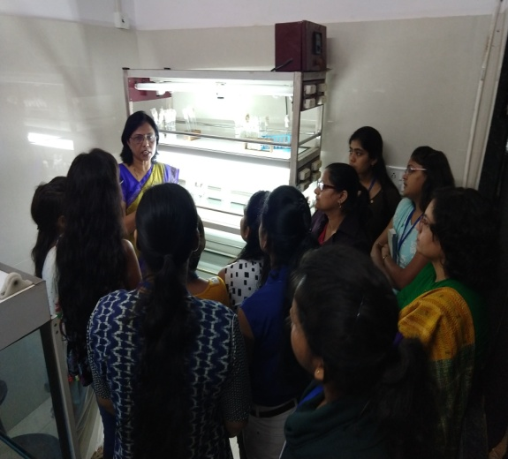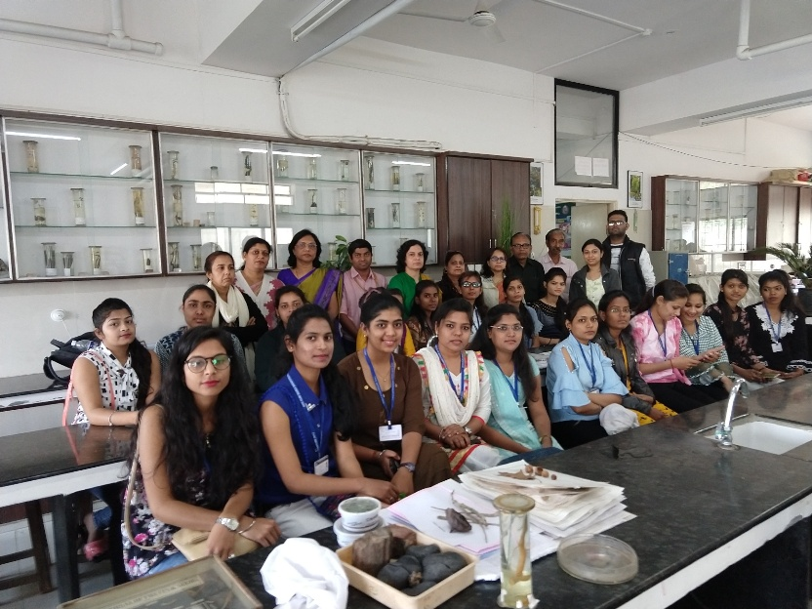
Students from Matagujari college, Jabalpur, M.P. attended the workshop

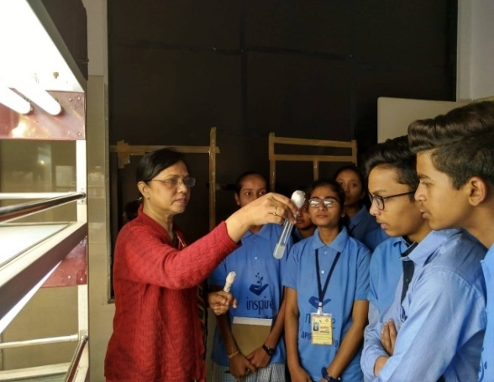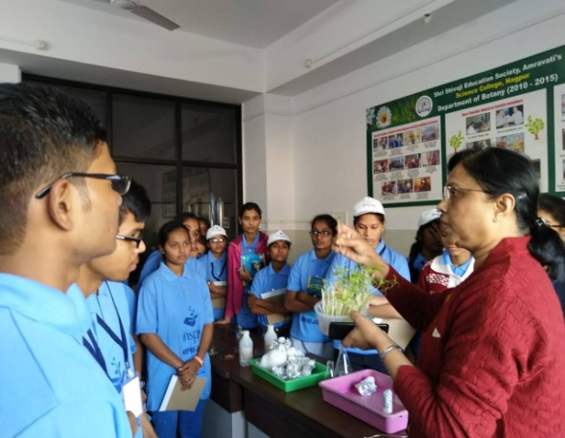
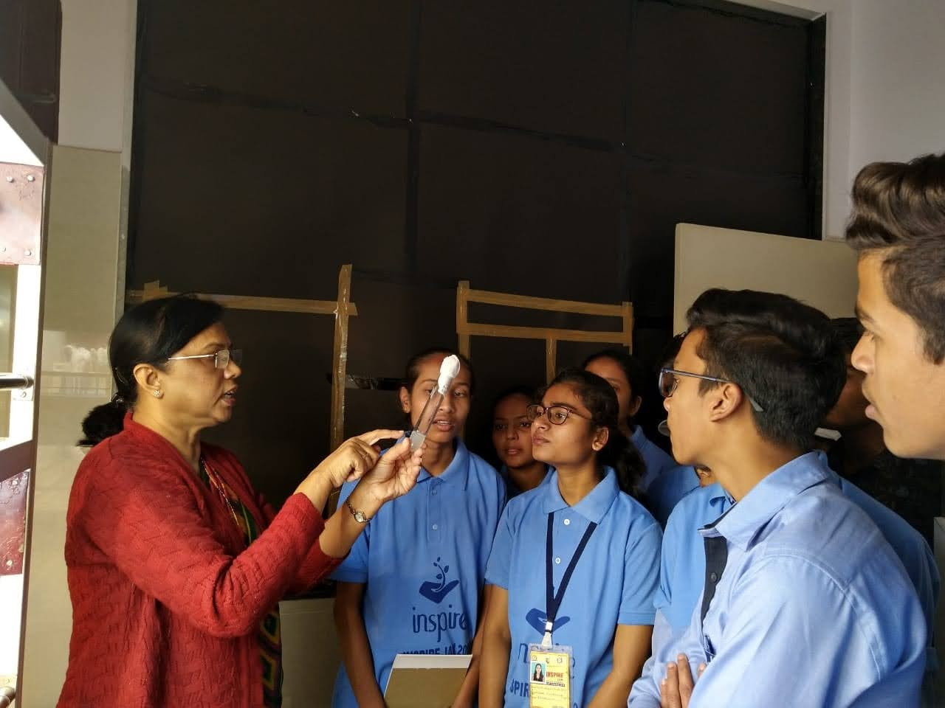
INSPIRE CAMP Students of 11th and 12th standard

Protoplast isolation technique workshop
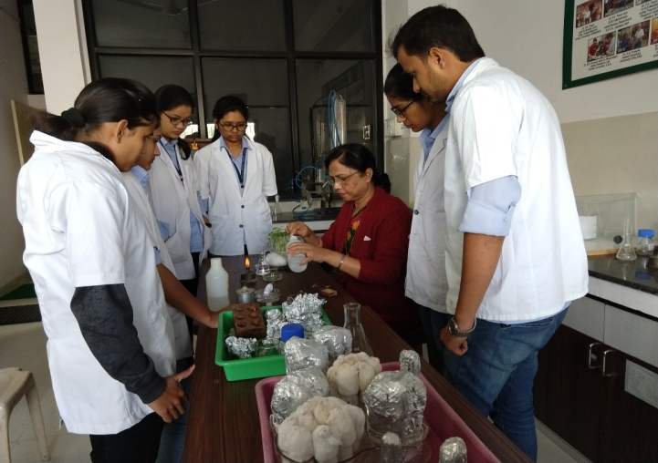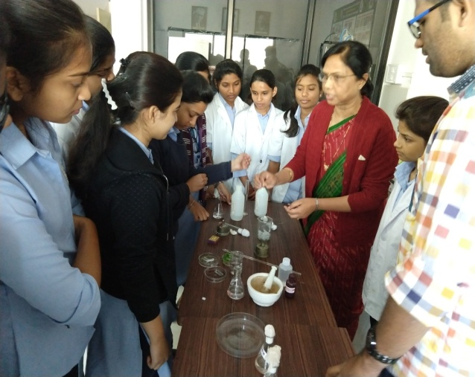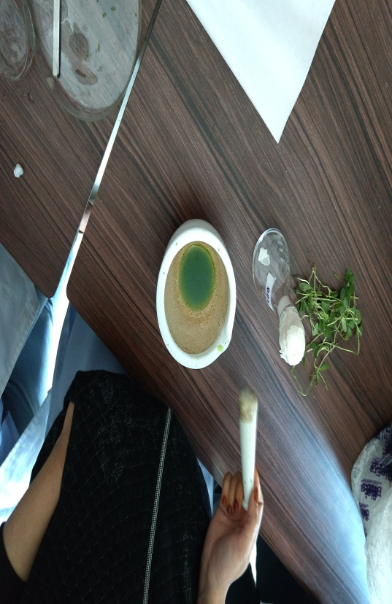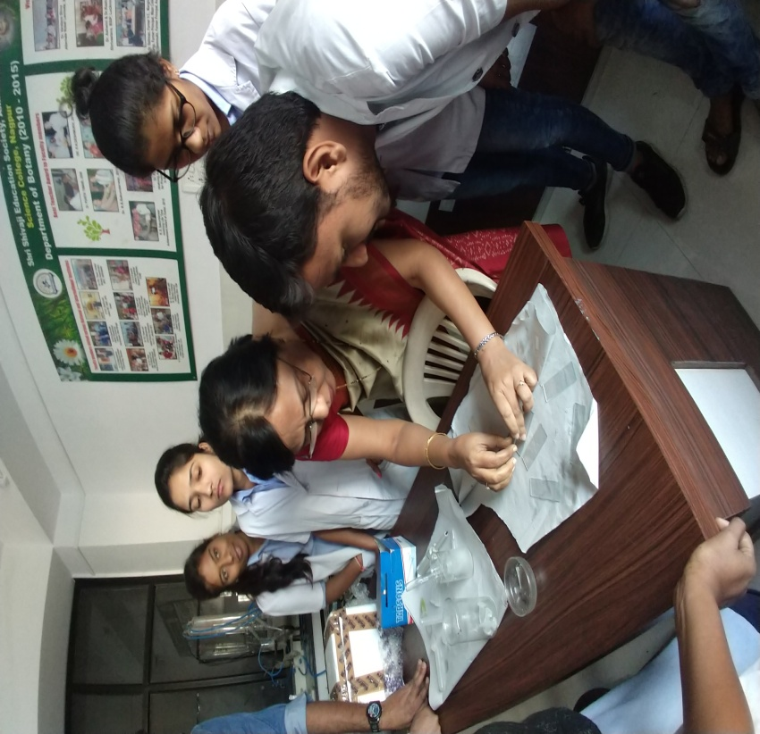
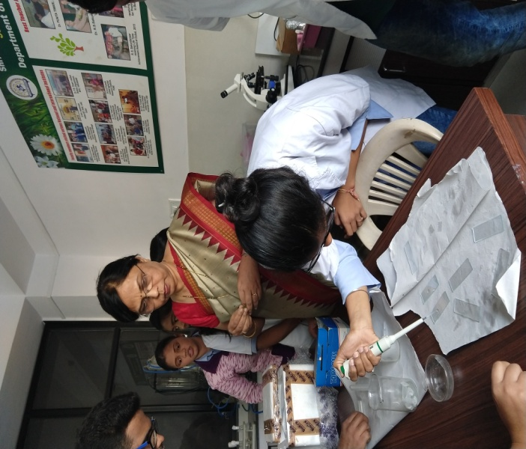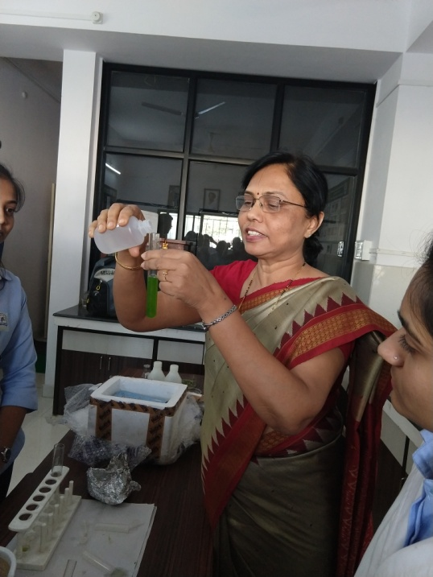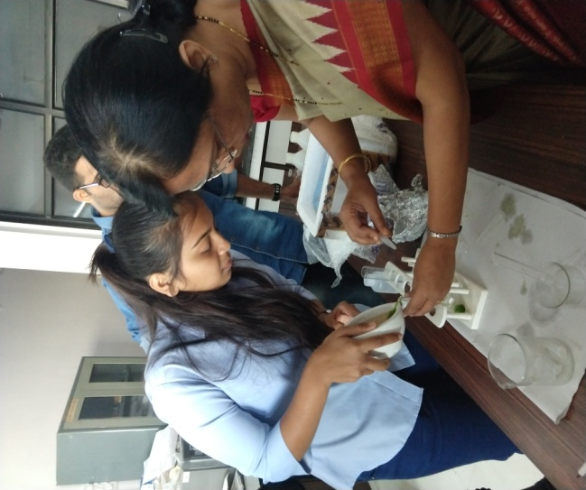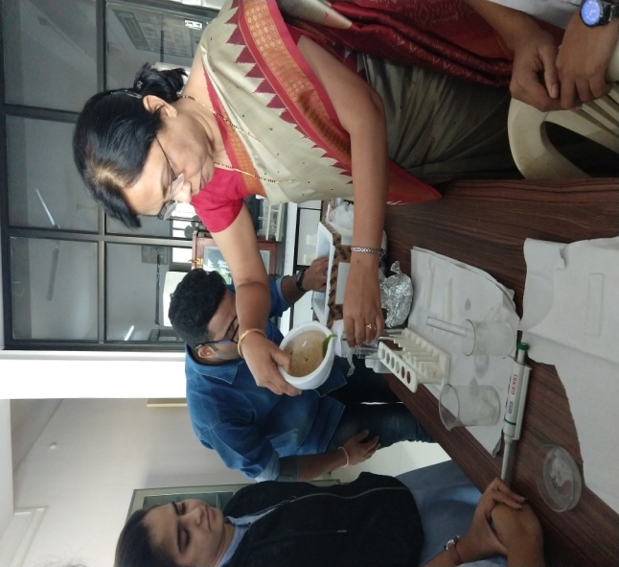
Protoplast isolation Process
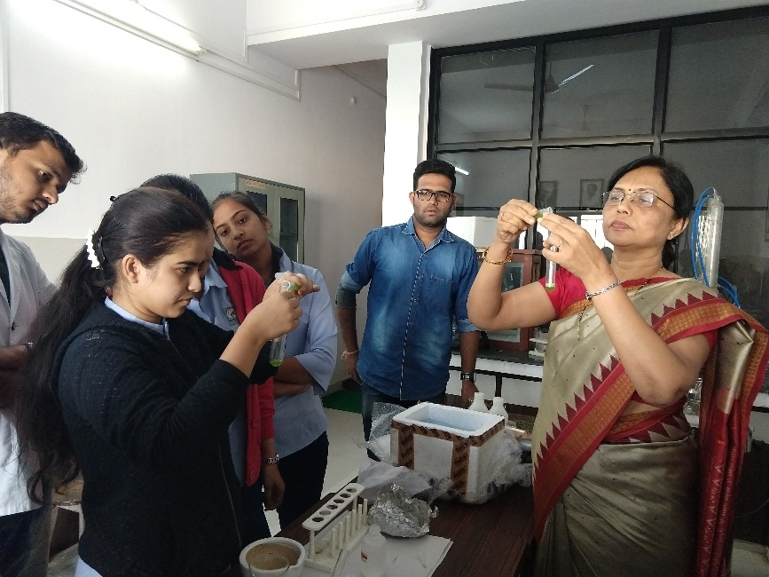
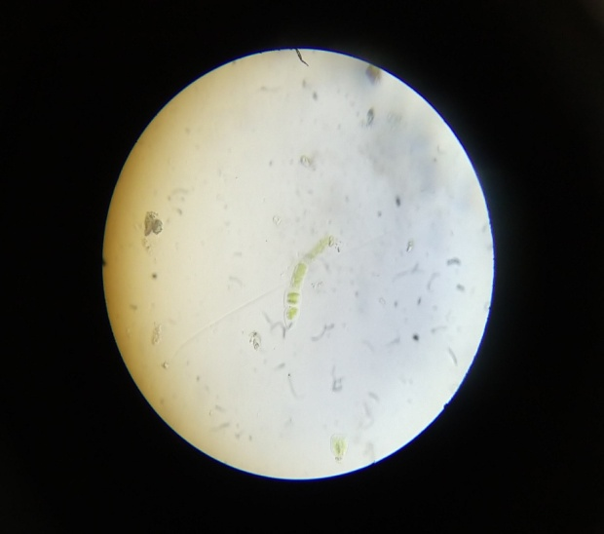
Isolated Protoplast
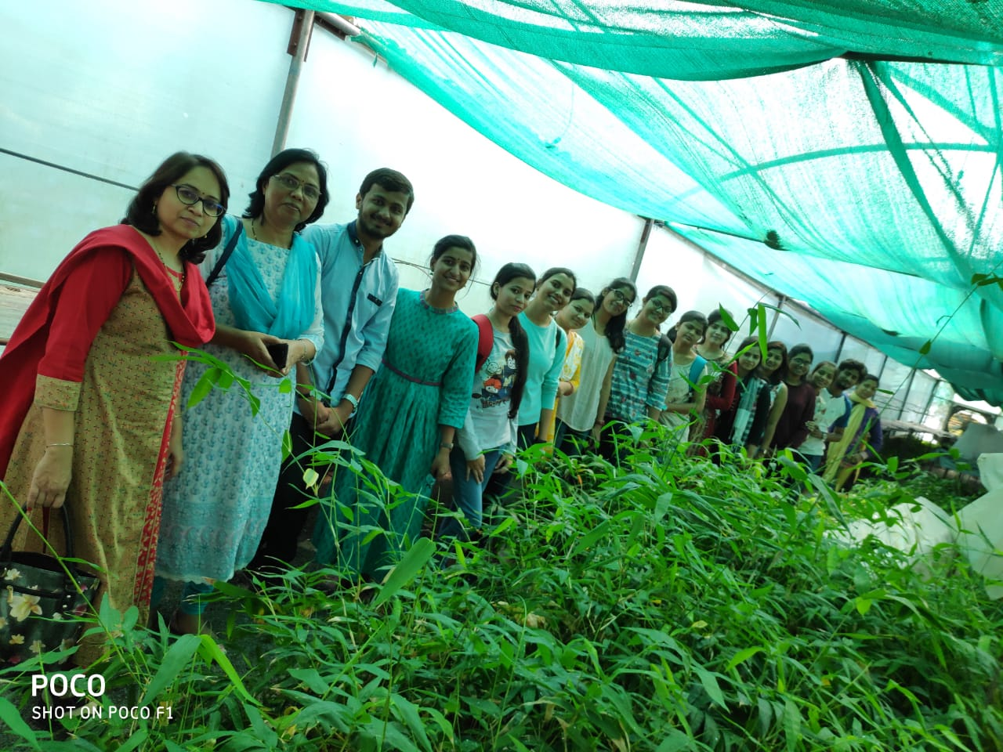
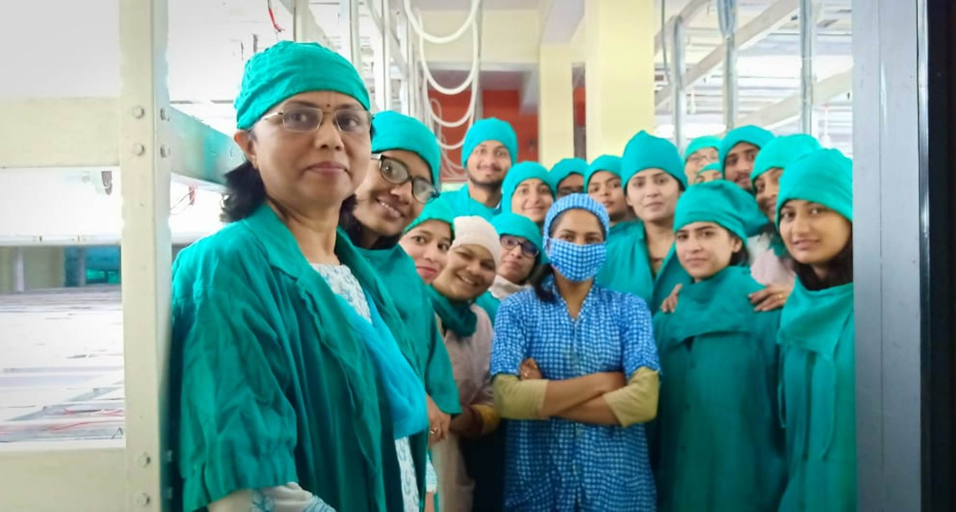
Visit to Central government lab ITI Biotech, Betul, M.P.
Bamboo Tissue Culture

Convener
Prof.P.S.Tiwari

