Shri Shivaji Education Society Amravati’s
SCIENCE COLLEGE, Congress Nagar, Nagpur
Workshop Organized
On
Plant Tissue Culture Techniques
2019-20
----------------------------------------------------------------------------------------------
A training program on Plant Tissue Culture Techniques was organize for the students of B.Sc. sem V and VI students by Department of Botany, SSES Amravati’s Science College, Congress Nagar. Work shop was conducted in association with Kamla Nehru College, Biotech Department. Dr. Nandeshwar from CICR, Nagpur conducted the wokshop as trainer, Moghe madam; head Biotech department took practical part and hands on training. Prof. Punita Tiwari, professor, Dept. of Botany, explained practical tips to the students. 3 to 15 days workshop included general introduction, Media preparation, sterilization technique, Explant preparation, Inoculation technique, incubation and observation. Observation of different stages viz: callus formation, shooting and rooting, multiple shoot formation, regenerative callus, identification.
29 students of botany dept., Shivaji science participated in the workshop.

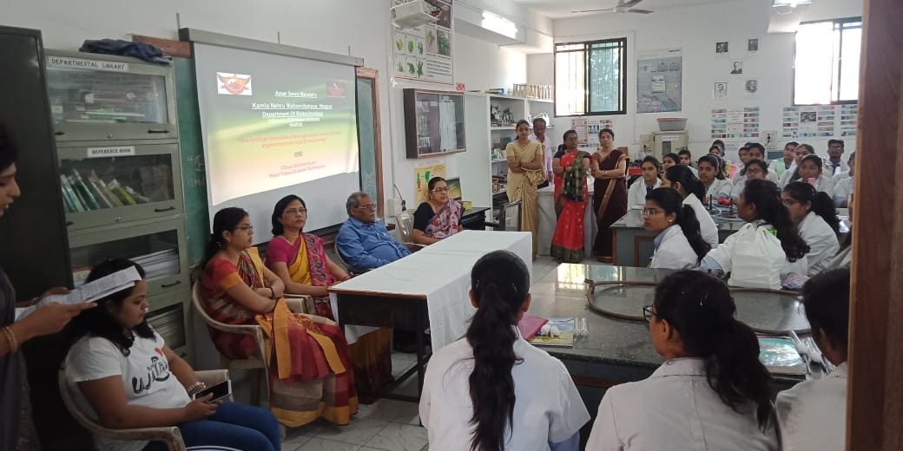
Dr. Nandeshwar from CICR, Nagpur, Dr. Moghe madam; head Biotech department and Convener, Prof. Punita Tiwari, professor, Dept. of Botany, Shivaji Science College, Botany Department
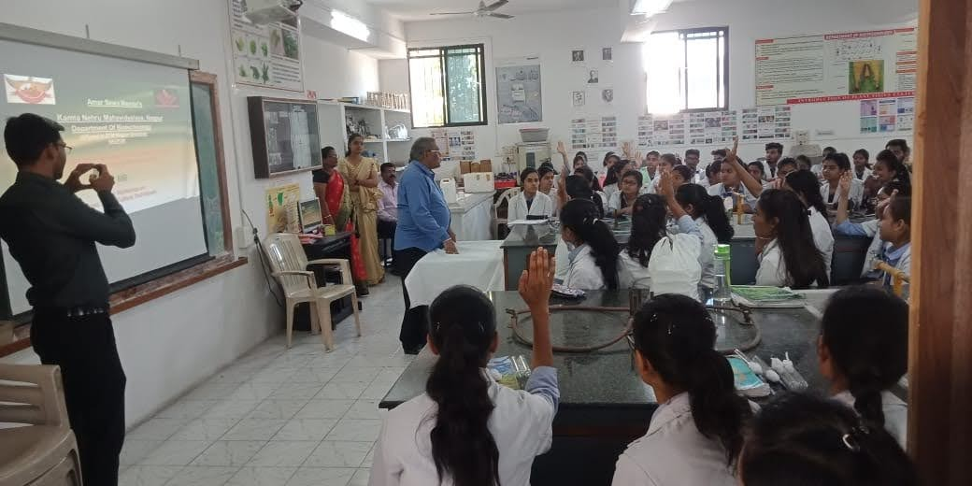
Dr. Nandeshwar from CICR, Nagpur explaining Plant Tissue Culture

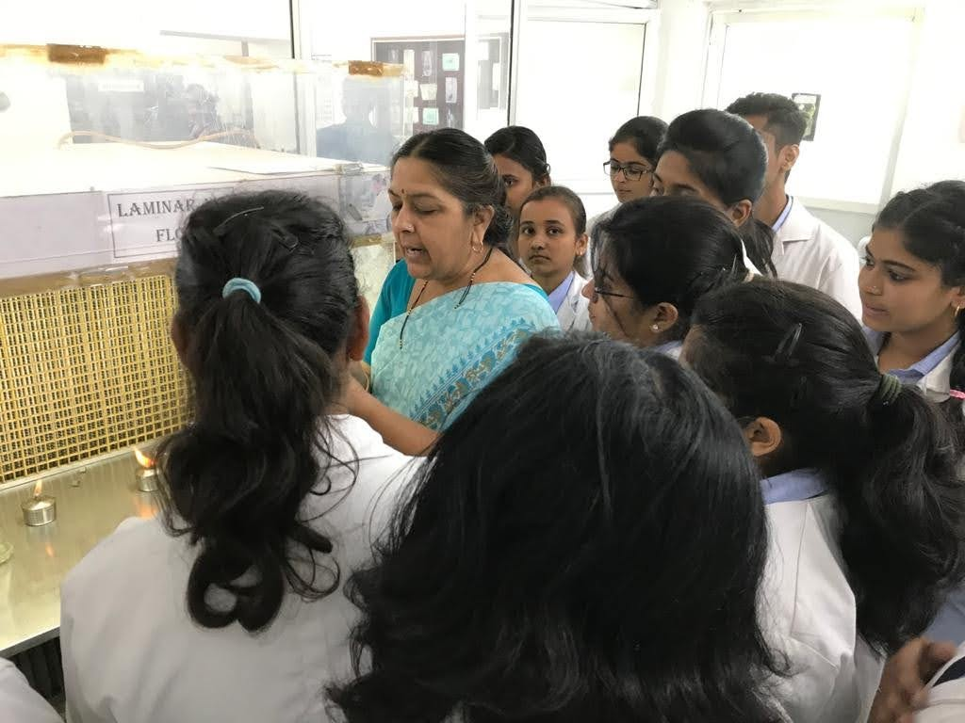
Dr. Moghe mam explaining the process
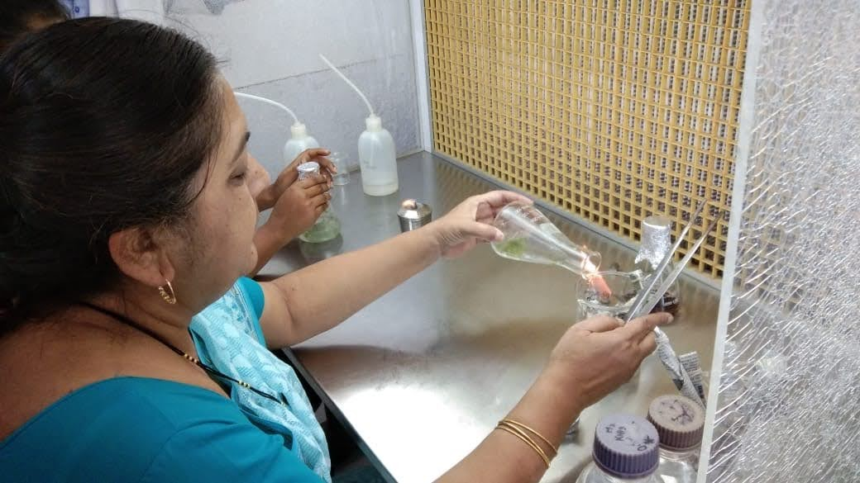
Dr. Moghe mam explaining Inoculation technique
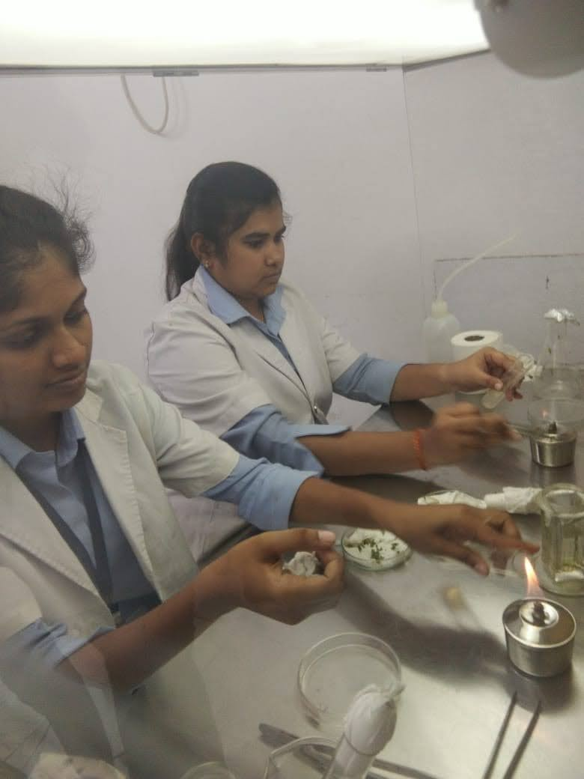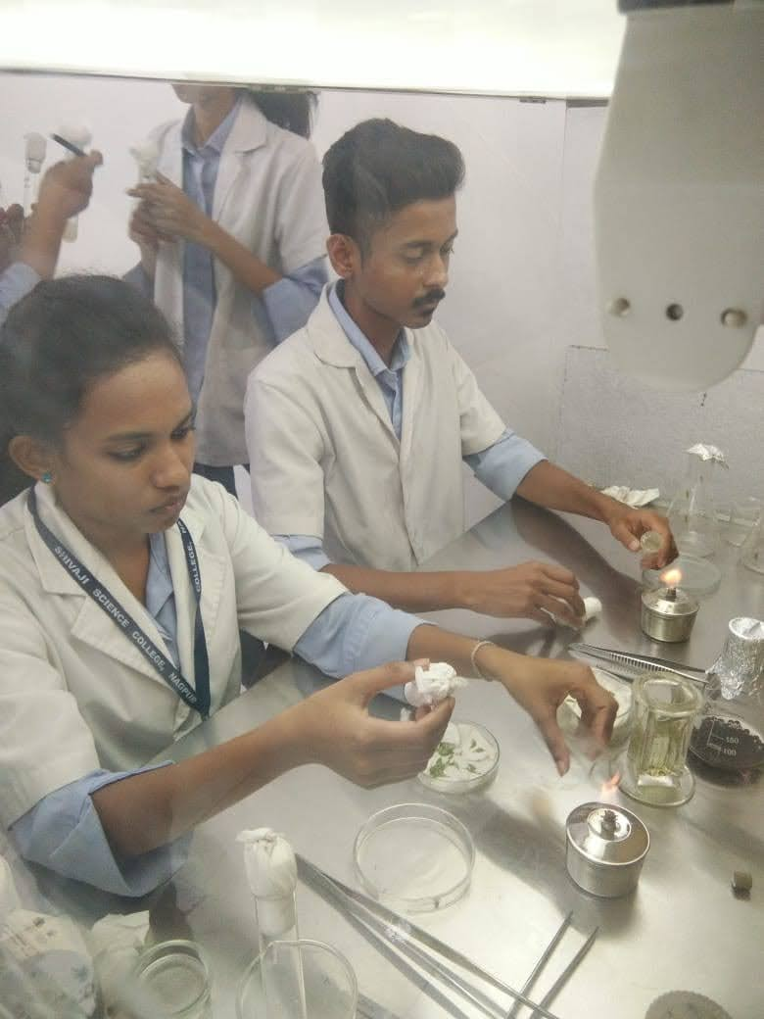
Students doing Inoculation
Convener
Prof.P.S.Tiwari

