Shri Shivaji Education Society Amravati’s
SCIENCE COLLEGE, Congress Nagar, Nagpur
Department of Botany
Organized
Skill- Based Mushroom Cultivation Certificate Course
Session 2019-20
=============================================REPORT

Department of Botany, Shivaji Science College organized one day workshop on “Edible Mushroom Cultivation” on 20th Feb. 2020 in the conference hall. Mr. Abhimanyu Rao Dongarwar, Expert, Sky Mushrooms, Nagpur inaugurated the workshop and Principal Dr. M. P. Dhore was present as a president of the function.
Mr. Abhimanyu Rao Dongarwar emphasized on entrepreneurship skill development regarding training in the mushroom technique. Principal Dr. M. P. Dhore, guided the students about their overall development by learning several skills in hand on training in mushroom cultivation and applauded the efforts taken by the Dept. of Botany. Dr. R. N. Deshmukh, HOD. Department of Botany guided the students about several benefits of mushroom in their daily life and also given some life learning tips on this occasion.
Dr. Mrs. S. D. Puranik, Convener of the workshop briefed about the lifelong activities and achievements of students benefitted by the workshop and several income opportunities. Dr. Mrs. P.S. Tiwari and Dr. Mrs. R. H. Mahakhode were also present on the dais. Miss. Tanushree Banerjee conducted the proceedings and proposed the vote of thanks.

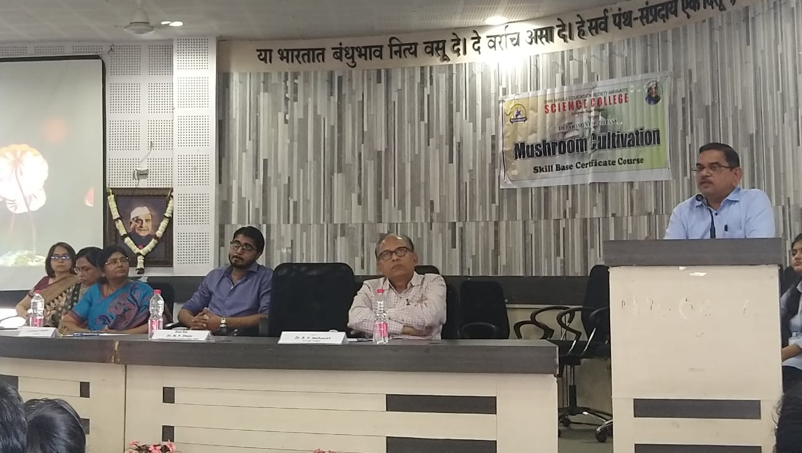
Dr. M .P. Dhore, Principal addressing to the students about overall development through skill based learning programs
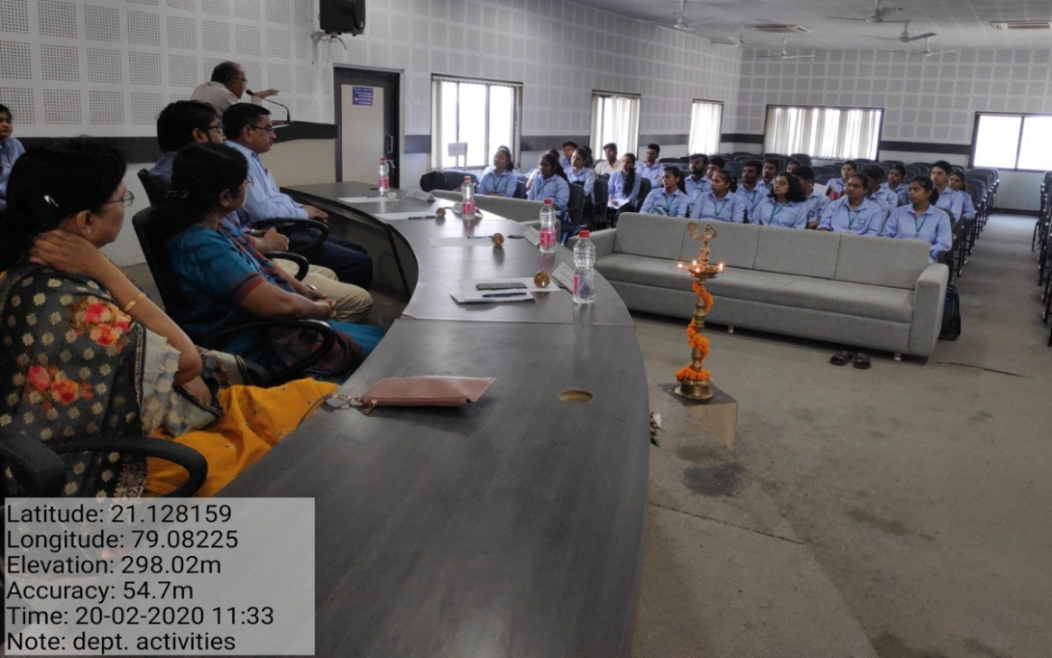
Dr. R. N. Deshmukh guided the students about the benefits of Mushrooms

One Day Workshop on Edible Mushroom Cultivation
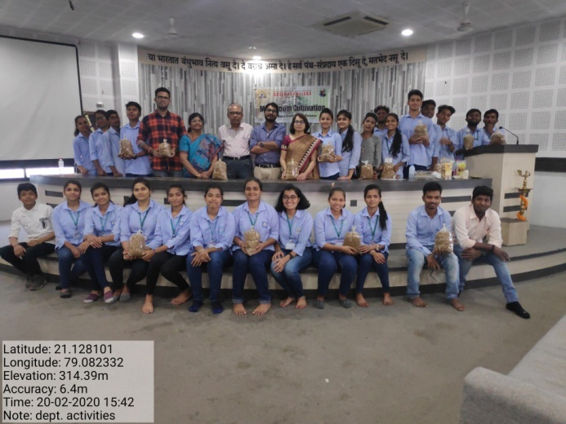
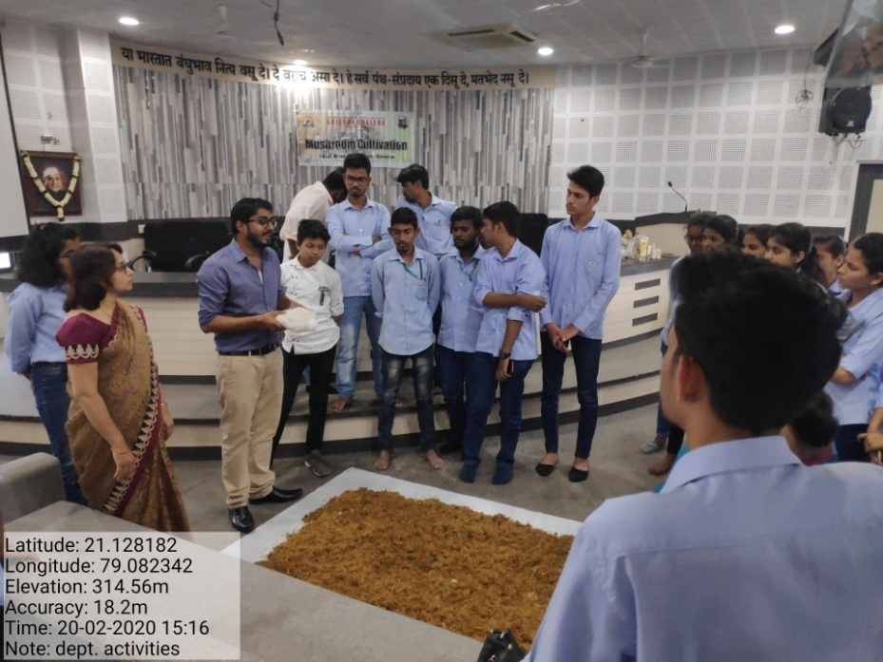
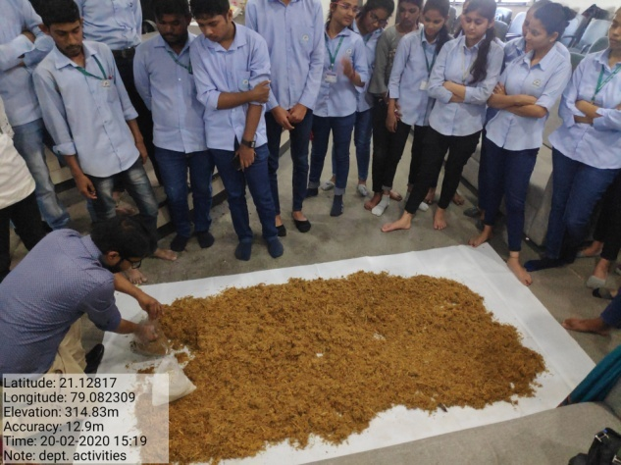]
One Day Workshop on Edible Mushroom Cultivation
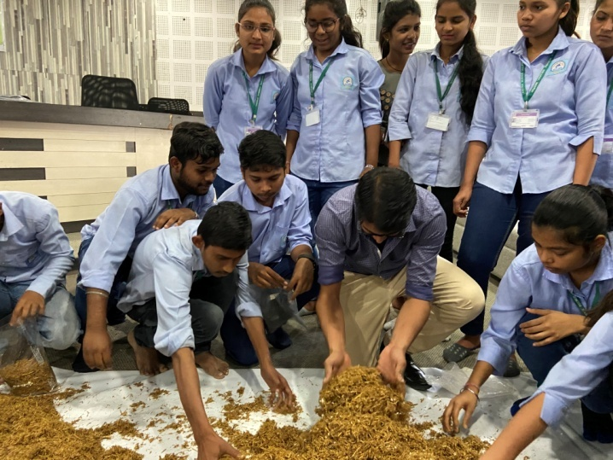
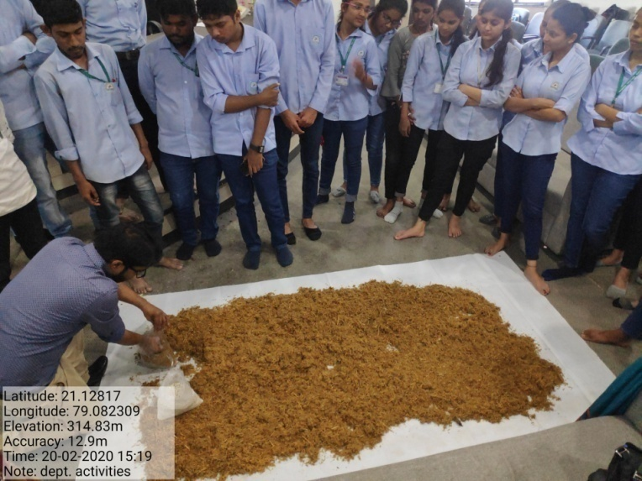
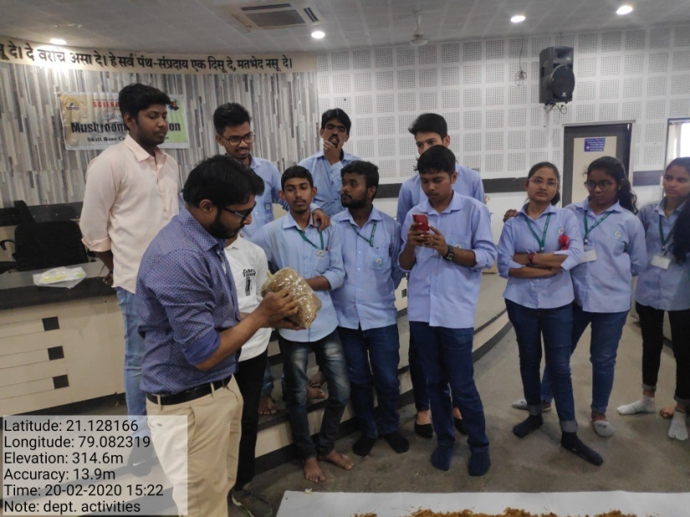

Convener
Dr. Mr. S.D.Puranik

