Shri Shivaji Education Society Amravati’s
Science College Congress Nagar, Nagpur
Department of Botany
Organized
Eco-friendly Rakhi Competition and Exhibition
Session- 2019-2020
---------------------------------------------------------------------------------------
REPORT
Eco-friendly Rakhi was celebrated in department of Botany with great enthusiasm. This event took place on 14th August 2019 at 12.30pm. Dr.M.P.Dhore, Principal, of college inaugurated the function. He inspired all the impotence of green activities and environment. He also appreciated the students who made eco-friendly rakhis. The competition was held to promote awareness of environment about hundred students were participated in the exhibition. The material were used such dry fruits, biscuits, paper cutting, grains, spices, chocolates, flowers, leaves and other eco-friendly material. This exhibition was held under the guidance of Dr.Mrs.S.D.Puranik. Dr.P.D.Burghate judged the program. Dr.R.NDeshmukh HOD, Dr.P.S.Tiwari, Dr.R.H.Mahakhode, Dr.Sharayu Deshmukh, Mr.Manish Chinchmalatpure & non teaching staff were present. Students worked hard for this exhibition.
In fresh material category winners are
- Padmavati Dehury (CBM) 1st year
- Aarya Chavan (CBM) 1st year

In Eco-friendly material category winners are
- Palllavi Nitnware (CBG)
- Parule Dhkate (CBG)
- Vedat Patwa (CBG)
Consolation Prize
- Vrunda Borkar (CBM)
- Ishant Nikure (CBM)

Innovative Model-
- Rutik Wasnik

Eco-friendly Rakhi Competition and Exhibition
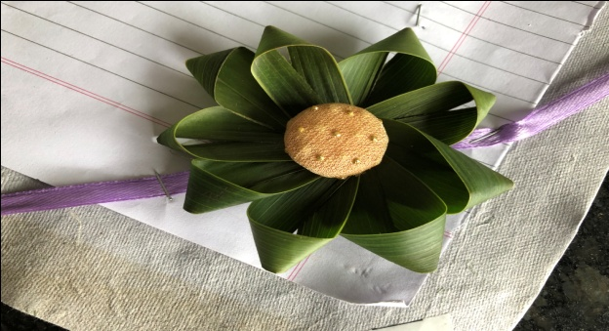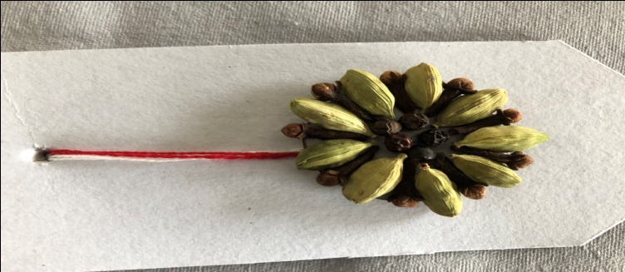
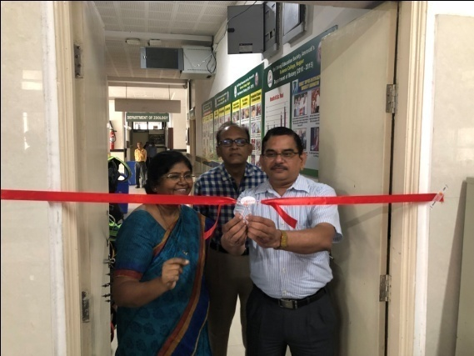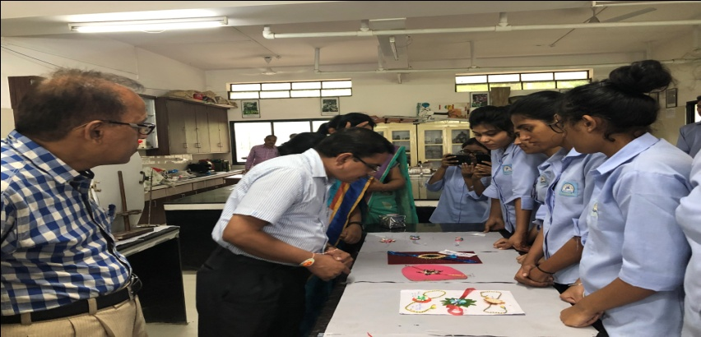
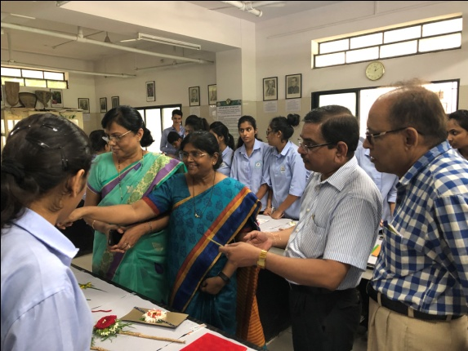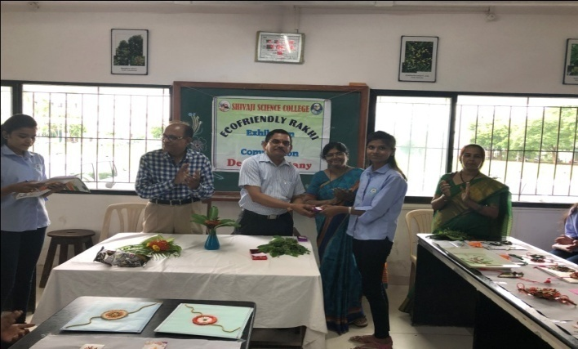
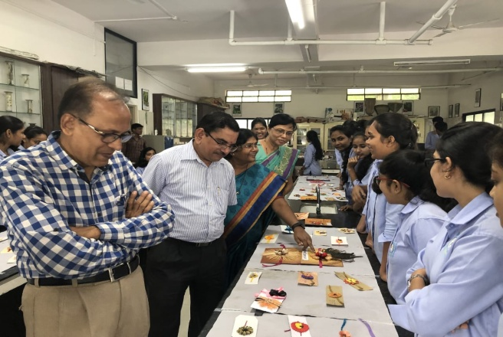
Convener
Dr. Mrs. S.D.Puranik

