Shri Shivaji Education Society Amravati’s
SCIENCE COLLEGE, Congress Nagar, Nagpur
Department of Botany
Organized
Floriculture & Landscaping Certificate Course
Session 2018-19
=============================================REPORT

Department of Botany conducted one day workshop on “waste segregation & composting” for the students of Sem. II & IV at “Golden Park” Besa, Nagpur on 26th March 2019. Fifty Eight students were participated. Mr. Manish Chinchamalatpure, Landscape expert demonstrating vermicompost technique to the students. The students collected material (earthworm, cow dung, soil, gunny bags, dry leaves/ weed biomass, water etc) required for the Vermicompost. The technique was taught practically as well as theoretically.
Vermicomposting is the process in which worms turn organic wastes into very high quality compost. Vermicompost contains water soluble nutrients & it is an excellent, nutrient rich organic fertilizer & soil conditioner. Students benefited & enjoyed by such type of project.
Mr. Manish Chinchamalatpure emphasised following benefits of Vermicompost to the students.
Benefits of Vermicompost:-
- Eco-friendly
- Enriches soil with micro organisms
- Improves water holding capacity
- The stings are rich in humic acids, which condition the soil & help balance pH
- Improves recycling
- Enhances germination, plant growth & crop yield
- Improves root growth & structure
- Provides plants with essential nutrients & aids in the suppression of plant diseases.
- Worm casting contain five times more nitrogen, seven times more phosphorus & 11 times more potassium than ordinary soil.
- Generate revenue.
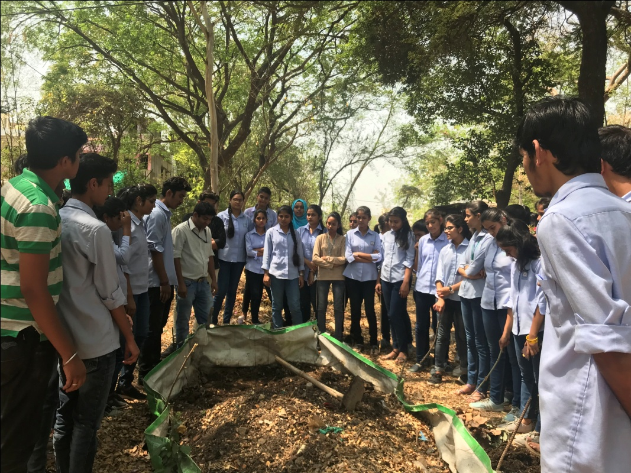
Mr. Manish Chinchamalatpure demonstrating Vermicompost Technique at Golden Park, at Manewada, Nagpur on 26th March 2019.
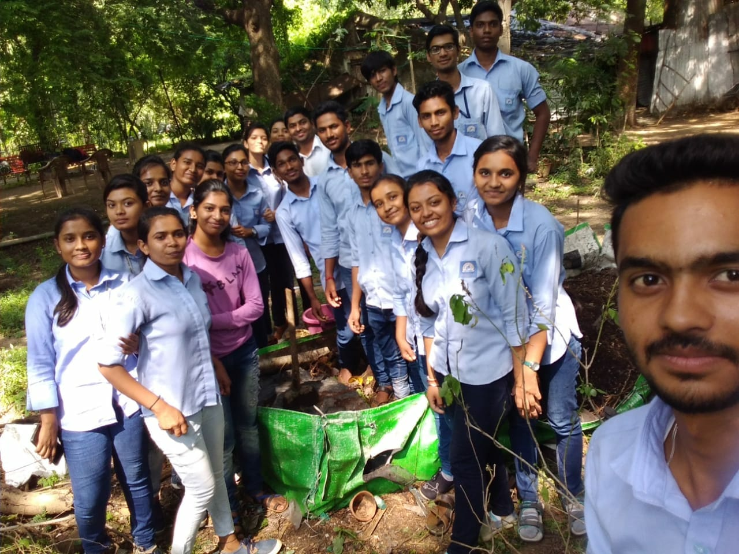

One Day Workshop on “Waste Segregation & Composting”

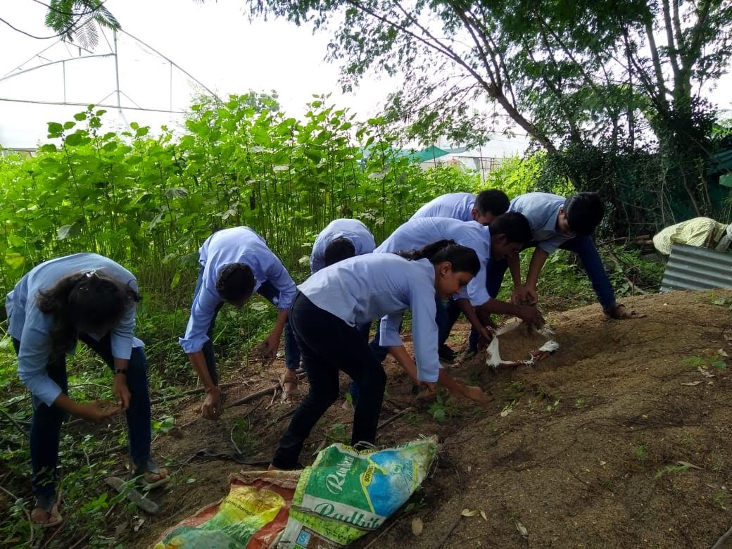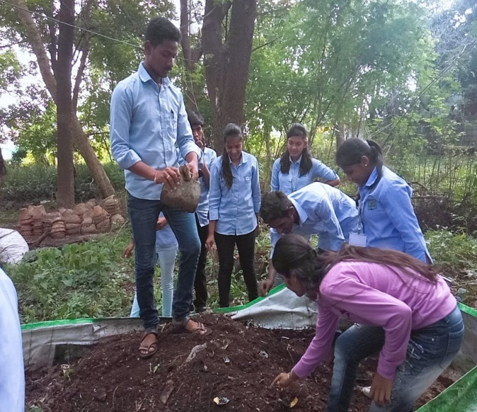

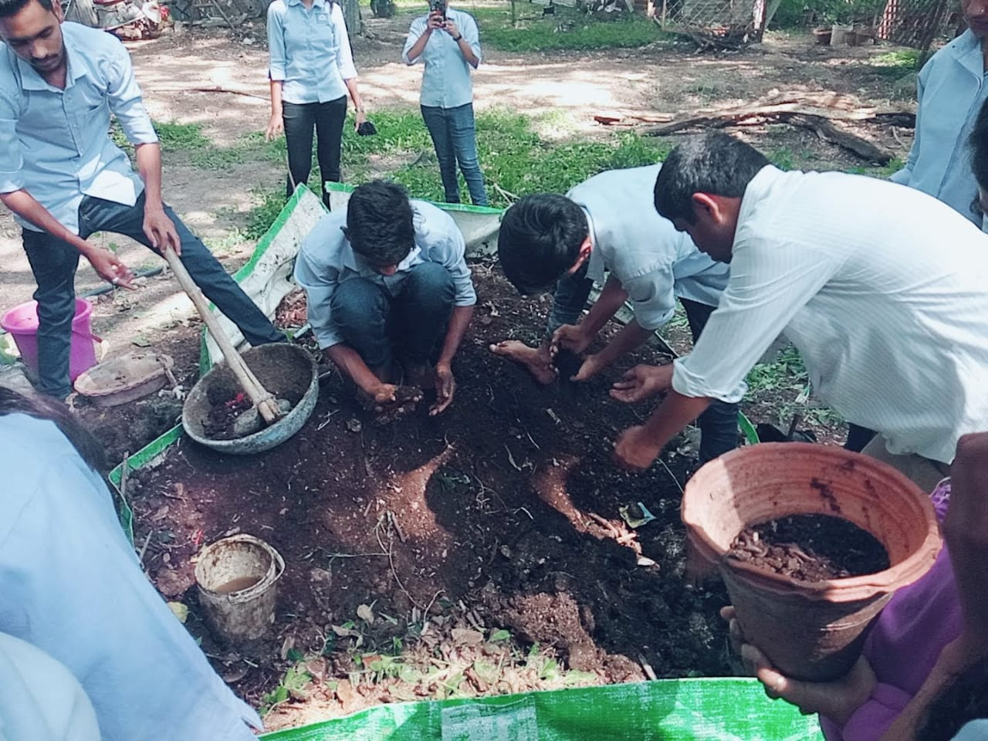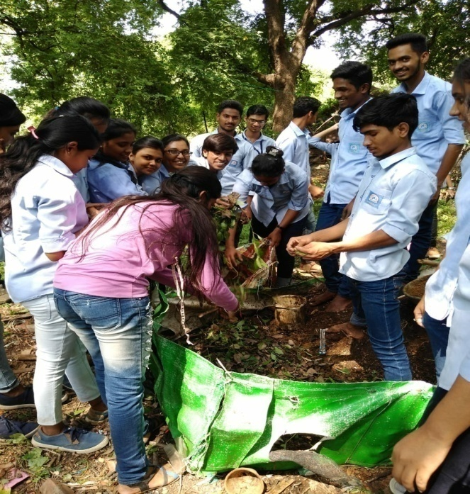

Convener
Dr. Mrs. R.H.Mahakhode

