Shri Shivaji Education Society Amravati’s
SCIENCE COLLEGE, Congress Nagar, Nagpur
Department of Botany
Organized
Floriculture & Landscaping Certificate Course
Session 2017-18
=============================================REPORT

Department of Botany carried out Self Finance Certificate Course on Floriculture & Landscaping for the students as regular practice of the department. Total 10 students were enrolled for the course. The student learned about the techniques of gardening, floriculture and landscaping.
The students of Floriculture & Landscaping visited “Golden Park” Besa, Nagpur on 26th Sep. 2017. Mr. Manish Chinchamalatpure, expert explained about the various chemical treatments to different types of seeds for the cultivation. Vegetative propagation, Cultivation of plants and gardening techniques like budding, grafting, layering, sowing guided by the expert.
Guest lecture was organised on 20th Feb. 2018 on the topic “Landscaping” by expert Hon. Amit Pophali, Home Agro, Nagpur as a part of curriculum of the course. He explained the importance of landscaping in industries, institutions, apartments etc. Students learned about the different types of landscaping, preparation of landscaping, selection of plants, designs of landscaping etc. during the power point presentation.
One day workshop on “Bouquet making and Flower arrangement” was organized on 20th March 2018 by Hon. Mrs. Anju Parchure, Vice President, Nagpur Garden Club to sharpen the entrepreneurship skill among the students under Floriculture & Landscaping certificate course. Flower arrangement is an art in which, creativeness and experimentation could be beautifully arranged. Different types of flower arrangement were made by the students.

Visited to Golden Park” Besa, Nagpur on 26th Sep. 2017

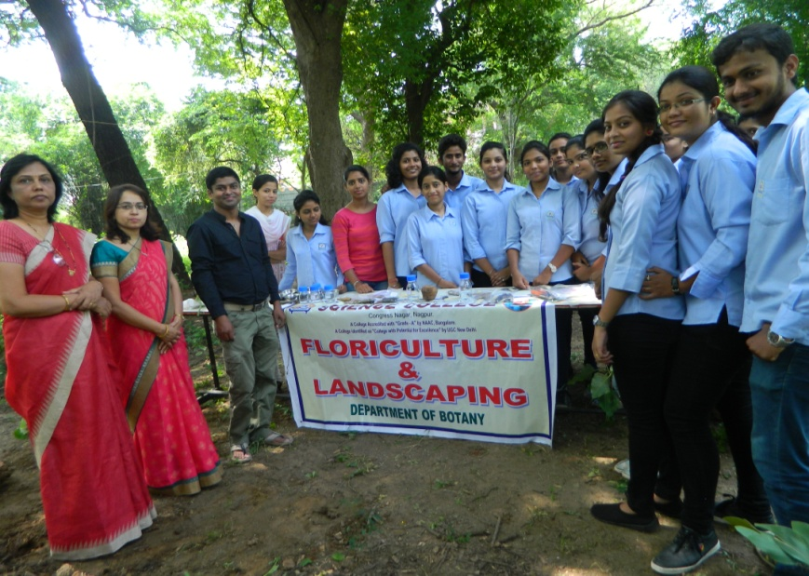
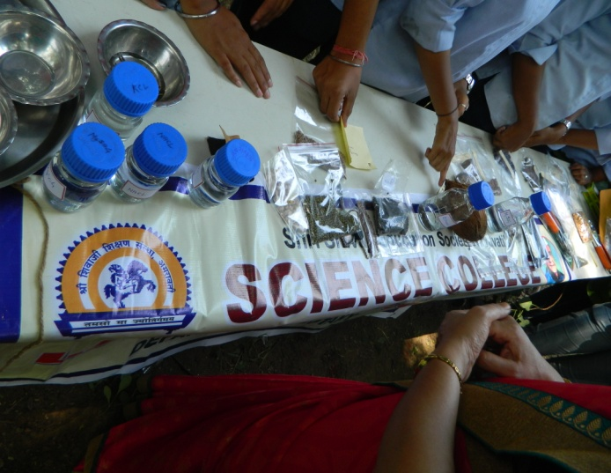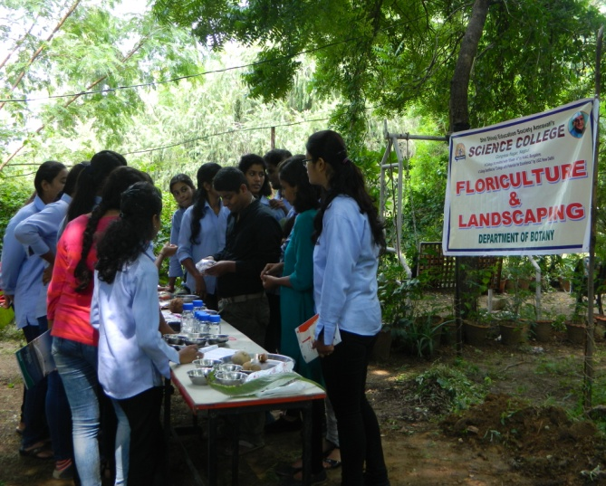

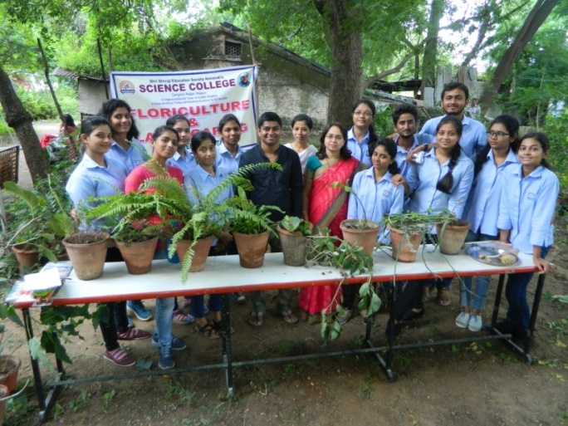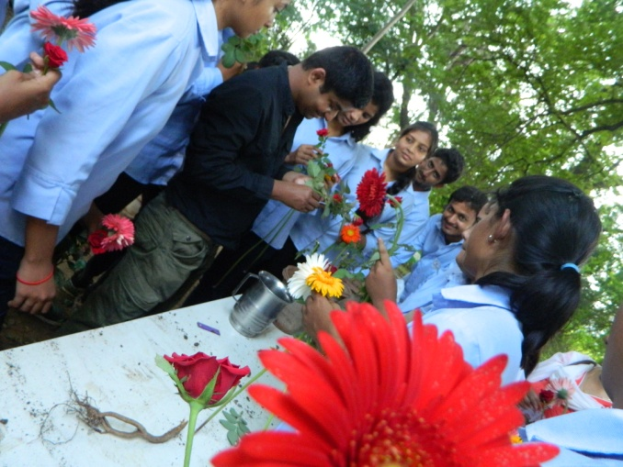
Student’s participation in self finance certificate course on Floriculture & Landscaping visited at “Golden Park” Besa, Nagpur on 26th Sep. 2017

Workshop on “Bouquet making and Flower arrangement” organized on 20th March 2018

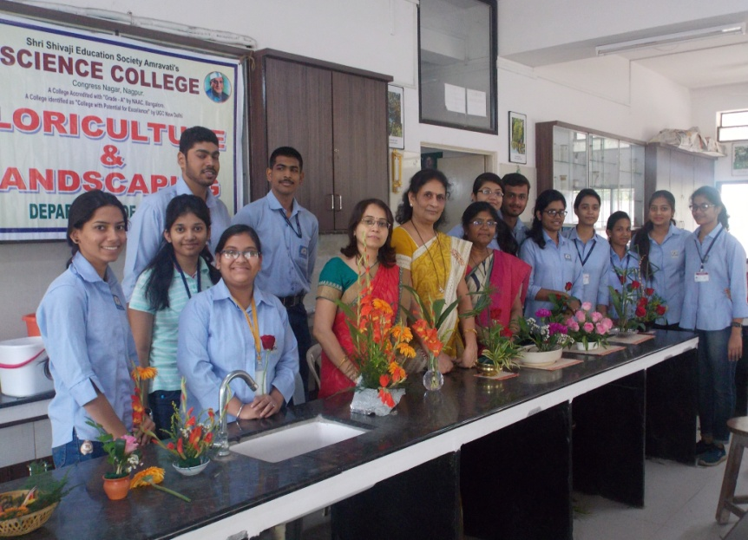
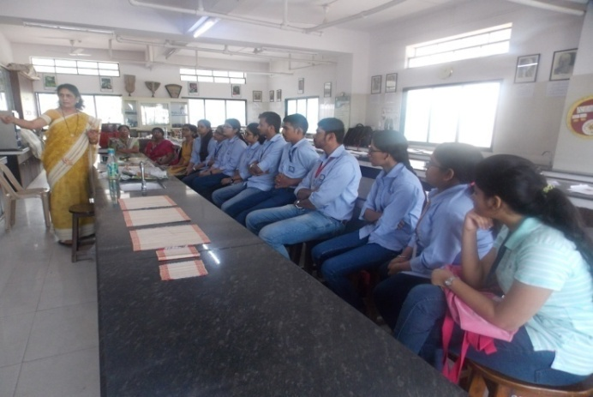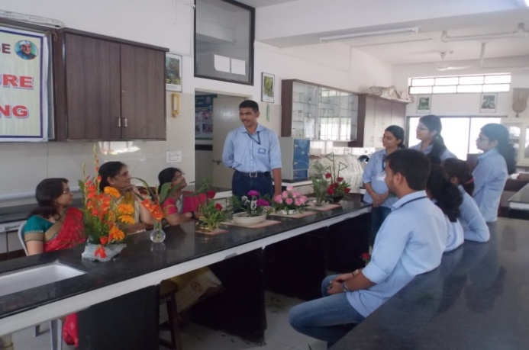
One day workshop was organized on “Bouquet making and Flower arrangement” on 20th March 2018

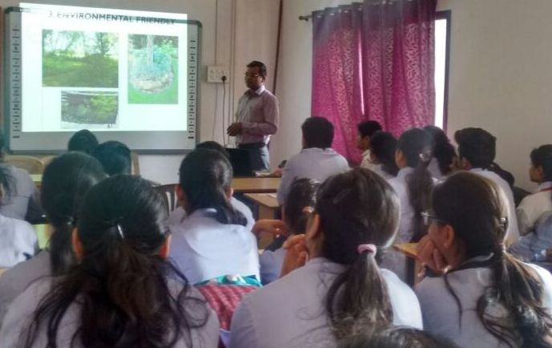
Guest lecture organized on “Landscaping” by Hon. Amit Pophali on 20th Feb. 2018

Convener
Dr. Mrs. R.H.Mahakhode

