Shri Shivaji Education Society Amravati’s
SCIENCE COLLEGE, Congress Nagar, Nagpur
Department of Botany
Organized
Mushroom Cultivation Self Finance Certificate Course
Session 2017-18
REPORT

One month workshop on Mushroom Cultivation under self finance certificate course was organized by the department on 13th October 2017. Dr. Mrs. S. D. Puranik explained about Mushroom cultivation and its importance to the students. Madam demonstrated about the technique oof mushroom cultivation at home in easy and cheap way. 17 students from B.Sc. First year were registered for this certificate course.
The mushroom which is cultivated in our college is Pleurotus sajor-caju i.e. oyster mushroom or Dhingri (warm weather varieties). Mushrooms are classic examples of fungi. They lack the sacred pigment of auto-trophicity viz., chlorophyll and hence live as saprophytes as weak parasites occurring on organic decays, on living plants in nature.
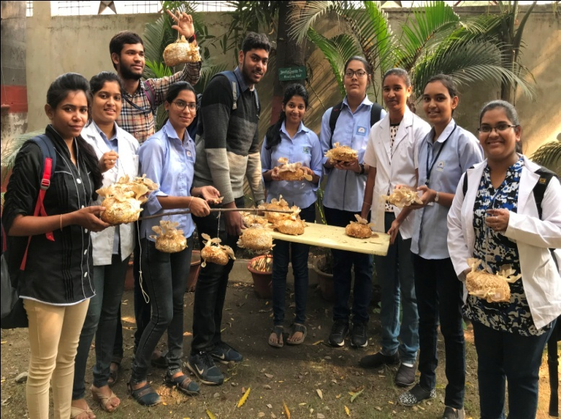
Workshop on Mushroom Cultivation organized under
Self finance certificate course
Four students of our department demonstrated the importance of mushroom cultivation to the students of Inspire Camp which was organized in our college from 26th to 30th March 2018.

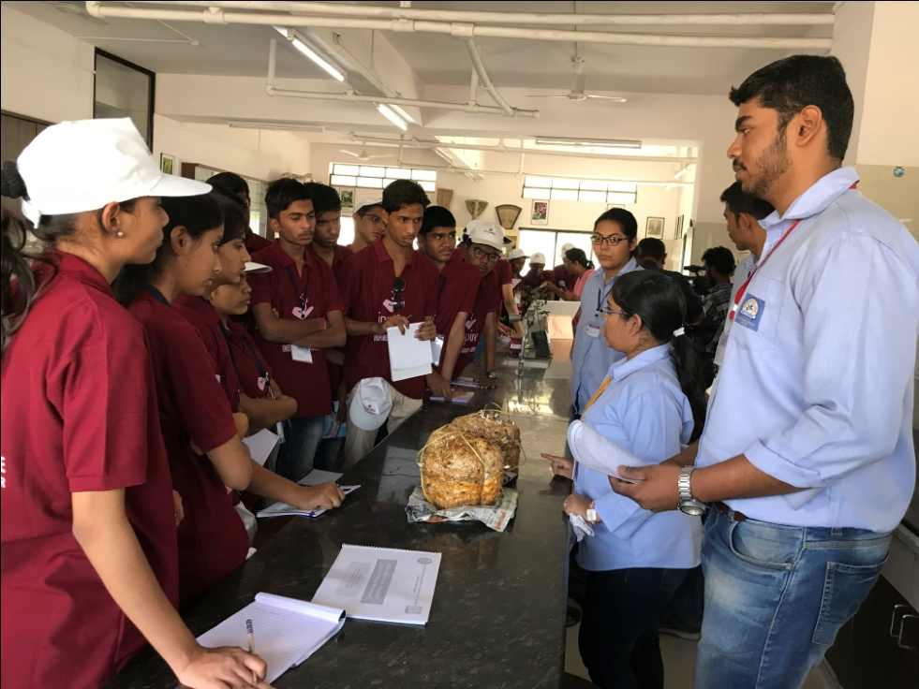
Students participated in Inspire Camp as trainer to explain Mushroom Cultivation Technique on 26-29 March 2018.

Convener
Dr. Mrs. S.D.Puranik

