Department of Botany
Report 2019-2020

Botany Department organized various activities to motivate the students for their overall development.
Activities:
- Student induction program (SIP) was organized from 15th to 20th July, 2019. Students of B.Sc Sem- I visited Botany Laboratory and Research laboratory.
- World Nature Conservation Day was organized on 30th July, 2019. On this occasion Prof. Anjali Phaley, Lecturer, LAD College, Nagpur invited as a Chief Guest & conducted workshop on “Miniature Garden & Seed Ball Technique”.
- Eco-Friendly Rakhi celebration by department on 14th August, 2019. Rakhis were prepared from Eco- friendly materials like seed grains, dry fruits, flowers and leaves, matchsticks, jute fibers etc. and spread the message of environmental protection as a social responsibility.
- INSPIR Program and Interactive seminar was organized from 3rd to 7th Dec, 2019. Students of 12th class visited Botany Laboratory and tissue culture lab and experiments were demonstrated by the students of B.Sc.
- Students of B.Sc. –III year visited Manali, Himachal Pradesh from 16th September to 23rd September 2019 to study flora in their natural habitat with special emphasis on biodiversity.
- Students of B.Sc. –I & II were visited one day tour at Wadgaon dam and Anandawan, Warora, M.H. on 8th February, 2020 to study flora of the region in their natural habitat with special emphasis on biodiversity.
- Department carried out Certificate Course on Plant Tissue Culture demonstrated by Dr. Nandeshwar, Scientist, ICAR in association with Kamala Nehru Mahavidyalaya, Nagpur on 13th February, 2020.
- Abhimanyu Rao, Sky Mushrooms, Nagpur demonstrated techniques in workshop on ‘Edible Mushroom Cultivation’ and ‘Spawn Preparation’ under the Skill Based Program on 20th Feb. 2020 for the students of B.Sc. Sem- I & II.
- Students of Semester IV visited ‘Button Mushroom Cultivation Farm’ Bhandara Road Nagpur, for learning and understanding the process of cultivation and it’s commercial values included under Diploma Course on 26th Feb. 2020.

Dr. R N Deshmukh
Associate Professor and Head

Department of Botany
Report 2019-2020

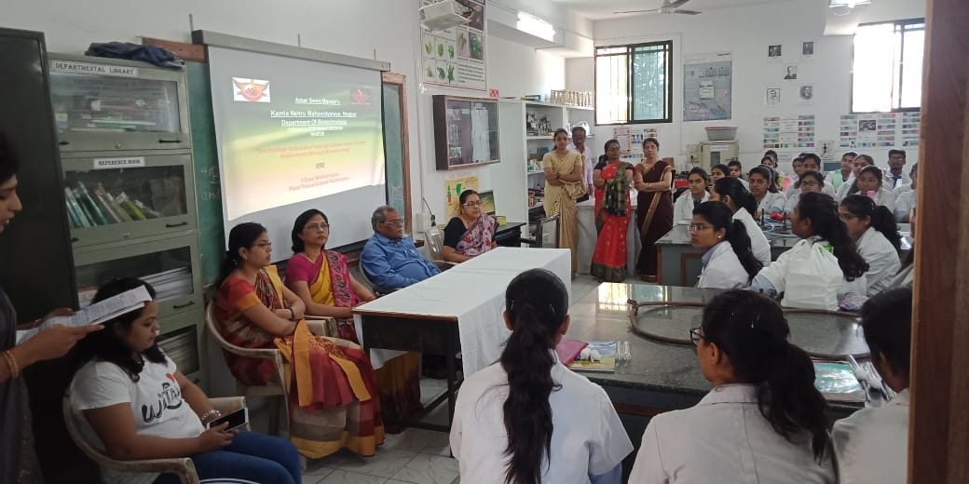
CRI-2, Certificate course on Plant Tissue Culture demonstrated by Dr. Nandeshwar, Scientist, ICAR in association with Kamala Nehru Mahavidyalaya, Nagpur on 13th February, 2020.

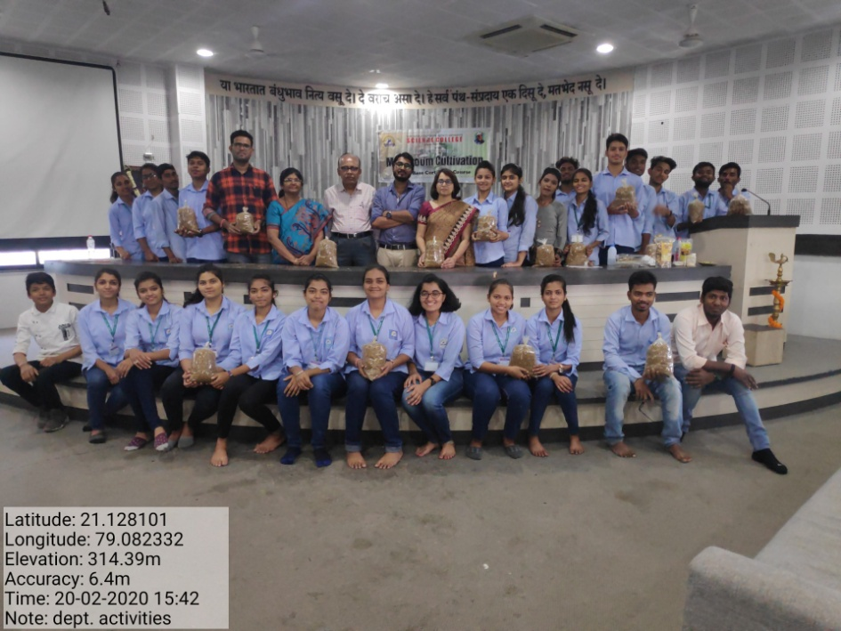
CRI-7, Abhimanyu Rao, Sky Mushrooms, Nagpur demonstrating techniques in workshop on ‘Edible Mushroom Cultivation’ and ‘Spawn Preparation’ under the Skill Based Program on 20th Feb. 2020.

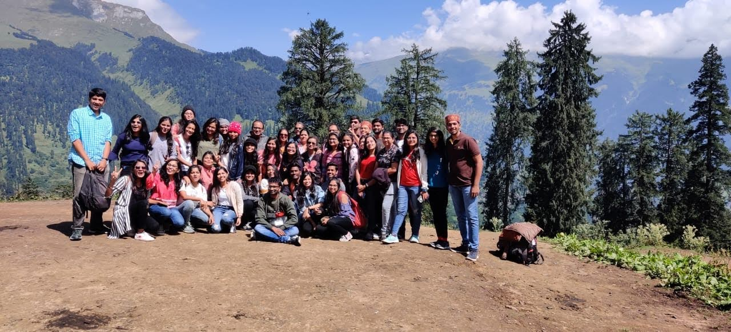
CRI-7, B.Sc.III students visited to Manali, Himachal Pradesh from 16th Sept. to 23rd Sept. 2019.

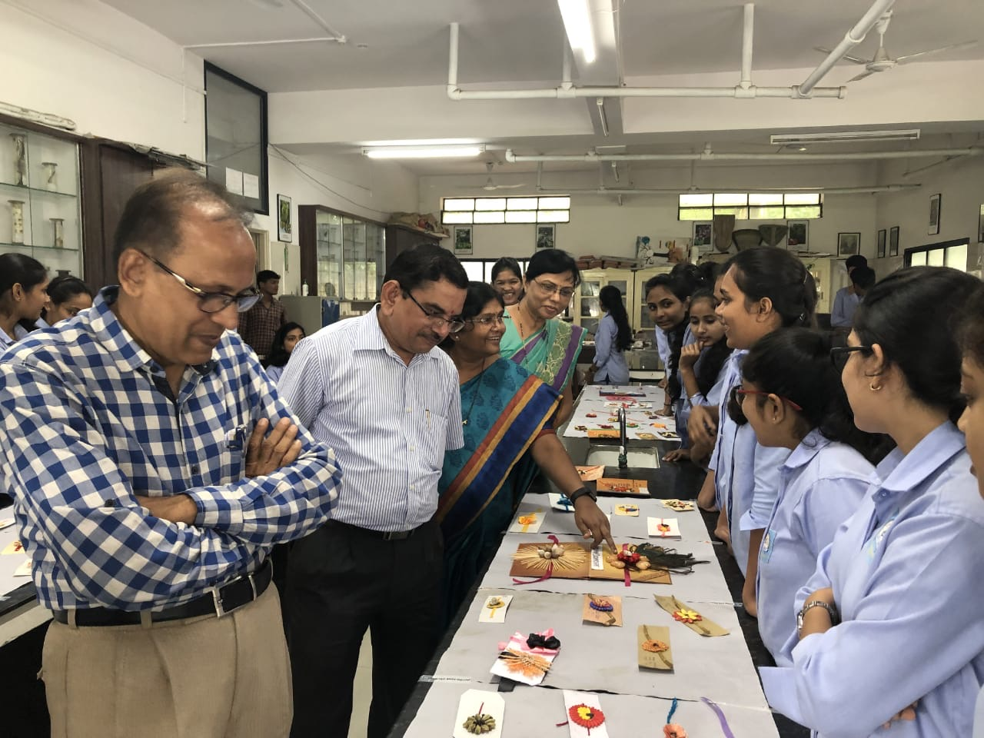
CRI-7, Dr.M.P.Dhore, Principal, Dr.R.N.Deshmukh, HOD and staff members observing Rakhis prepared by students on 14th Aug. 2019.

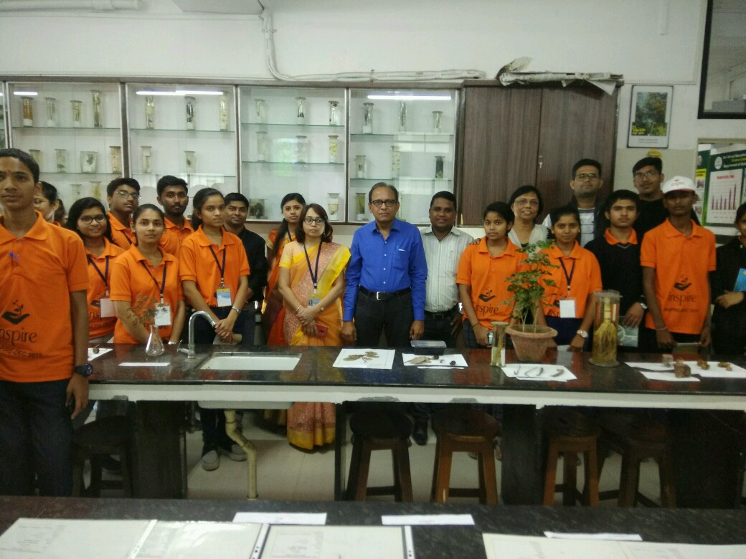
CRI-7, INSPIR Program and Interactive seminars conducted from 3rd to 7th Dec, 2019.

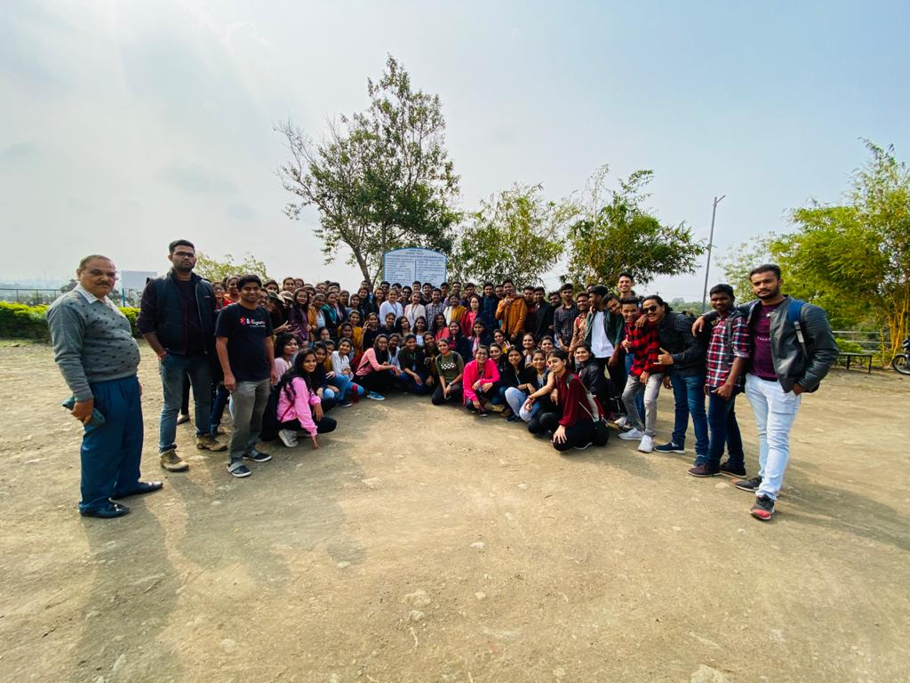
CRI-7, Students of B.Sc. –I & II were visited Wadgaon dam and Anandawan, Warora, M.H. on 8th February, 2020.

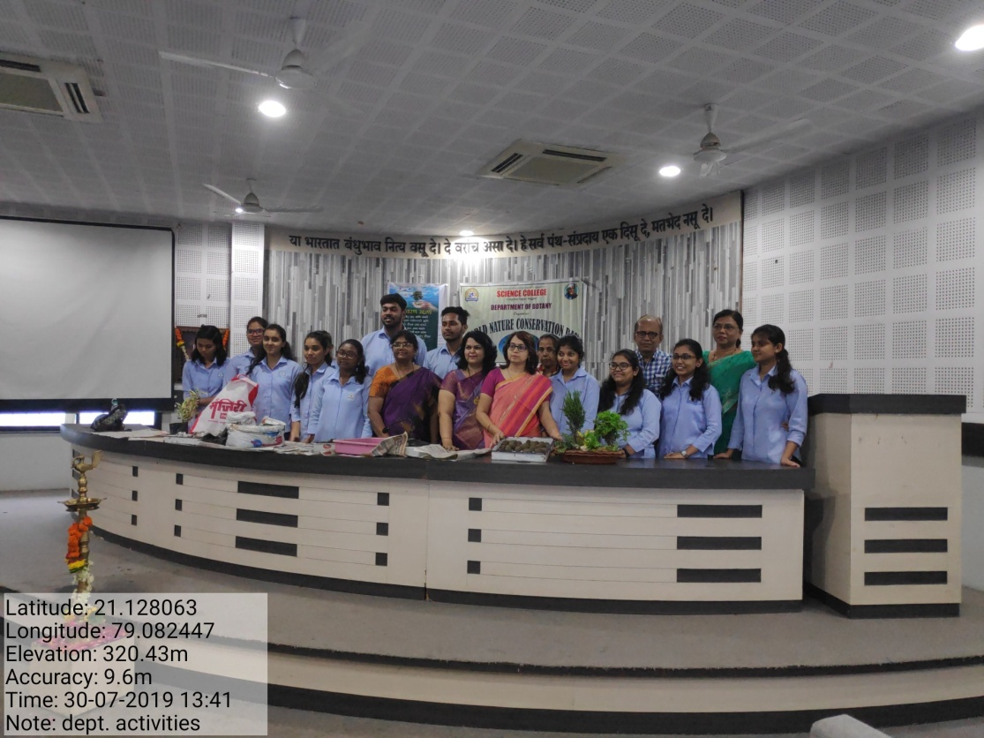
CRI-7, World Nature Conservation Day organized on 30th July, 2019. Prof. Anjali Phaley, LAD College, Nagpur demonstrating “Miniature Garden & Seed Ball Technique”.

