Department of Botany
Report 2018-2019

Botany Department organized various activities to motivate the students for their overall development.
Activities:
- Student demonstrated the technique of Mushroom Cultivation at M M College of Science, Nagpur on 7th July 2018
- World Nature Conservation Day organized on 4th Aug. 2018. On this occasion Dr. Prakash A. Itankar, Asstt. Prof. (Sr. Gr.), Pharmaceutical Sciences, RTM Nagpur University, Nagpur invited as a Chief Guest & delivered a power point presentation on the topic “Translational Research in Herbals: Past to Future to Past”.
- This year students of B.Sc. – I, II and III visited Pachmarhi, Dist. Chindwada, M.P. from 30th Aug. to 2nd Sept. 2018 to study flora of the different region in their natural habitat with special emphasis on biodiversity.
- Department carried out Certificate Course on Floriculture & Landscaping, Plant Tissue Culture and Cultivation of Mushroom for students as regular practice of the department.
- Department signed MOU with SKY Mushrooms, Nagpur on 22nd Sept. 2018.
- Workshop on herbal textile colors & herbal cosmetics in association with Somalwar Nikhalas Mahila Mahavidyalaya, Nagpur on 26 October 2018 & 13 December, 2018 respectively.
- Team of Botany department conducted survey in local area for various types of Pollution on 27 Dec. 2018.
- Self Finance Certificate Course on Plant Tissue Culture Technique held on 23rd Jan 2019.
- Students of Matagujari College, Jabalpur, M.P. visited Botany laboratory on 6th Feb. 2019.
- Abhimanyu Rao, Sky Mushrooms, Nagpur demonstrating techniques in workshop on Mushroom Cultivation under the Skill Based Program on 9th Feb. 2019.
- Training program on Protoplast culture at Botany Department on 12th Feb 2019.
- Students visited Kamptee Open Cast Mine, Nagpur on 14th Feb. 2019.
- Eco-Friendly Dry Holi celebration by department on 16th March 2019.
- Mr. Manish Chinchamalatpure conducted workshop on waste segregation & composting for the students of Sem. II & IV at “Golden Park” Besa, Nagpur on 26th March 2019.
- Students of Semester VI visited ITI Biotech DST Lab. Betul, MP. for Plant Tissue Culture of commercial Banana & Bamboo production on 26th Feb. 2019.
- Green Audit regularly conducted by the Department.

Achievements:
- Ku. Nikhat Farooque & Ku. Priyanka Doondani secured 4th & 5th position in merit list declared by RTM Nagpur University, Nagpur Summer 2018.
- Ku. Shruti Agrawal & Ku. Sakshi Dubey bsgged 1st & 3rd prize in debate competition held at Mahatma Fule Arts, Commerce & Chaudhary Science College, Warud in association with IIT, Kharagpur on 8th-9th Feb. 2019.
- Ku. Iffat Quazi & Ku. Ashwini Zurmure secured second position in oral paper presentation competition at National Students Conference organized by Institute of Science, Nagpur on 6th -7th March 2019.

Dr. R N Deshmukh
Associate Professor and Head

Department of Botany
Report 2018-2019

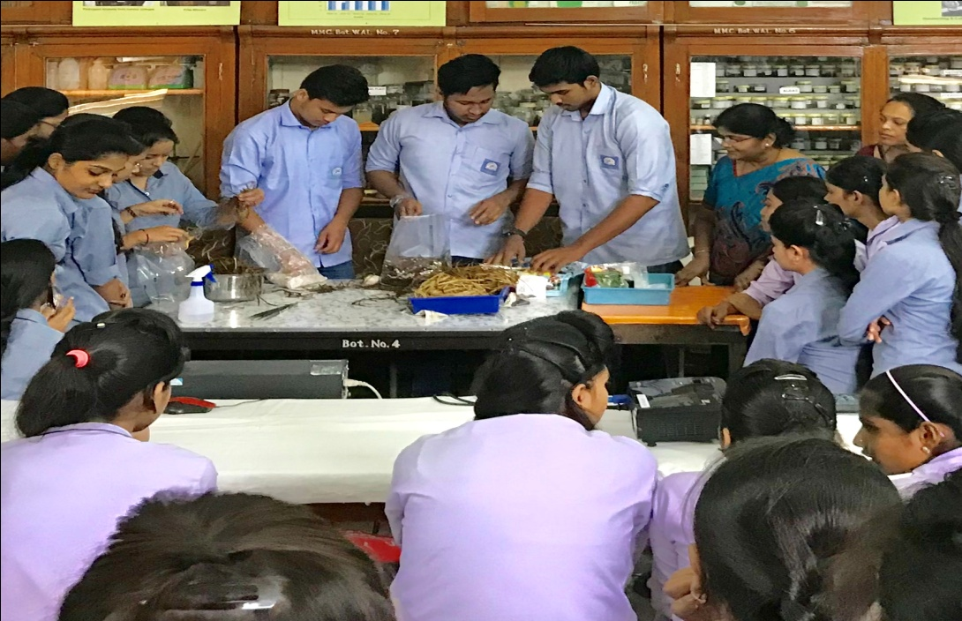
Student demonstrated the technique of Mushroom Cultivation at M M College of Science, Nagpur on 7th July 2018

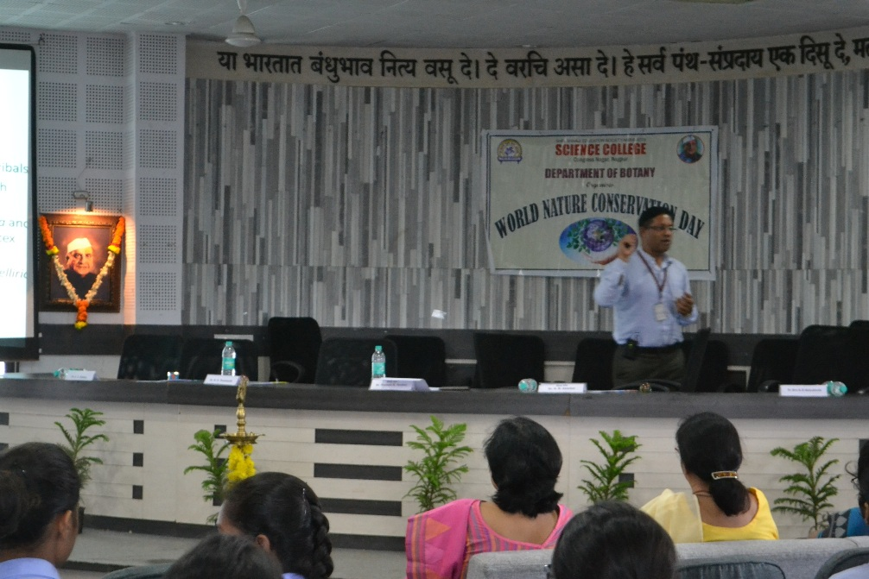
Dr. Prakash R. Itankar delivered talk on “Translational Research in Herbals Past to Future to Past” on 4th August 2018 on the occasion of World Nature Conservation Day.

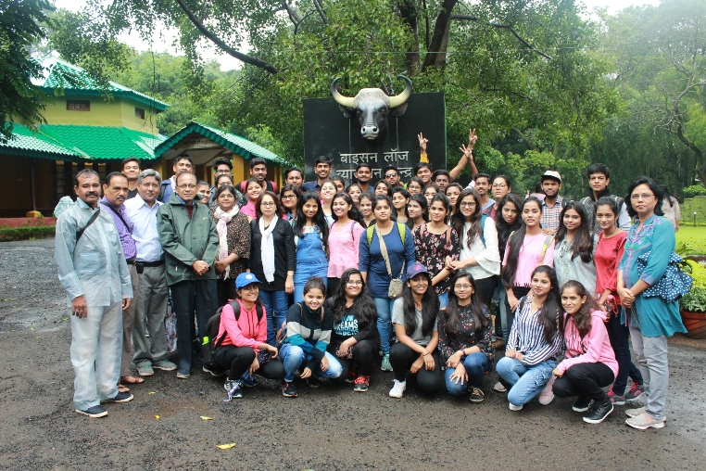
Students visited Pachmarhi, Dist. Chindwada, M.P. from 30th Aug. to 2nd Sept. 2018 to study flora of the different region in their natural habitat with special emphasis on biodiversity.

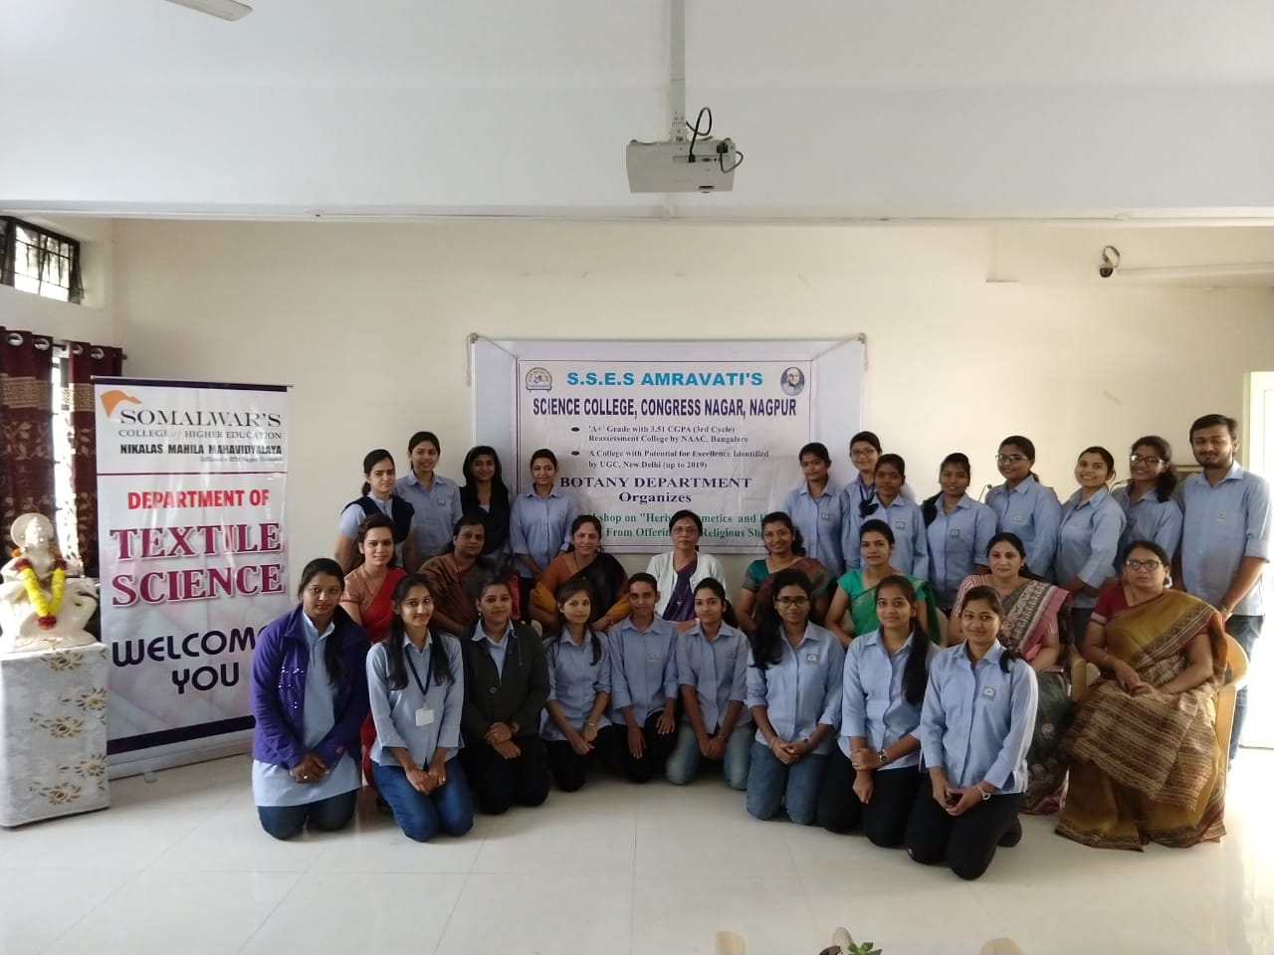
Workshop on herbal Textile colors in association with Somalwar Nikalas Mahila Mahavidyalaya on 26 October 2018.
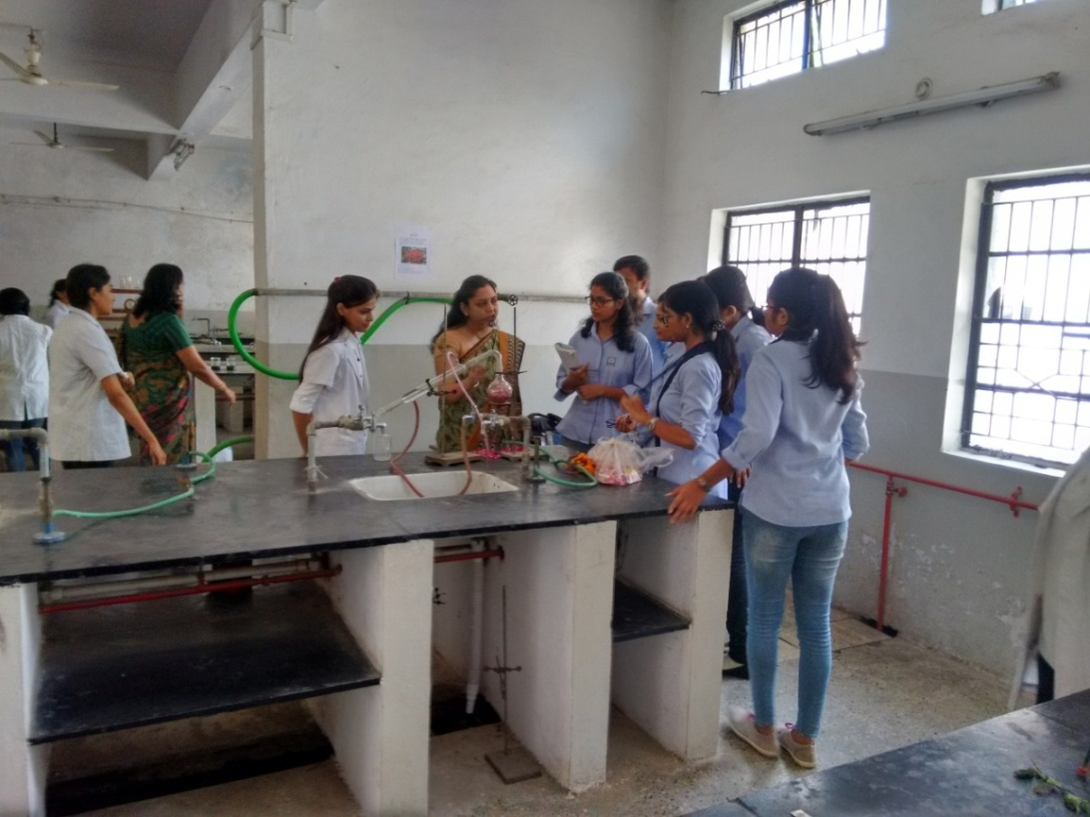
Workshop on herbal cosmetics in association with Somalwar Nikalas Mahila Mahavidyalaya on 13 December, 2018.

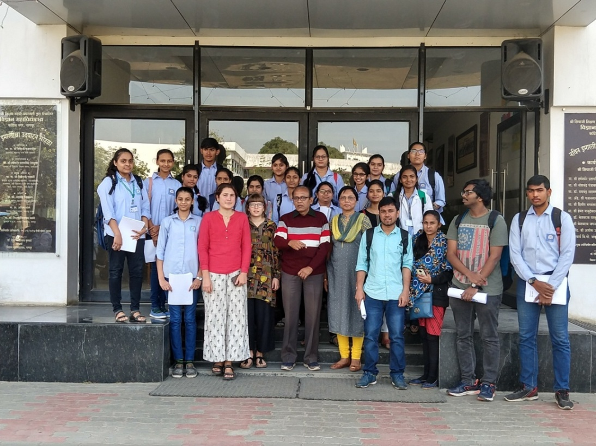
Team of Botany department conducted survey in local area for various types of Pollution
on 27 Dec. 2018.
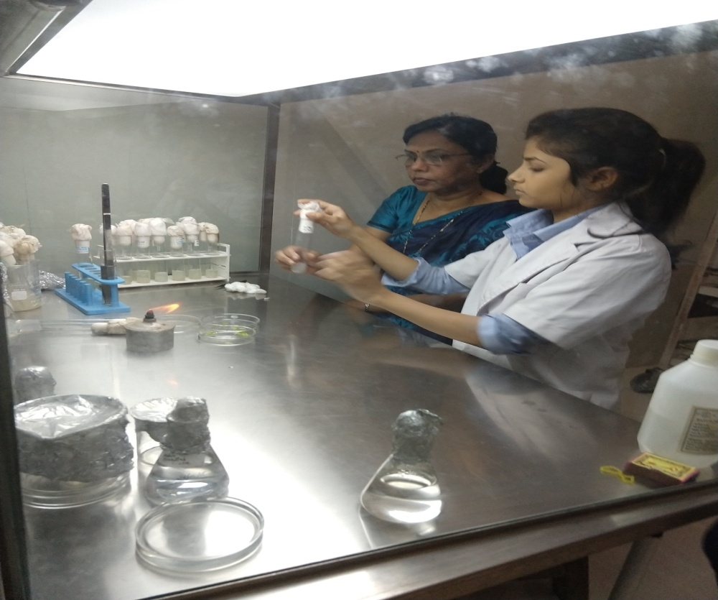
Self Finance Certificate Course on Plant Tissue Culture Technique held on 23 ^{rd} Jan 2019.

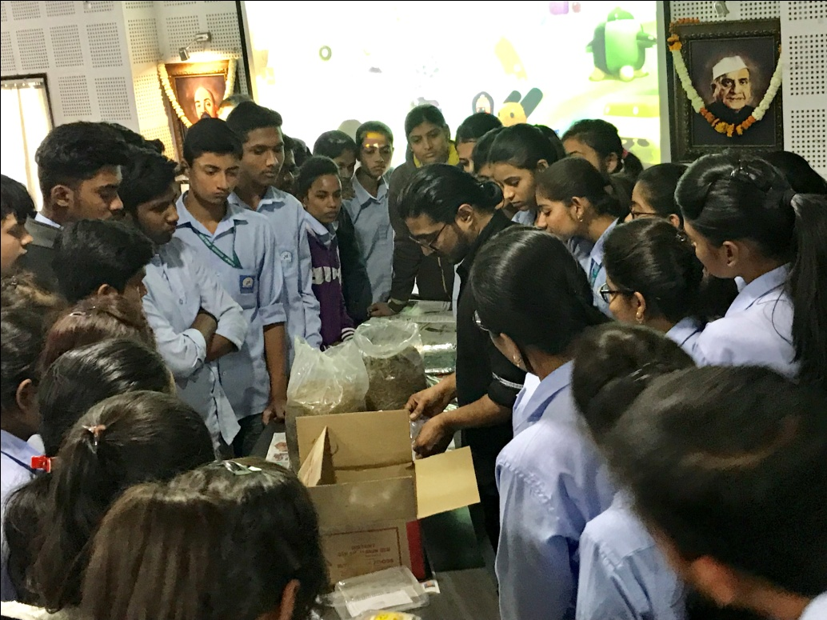
Abhimanyu Rao demonstrating techniques in workshop on Mushroom Cultivation under the Skill Based Program on 9th Feb. 2019.

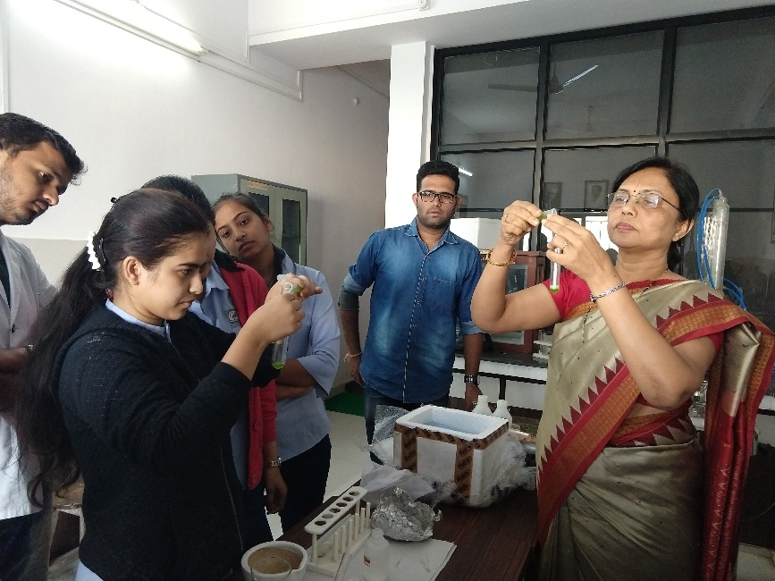
Training program on Protoplast culture at Botany Department on 12 Feb 2019.

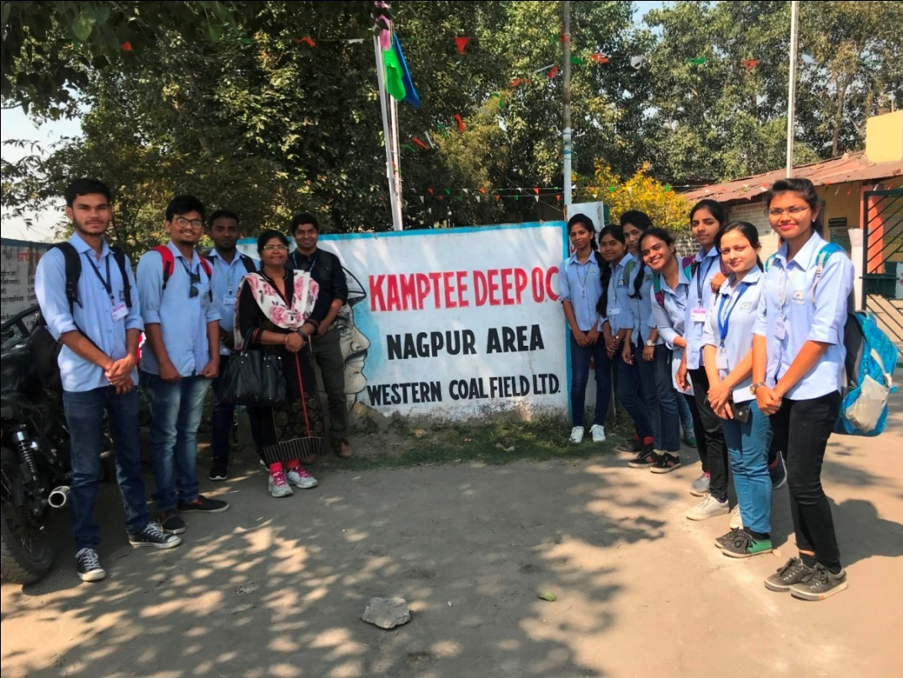
Students visited Kamptee Open Cast Mine, Nagpur on 14th Feb. 2019.

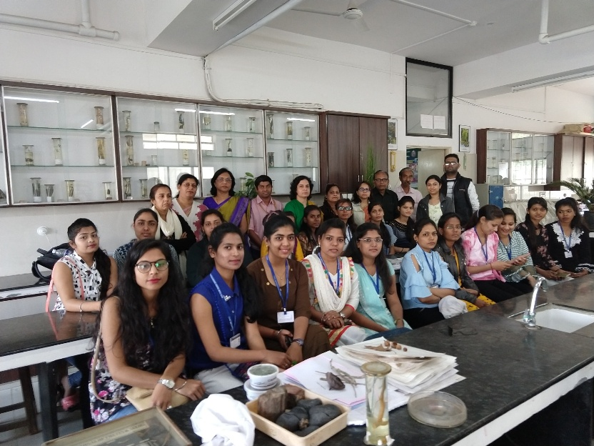
Students of Matagujri College, Jabalpur, M.P. visited Botany laboratory on 6th Feb. 2019.

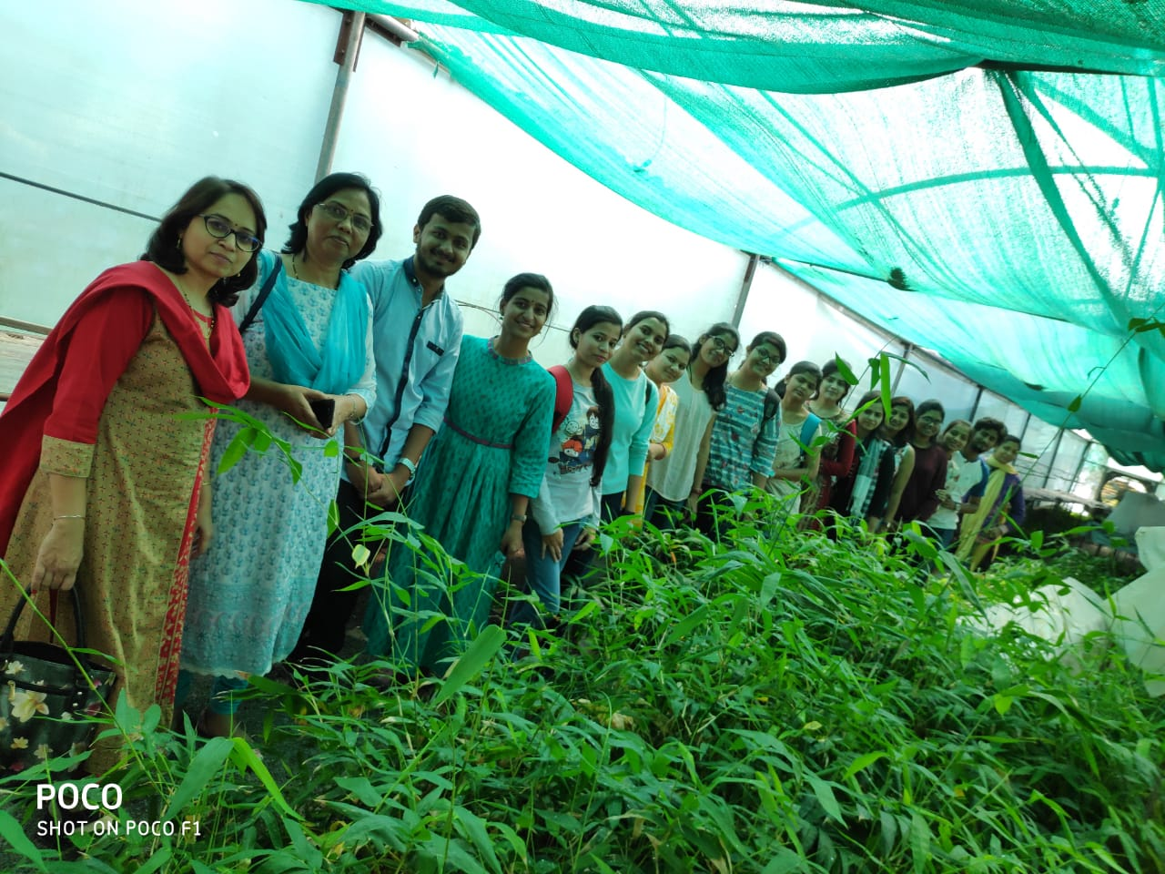
Visit to ITI Biotech labortary, Betul, M.P. organized for B.Sc. Sem VI students on 26th Feb 2019.

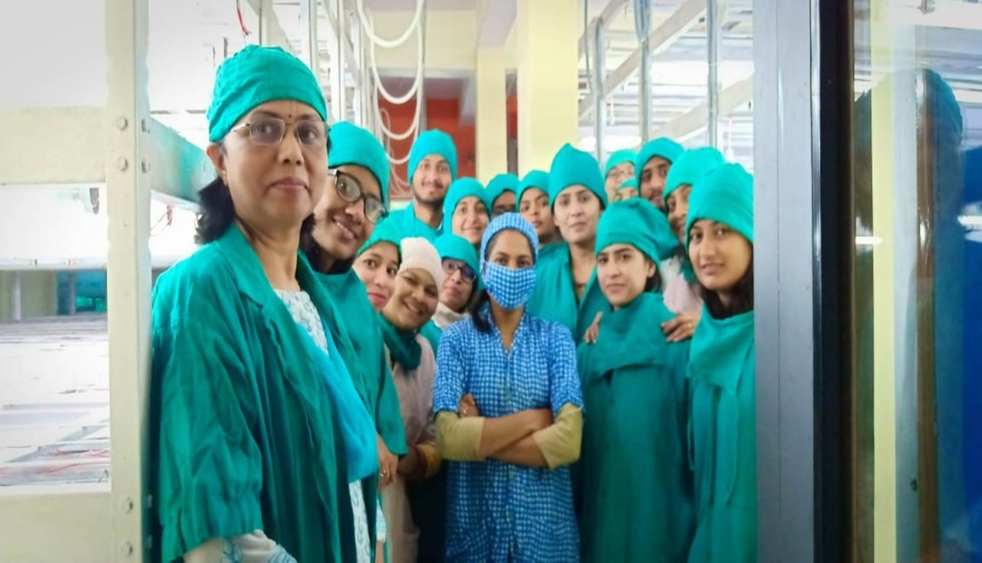
Visit to DST sponsored Plant Tissue culture lab at ITI Biotech,Betul, MP, on 26th Feb 2019.

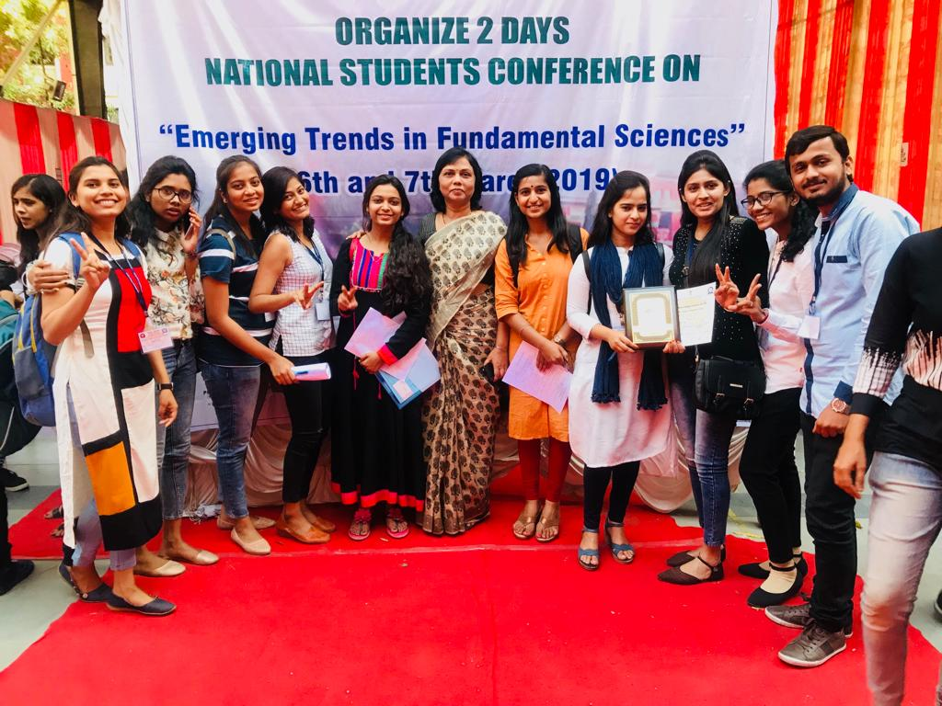
Participation of students in National conference organised by Institute of Science
on 6th & 7th March 2019.

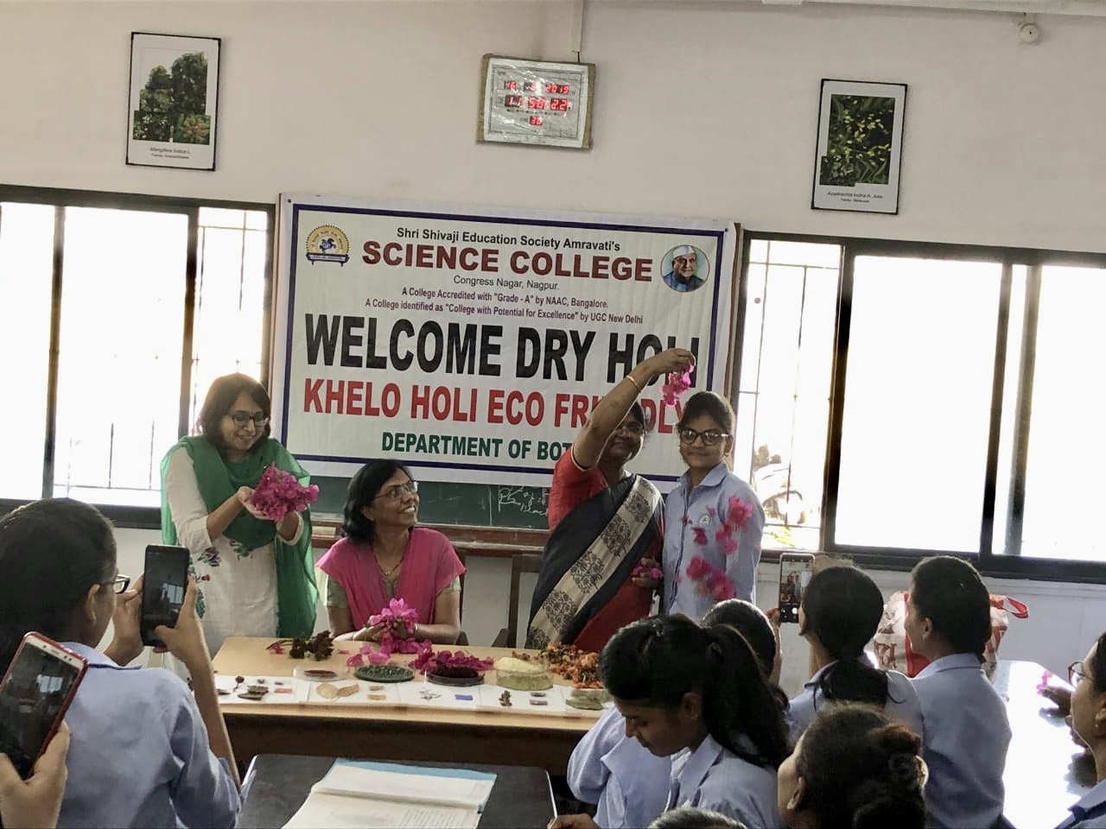
Eco-Friendly Dry Holi celebration by department on 16th March 2019.

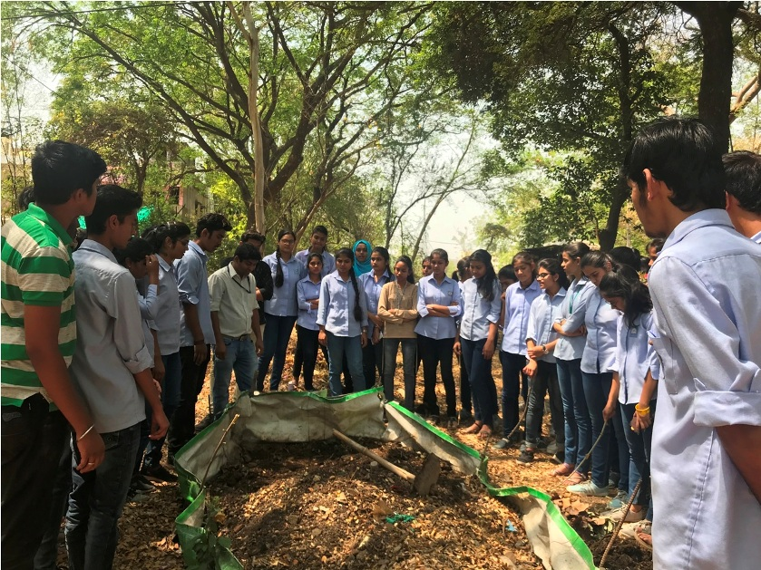
Mr. Manish Chinchamalatpure conducted workshop on Workshop on waste segregation & composting for the students of Sem. II & IV at “Golden Park” Besa, Nagpur on 26th March 2019.

Department of Botany 2018-2019
Students Achivements

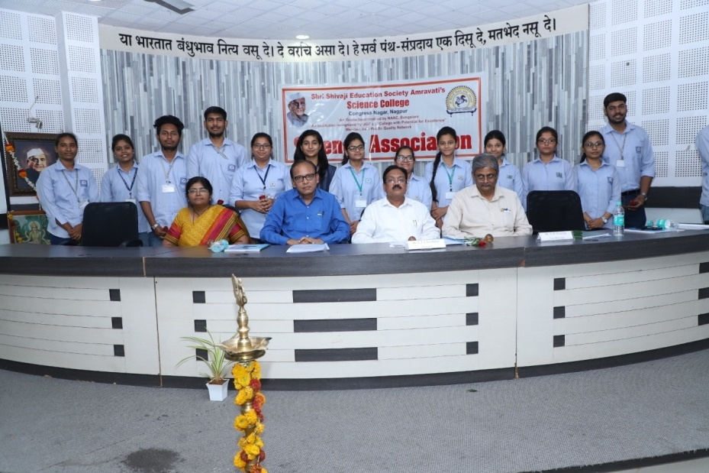
Office Bearer of Department at Inaugral function of Science Association on 29th March 2019
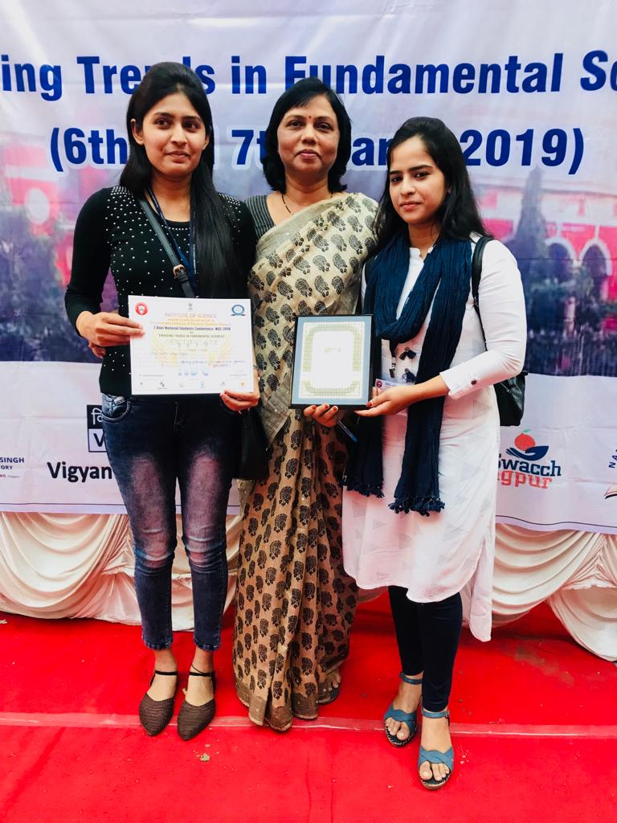
Ku. Iffat Quazi & Ku. Ashwini Zurmure: winners of Oral Paper presentation in National conference organised by Institute of Science, Nagpur on 7th March 2019.
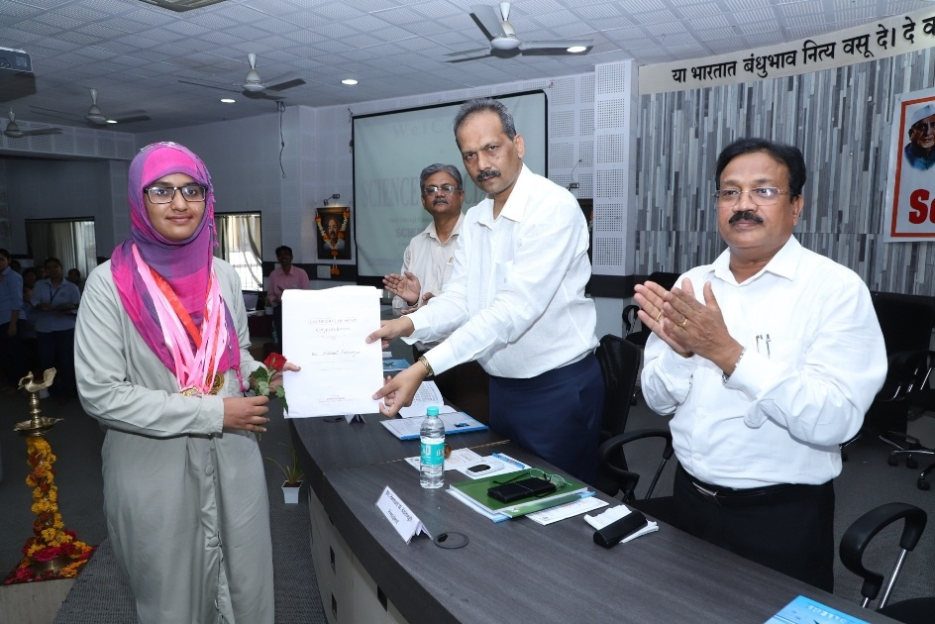
Ku. Nikhat Farooque secured fourth position in RTMNU Merit list Summer 2018.

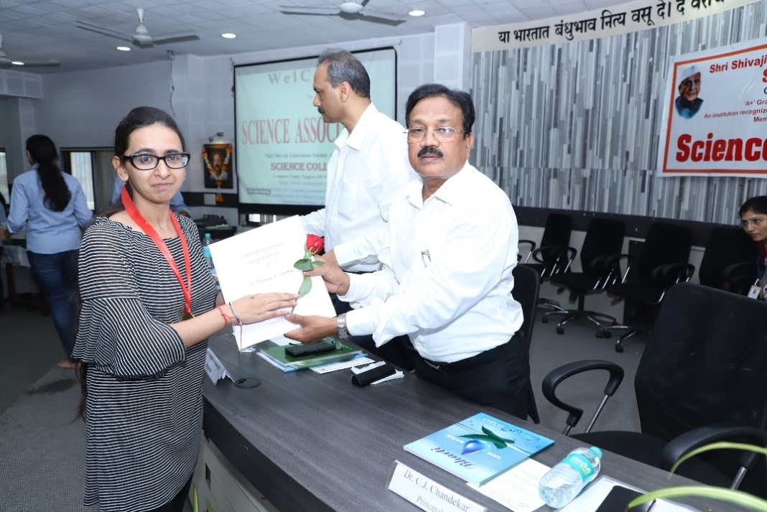
Ku. Priyanka J. Doondani secured fifth position in RTMNU Merit list Summer 2018

