Shri Shivaji Education Society Amravati’s SCIENCE COLLEGE, Congress Nagar, Nagpur

Student Achievement in Science Expo ‘VIDNYAN WARI’ at Shri Shivaji Education Society, Amravati
Session 2022-23
===================================================
Report

Ku. Ketki Sonkusare Sem VI student of Botany department from Shivaji Science College, Nagpur won the third prize in Science Expo ‘VIDNYAN WARI’ on the eve of National Science Day organized by Shri Shivaji Education Society Amravati to commemorate the 125th birth anniversary celebration year of Dr. Panjabrao Deshmukh at Amravati. The title of her model is “Phytorid Technology”. Phytorid Technology is a recycling technology of wastewater to reduce the water scarcity. This system is based on the specific plants such as Typha, Reeds, Cannas sp., Elephant grass having filtration and treatment capability.
‘VIDNYAN WARI’ an Science Exhibition and Competition has been organized by Shivaji Science College, Amravati at Shivaji Horticulture College premises, Rampuri Camp in collaboration with Dr Panjabrao Deshmukh Memorial Science Centre and Dr Panjabrao Deshmukh Research and Training Centre, both run by Shivaji Education Society, Amravati, on February 27 and 28.
The programme was proove to be an innovative treat for the students who were in search of dais to bring into reality their innovative concepts. The Vidnyan Wari has been organized to mark the Science Day, and also 125th birth anniversary of Dr Panjabrao alias Bhausaheb Deshmukh.
Dr. Arun Sapre, Advisor, Rajiv Gandhi Science and Technology Commission, Government of Maharashtra will inaugurate the programme. Hon’ble Harshwardhan ji Deshmukh, President of Shivaji Education Society, Amravati will preside over the programme, while executive committee member of the society will prominently remain present on the occasion. Dr Shivling Patve, Divisional Deputy Director of Education will remain present. Various programmes such as science through fun and entertainment from science centre, games clearing scientific concept, incredible science exhibition, entertaining magic show of Magician Goga, science-based movies, entertaining questionnaire and cultural programmes will be held under Vidnyan Wari. Various prizes such as child scientist, young scientist, innovative scientist and others also be presented to the students.
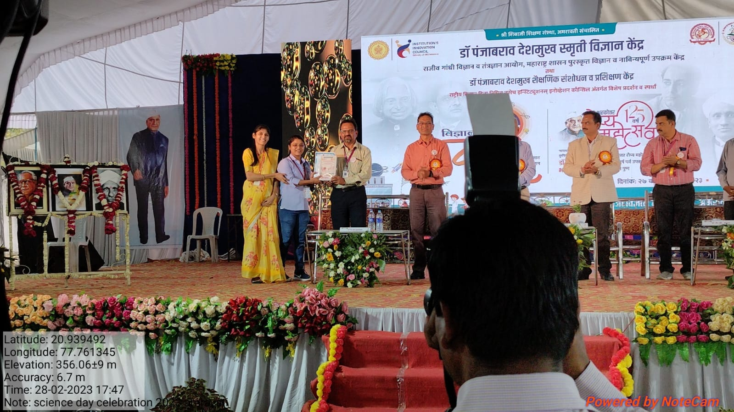
Ku. Ketki Sonkusare Sem VI student of Botany department from Shivaji Science College, Nagpur won the third prize in Science Expo ‘VIDNYAN WARI’ Day organized by Shri Shivaji Education Society Amravati to commemorate the 125th birth anniversary celebration year of Dr. Panjabrao Deshmukh at Amravati
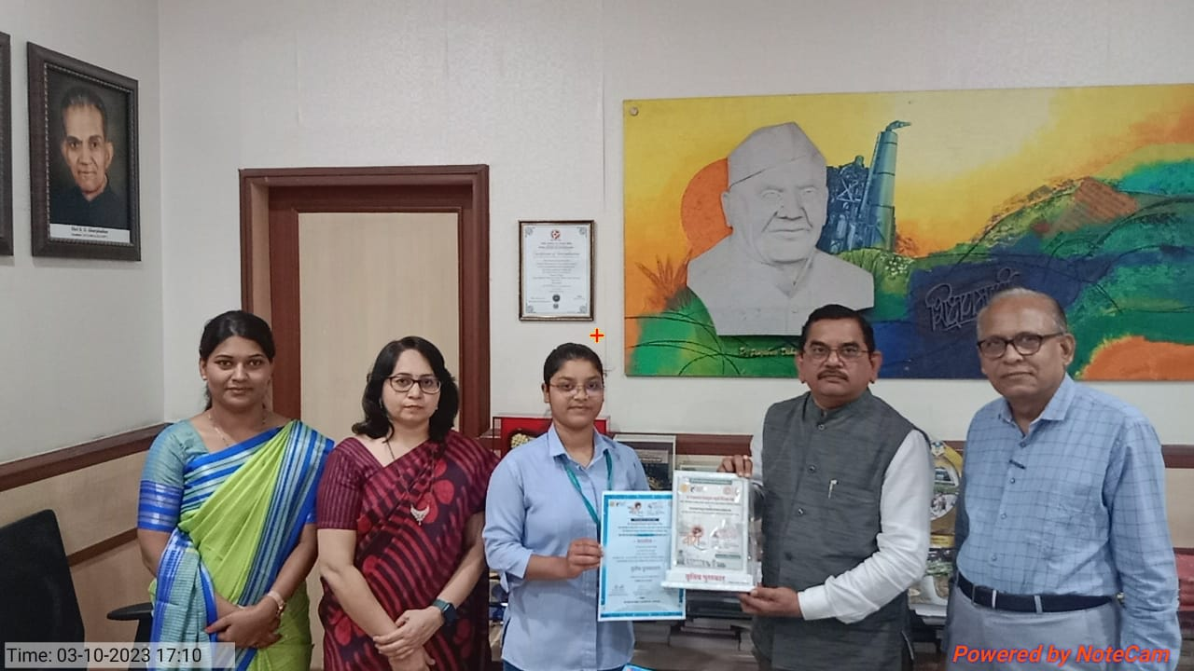
Hon’ble Principal Prof. M.P.Dhore, felicitating Ku Ketki Sonkusare Sem VI student of Botany department for receiving third prize in ‘VIDNYAN WARI’, Science expo organized by Shri Shivaji Education Society Amravati on 28th February 2023.

Teacher Incharge
Dr. Mrs. R.H.Mahakhode

